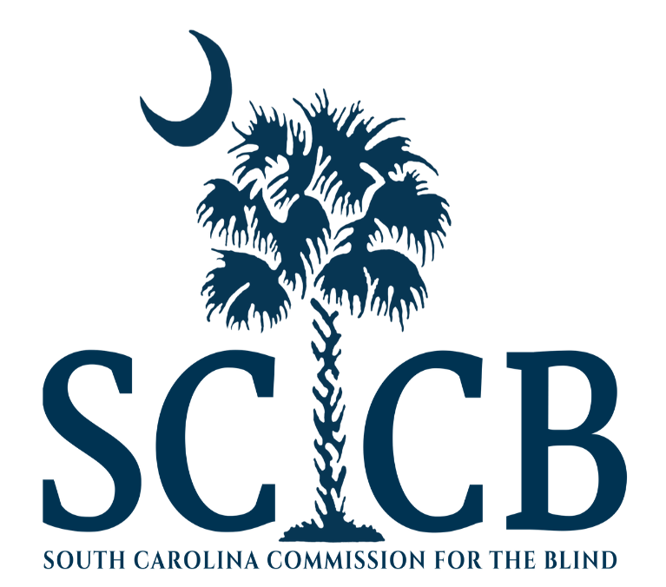
South Carolina Commission for the Blind
Vocational Rehabilitation Program Section
South Carolina Unified State Plan
2018 Modification

GAP 1: South Carolina’s current labor force, including individuals who are blind or visually impaired, do not have industry recognized credentials, knowledge, skills, or abilities to meet current or emerging demands of the business community.
Objective 1: Identify, invest and support job seekers who are blind and visually impaired in the attainment of industry recognized credentials and vocational training required for current and emerging jobs.
Goal 1.1: Provide comprehensive vocational rehabilitation services to youth and transition students resulting in the attainment of industry recognized in-demand credentials required for competitive integrated employment.
Strategy 1.1.1: Provide Pre-Employment Transition Services (Pre-ETS) through the Career BOOST and Summer Teens Programs. In cooperation and collaboration with public schools these services include career exploration and counseling, self-advocacy skills training, work readiness training, work-based learning experiences, and exploration of post-secondary education and training.
Key Performance Indicator 1.1.1: Number of Students Completed
Strategy 1.1.2: Support the attainment of a High School Diploma, GED and/or SC Employability Credential through vocational counseling and guidance, assistive technology, coordination and collaboration with public schools.
Key Performance Indicator 1.1.2: Number of Students Completed
Strategy 1.1.3: Invest in, facilitate and support completion of Post-Secondary college and/or university vocational training.
Key Performance Indicator 1.1.3: Number of Students Completed
Goal 1.2: Provide comprehensive vocational rehabilitation services to adult job seekers who are blind or visually impaired resulting in the attainment of industry recognized in-demand credentials required for competitive integrated employment.
Strategy 1.2.1: Provide quality Adjustment to Blindness and Pre-Vocational Training at the Ellen Beach Mack Rehabilitation Center for Employment & Independence. Adjustment to Blindness Training includes: Orientation & Mobility (Independent Travel), Independent Living Skills, Braille Literacy, Employability Soft Skills, Basic Financial Literacy, and Psychosocial Adjustment to Blindness Counseling. Pre-Vocational Training includes: Basic Keyboarding, Basic Microsoft Office Suite Training, and Assistive Technology Training such as Computer Screen Readers, Text Magnifiers, Low Vision Aids, Etc.
Key Performance Indicator 1.2.1: Number of Consumers Completed
Strategy 1.2.2: Support the attainment of a High School Diploma, GED, and SC Employability Credential through vocational counseling and guidance, assistive technology, collaboration and technical assistance to adult education programs.
Key Performance Indicator 1.2.2: Number of Consumers Completed
Strategy 1.2.3: Invest in, and support the completion of Post-Secondary vocational training through career exploration, vocational counseling and guidance, assistive technology, tuition assistance, collaboration and technical assistance to colleges and universities.
Key Performance Indicator 1.2.3: Number of Consumers Completed

GAP 2: SCCB needs to improve alignment of policies, resources, and staff expertise to provide job driven, labor market informed, vocational counseling and guidance that aligns with South Carolina’s Talent Pipeline Project and Sector Strategies initiatives to assist eligible consumers in accessing career pathways that lead to high and middle skill/income jobs in growth sectors.
Objective 2: Align resources, policy, and strategies to continuously improve competitive integrated employment outcomes for blind and visually impaired job seekers.
Goal 2.1: Develop and enhance job seeker work readiness and soft skills.
Strategy 2.1.1: Provide Adjustment to Blindness and Pre-Vocational Training at the Ellen Beach Mack Rehabilitation Center for Employment & Independence. Adjustment to Blindness Training includes: Orientation & Mobility (Independent Travel), Independent Living Skills, Braille Literacy, Employability Soft Skills, Basic Financial Literacy, and Psychosocial Adjustment to Blindness Counseling. Pre-Vocational Training includes: Basic Keyboarding, Basic Microsoft Suite Training, and Assistive Technology Training such as Computer Screen Readers, Text Magnifiers, Etc.
Key Performance Indicator 2.1.1: Number of Consumers Completed
Strategy 2.1.2: Facilitate The BRIDGE Program Job Club (Building Readiness for Individualized Development of Gainful Employment) provides consumers who have completed the Adjustment to Blindness and Pre-Vocational Training at the Ellen Beach Mack Rehabilitation Center for Employment and Independence a paid work based learning experience (internship) and job club activities to enhance employability and jump start job placement in their local community.
Key Performance Indicator 2.1.2: Number of Consumers Completed
Strategy 2.1.3: Summer Internship Program (SIP) provides college and university students with a paid summer internship in their field of study during their Sophomore, Junior and Senior year.
Key Performance Indicator 2.1.3: Number of Consumers Completed
Goal 2.2: Enhance and improve job placement services and job support services for job seekers who are blind or visually impaired.
Strategy 2.2.1: Increase job placement by SCCB Employment Consultants through talent acquisition services to business partners matching qualitied job seekers who are blind or visually impaired with current job openings.
Key Performance Indicator 2.2.1: Number of Consumers Employed
Strategy 2.2.2: Provide Supported Employment (SE) utilizing the initial placement and job coaching provided on a short term basis by an SCCB JOBS Specialist (Job Oriented Blind Service) with long term extended supports provided by another agency such as an employment network, state agency, or natural supports.
Key Performance Indicator 2.2.2: Number of Consumers Employed
Strategy 2.2.3: Provide Customized Employment that includes intensive discovery of individualized skills, abilities, potential; and intensive customization of an existing job opening, creation of a job that fills an unmet need, and other customized options. SCCB provides Customized Employment through a qualified and trained JOBS Specialist (Job Oriented Blind Service).
Key Performance Indicator 2.2.3: Number of Consumers Employed
Gap 3: SCCB needs to improve partnerships with business in order to more accurately identify current and future workforce needs of business and industry to support career pathways in growth sectors and improve services to business.
Objective 3: Identify current and future needs of business and industry to support career pathways in growth sectors.
Goal 3.1: Provide specialized training through a Pre-Apprenticeship Program to prepare adults not enrolled in college programs, as an alternative career pathway to current and future business and industry needs.
Strategy 3.1.1: Utilize the principles STEM education to develop a Pre-Apprenticeship training program for job seekers who are blind and visually impaired that will satisfy the entry level skills needed for acceptance into registered apprenticeship programs. Incorporate the use of the most current Assistive Technology that will make graduates competitive when applying to fill open apprenticeship positions.
Key Performance Indicator 3.1.1: Number of Consumers Completed
Strategy 3.1.2: Collaborate with the South Carolina US Department of Labor Apprenticeship Office to discover the industry needs for apprentices in South Carolina. Meet with employers to promote program and consumers before, during, and after program participation to facilitate job development opportunities.
Key Performance Indicator 3.1.2: Number of Apprenticeships Entered by Consumers
Strategy 3.1.3: Engage and collaborate with WIOA core partner’s business service coordination council to collaborate and coordinate business service efforts to include the blind and visually impaired in the labor market.
Key Performance Indicator 3.1.3: Number of Business Services Delivered
Goal 3.2: Increase and improve talent acquisition and talent retention services to business in support of employees who are blind or visually impaired.
Strategy 3.2.1: Provide Workplace Sensitivity Training Workshops and Accessibility Technical Assistance (TA)to business partners in order to facilitate the employment of people who are blind or visually impaired.
Key Performance Indicator 3.2.1: Number Workshops/TA Delivered
Strategy 3.2.2: Provide Talent Acquisition Services to business partners by matching current open positions with qualified applicants who are blind or visually impaired, providing technical assistance in regards to assistive technology and reasonable accommodations.
Key Performance Indicator 3.2.2: Number of Job Placements
Strategy 3.2.3: Provide Talent Retention Services to business partners by providing technical assistance, support, and training necessary for the business to retain an employee who is blind or visually impaired.
Key Performance Indicator 3.2.3: Number of Job Retentions

Gap 4: SCCB needs to improve marketing, branding, and engagement with business, consumers, and other workforce partners to increase awareness, improve partnerships, and increase effectiveness and efficiency of services leading to competitive integrated employment.
Objective 4: Engage job seekers, business leaders, and other workforce partners through marketing and outreach to articulate a value proposition to each.
Goal 4.1: Improve visibility and branding of SCCB with job seekers who are blind or visually impaired, businesses seeking to diversify their labor market talent pool, and other workforce partners to increase the awareness and effectiveness of SCCB services.
Strategy 4.1.1: Complete Rebranding & Promotional Materials.
Key Performance Indicator 4.1.1: Rebranding Completed and Implemented
Strategy 4.1.2: Attend and distribute branding materials at Community Health Fairs, Career and Job Fairs, and other Community Resource Education Events.
Key Performance Indicator 4.1.2: Number Attended
Goal 4.2: Improve visibility and awareness of SCCB within the Workforce Development System.
Strategy 4.2.1: Enhance programmatic presence in SC Works American Job Centers through assigned liaison relationships with field staff, standardized colocation hours, infrastructure cost sharing, accessibility assessment technical assistance and implementation, and availability of program educational information and rebranded materials.
Key Performance Indicator 4.2.1: N/A
Strategy 4.2.2: Enhance programmatic presence at South Carolina Workforce Development Board meetings to ensure that the needs of job seekers who are blind or visually impaired are represented.
Key Performance Indicator 4.2.2: Number of Board Meetings Attended by SCCB

2016 Unified State Plan Progress Review

Goal 1: Increase Program Capacity Leveraging Partnerships & Community Engagement
Priority 1.1: Improve WIOA Partnerships & One-Stop System Engagement
Priority 1.2: Improve Partnerships & Strategic Alliances to Increase Program Capacity
Priority 1.3: Increase Public Awareness & Community Engagement
Priority 1.4: Align Ellen Beach Mack Rehabilitation Center (EBMRC) Programing
Report of Progress Goal 1: SCCB has achieved substantial progress on goal 1. SCCB improved WIOA partnerships and One-Stop System Engagement through the strategies of formalizing American Job Center partnerships with Memorandum’s of Understanding which include infrastructure cost agreements, specified co-located staff office times and space, center accessibility assessment and technical assistance, and staff cross training. SCCB has active MOU’s with all SC Works Centers. SCCB worked with core WIOA partner programs to create agency cross training modules for partnership workforce staff, and explored data sharing and common intake opportunities. SCCB finalized a Cooperative Agreement with SC Department of Education and is currently negotiating an update to the SC Vocational Rehabilitation Department Cooperative Agreement. SCCB negotiated and entered into a number of Cooperative Agreements with community based qualified fee-for-service vendors and other partners to expand capacity and available resources statewide. This has expanded program capacity to provide independent travel training (8 new vendors), home management training (2 new vendors), and Braille Literacy (2 new vendors) in community settings. SCCB also provides ZoomText, Jaws, and other assistive technology training through a fee-for-service contract with the National Federation of the Blind of South Carolina. SCCB established contractual programs for Pre-Employment Transition Services with South Carolina’s Independent Living Centers and the National Federation of the Blind. Since inception Career BOOST has provided 761 students with Self-Advocacy Workshops, 494 Work Readiness Workshops, and 160 Work Based Learning Experience such as paid internships and work site tours and job shadowing. Under Career Boost 62 eligible and potentially eligible high school students have participated in college and university tours, exploration of post-secondary educational options, and counseling on financial aid opportunities. SCCB conducted public awareness outreach and implemented a social media presence to enhance agency visibility. In 2017 SCCB rewrote the curriculum and courses offered at the Ellen Beach Mack Rehabilitation Center for Employment and Independence. This new curriculum includes pre-test and post-test assessments to measure skill gains and provide for continuous improvement. Several new center programs have been implemented including a partnership with Adult Education that brings GED preparation instruction and testing to the center. SCCB added a Basic Financial Literacy course using curriculum designed by the Consumer Financial Protection Bureau. SCCB has also added Soft-Skills training based on the “Skills to Pay the Bills” curriculum.

Goal 2: Increase Quantity & Quality of Employment Outcomes
Priority 2.1: Align VR Counseling with South Carolina’s Talent Pipeline Project, Emphasizing Career Pathways, Attainment of Industry Recognized Credentials, Job Driven/Sector Strategies & Labor Market Information
Priority 2.2: Increase Employment for those with Most Significant Disabilities
Priority 2.3: Increase Vocational Exploration & Opportunities for Transition Students
Priority 2.4: Increase Employment for all eligible consumers
Report of Progress Goal 2: Under the previous state plan, SCCB focused efforts on building program capacity, resources and expertise needed in order to meet goal 2. This required resource location, resource reallocation, and program building. As these programs have been built, SCCB has not experienced an increase in the number of successful employment outcomes. Under the provisions of the previous Unified State Plan, SCCB has aligned VR Counseling, career exploration, vocational goal selection, and Individualized Plan for Employment development with labor market information and sector strategies. SCCB has instituted the use of The Career Index Plus for analyzing labor market information and helping consumers make informed job driven decisions. SCCB implemented significant staff training in the area of using labor market information and understanding South Carolina’s regional economic conditions. SCCB leveraged partnerships with the Department of Employment and Workforce, and the Job Driven Technical Assistance Center to provide staff with training on sector strategies, the talent pipeline efforts, and the use of labor market information. SCCB has established program capacity and resources to better serve individuals who have Most Significant Disabilities. SCCB has established JOBS Specialists who are providing Supported Employment and Customized Employment, evidence based practices that have not been offered by SCCB in the past. In addition, SCCB has hired and trained a Certified Work Incentive Counselor to help beneficiaries understand the implications of gainful employment on their Social Security benefits. SCCB established Career BOOST, a contractual program in partnership, collaboration, and coordination with Independent Living Centers, the National Federation of the Blind, and South Carolina’s Local Education Authorities. This program provides the required Pre-Employment Transition Services to eligible and potentially eligible students with disabilities. SCCB hosted the first Science, Technology, Engineering, and Math Career (STEM) Exploration Week for transition students during the summer of 2017. During the STEM Career Exploration week, 9 high school students who are blind or visually impaired were provided instruction by a team of scientists from San Jose State University, Edinboro University of Pennsylvania, NASA’s Goddard Space Flight Center, the Space Telescope Science Institute, and the International Astronomical Union. The students explored STEM careers using 3D printed tactile models of galaxies, planets, and other astronomical phenomena. Additionally, students were exposed to “sonification” techniques used by blind and visually impaired Astronomers to study the universe. SCCB is repeating the program in the summer of 2018.

Goal 3: Increase & Improve Innovative Coordinated Services to Business.
Priority 3.1: Engage with Business Community & Business Organizations
Priority 3.3: Increase Coordination with WIOA Partner’s Business Services
Priority 3.4: Seek Opportunities for Customized Training Partnerships
Report of Progress: SCCB has made less progress on goal 3. During the last program year SCCB has experienced turnover and long term vacancies in 2 of the 3 statewide Business Services Employment Consultant positions. These positions have primary responsibilities for the strategies under goal 3. In addition, SCCB experienced the retirement and long term vacancy of the Director of the Division of Training & Employment, the position that supervises and directs the business services unit and coordinates with WIOA partner business services staff. SCCB is in the process of recruiting, selecting, and hiring the business services unit and will refocus efforts to meet goal 3.

