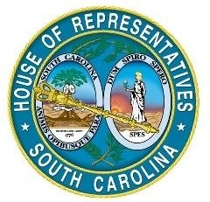
Legislative Oversight Committee
South Carolina House of Representatives
Post Office Box 11867
Columbia, South Carolina 29211
Telephone: (803) 212-6810 • Fax: (803) 212-6811
Program Evaluation Report
Agency Responses
Submitted by

Blind, Commission for the
July 27, 2015

Agency Responding |  |  | Blind, Commission for the
Date of Submission |  |  | 7/27/2015
Resources utilized to Complete Chart
Cost |  |  | $724.92
Total Employee Time |  |  | 23 hours
# of Employees who |  |  | 15 people
Similar Information |  |  | Information Requested below is also requested in…
Other Report: |  |  | N/A
Question # of the Other
Instructions: Below is the information included in the "goals, strategies, objectives and description" columns of the Strategic Planning template the agency submitted in its 2013-14 Accountability Report, if the agency was required to submit an Accountability Report. Update with any changes from 2014-15 and in the "Public Benefits" column, type the public benefit provided or public harm prevented by accomplishment of each goal, strategy and objective (i.e. tangible benefit realized by citizens).
From Strategic Planning Template agency submitted in its 2013-14 Accountability Report
G# | S# | O# | Description | Public Benefits
G1 |  |  | Deliver quality, individualized vocational rehabilitation services that will assist Blind and visually impaired individuals in obtaining or maintaining competitive employment | Increased employment leads to increased economic self-sufficiency, independence, and self-reliance. Expanded tax-base, increase tax payers. Decreased demand on other public service and benefit programs such as welfare programs, subsidized housing, etc.
 | S1.1 |  | Increase the number of consumers served by the vocational rehabilitation program | Increased employment leads to increased economic self-sufficiency, independence, self-reliance, an expanded tax-base, and an increase in tax payers. Decreased demand on other public service and benefit programs such as welfare programs, subsidized housing, etc.
 |  | O1.1.1 | Expand outreach services to the unserved and underserved rural counties | Increased employment leads to increased economic self-sufficiency, independence, self-reliance, an expanded tax-base, and an increase in tax payers. Decreased demand on other public service and benefit programs such as welfare programs, subsidized housing, etc.
 |  | O1.1.2 | Recruit community rehabilitation programs | Expands SCCB's service capacity by creating community based service providers to provide job development, job placement, job training, and job coaching services.
 |  | O1.1.3 | Engage in random case service review process | Ensures that service delivery and case management practices are in compliance with federal, state and agency established policy and procedures
 |  | O1.1.4 | Maintain an adequate consumer to counselor ratio to ensure expediency of service delivery | Optimal VR Counselor to Consumer ratios lead to increased successful outcomes. Increased employment leads to increased economic self-sufficiency, independence, and self-reliance. Expanded tax-base, increase tax payers. Decreased demand on other public service and benefit programs such as welfare programs, subsidized housing, etc.

 |  | O1.1.5 | Provide adjustment to blindness, assistive technology and job readiness training | Adjustment to blindness, assistive technology, and job readiness training is essential to successfully rehabilitation person with blindness. These services result in successful employment outcomes. Increased employment results in increased economic self-sufficiency, independence, and self-reliance. Decreases demand on other public service and benefit programs such as welfare programs, subsidized housing, etc.
 |  | O1.1.6 | Maintain interagency collaboration and community contacts to increase public awareness of SCCB services | Interagency collaboration ensures that SCCB coordinates, never duplicates services available in the community or in partnership with other state or federal agencies. These partnerships ensure effective use of public resources.
 |  | O1.1.7 | Expand job search, development and placement opportunities | Increased direct employer presentations on the benefits and strategies set up for successful outcomes of hiring vision ally impaired qualified employees for competitive integrated employment. Attendance of SCCB staff at job fairs, local chamber and other organizations expand a network of opportunities. This allows for self-sufficiency, independence and self-reliance for consumers, thus increasing tax payers, and decreasing the need for other public services and benefit programs.
 |  | O1.1.8 | Increase the number of successful closures by 10% in FY 2015 | Increased employment leads to increased economic self-sufficiency, independence, and self-reliance. Expanded tax-base, increase tax payers. Decreased demand on other public service and benefit programs such as welfare programs, subsidized housing, etc.
 |  | O1.1.9 | Maintain 80% of competitive employment placements at or above the minimum wage | Increased competitive employment at or above the minimum wage leads to increased economic self-sufficiency, independence, and self-reliance. Expanded tax-base, increase tax payers. Decreased demand on other public service and benefit programs such as welfare programs, subsidized housing, etc.
G2 |  |  | Provide adjustment to blindness and independent living skills training to Blind and visually impaired consumers | Increased independent living skills and improved adjustment to blindness results in expanded individual freedom, independence, self-reliance, and leads to employment and economic self-sufficiency. Decreases demand on other public services.
 | S2.1 |  | Maintain consistent and quality individualized independent living services | Quality Independent Living services expand individual freedom, independence, and full community inclusion. These are also the foundation to competitive integrated employment, self-reliance, and economic self-sufficiency.
 |  | O2.1.1 | Maintain community interaction and develop referral sources in unserved and underserved rural counties | Increased employment leads to increased economic self-sufficiency, independence, and self-reliance. Expanded tax-base, increase tax payers. Decreased demand on other public service and benefit programs such as welfare programs, subsidized housing, etc.
 |  | O2.1.2 | Conduct home and community meetings to coordinate individualized training | Consistent efforts to increase awareness of Agency services through community meetings and coordinate comprehensive adjustment skills training results in an increase in independent living and self-reliance. Subsequently, the Agency's intervention minimizes the need for other programs such as skilled nursing care, Home Health assistance, other public services, etc.

 |  | O2.1.3 | Collaborate with nonprofit, social and human service organizations to provide early intervention services | Collaborative efforts further increase and enhance service opportunities and results in providing timely and necessary adjustment to blindness assistance and improved independent living skills. Reduces the need for institutional care and other public service programs.
G3 |  |  | Provide the administrative leadership necessary to accomplish the agency mission | Mission focused leadership and sound fiscal stewardship ensure that the agency meets its legal purpose.
 | S3.1 |  | Ensure that the job functions of all staff contribute to the achievement of the agency's mission | Alignment of job duties and functions to agency mission and purpose ensure efficient, effective, and fiscally sound services to taxpayers.
 |  | O3.1.1 | Maintain a diversified workforce | Alleviate culturally sensitive hot issues and foster effective relationships in the community
 |  | O3.1.2 | Ensure the timely submission of EPMS documents for all permanent employees | Ensures that human resources are productive and in alignment with agency mission, purpose, and productivity goals.
 |  | O3.1.3 | Provide staff development training to improve employee's skills | Increase in employee skill set which leads to greater confidence in reaching out to unserved and under-served communities
 |  | O3.1.4 | Automate and maintain the integrity of agency workflow data systems | Supports work productivity of employees who have direct contact with consumers and the public in general. Secures the private data collected from the citizens of SC whom we serve. In doing so, SCCB maintains integrity by using a closed network secured by VPN, Active Directory 3-factor user authentication, Palo Alto Layer 7 firewall, and an SOC (Security Operations Center). Provides productivity information to the public.

Agency Responding |  |  | Blind, Commission for the
Date of Submission |  |  | 7/27/2015
Resources utilized to Complete Chart
Cost |  |  | $86
Total Employee Time |  |  | 3 hours
# of Employees who |  |  | 11 people
Similar Information |  |  | Information Requested below is also requested in…
Other Report: |  |  | N/A
Question # of the Other
Instructions: Copy and paste the information from the agency's Strategically Planned Public Benefits Chart into the first four columns. In the remaining columns please provide information about the individual who has primary responsibility/accountability for each goal, strategy and objective (i.e. Responsible Lead). The Responsible Lead has employees and possibly even different teams of employees beneath him/her to help accomplish the objective. However, the Responsible Lead is the person who, in conjunction with his/her team and approval from higher level superiors, sets the performance measure targets and heads the game plan for how to accomplish the goal, strategy or objective for which they are responsible. Under the "Position" column, type the Responsible Lead's position at the agency. Under "Office Address" column, type the address for the office from which the Responsible Lead works. Under the "Department/Division" column, type the department or division at the agency in which the Responsible Lead works. Under the "Department/Division Summary" column, type a brief summary (no more than 1-2 sentences) of what that department or division does in the agency.
From Strategic Planning Template agency submitted in its 2013-14 Accountability Report |  |  |  | Responsible Lead (i.e. Employee who has primary responsibility/accountability for ensuring goal, strategy or objective is met or exceeded)
G# | S# | O# | Description | Name | Position | Office Address | Dept./Division | Dept./Division Summary
G1 |  |  | Deliver quality, individualized vocational rehabilitation services that will assist Blind and visually impaired individuals in obtaining or maintaining competitive employment | Kyle Walker | Director of Vocational  Rehabilitation Consumer  Services | 1430 Confederate Ave.  Columbia, SC 29201 | Vocational Rehabilitation | Supervises all activities of VR counselors, EMBRC, O & M instructors, Home management instructors, manual arts instructors, and A.T. instructors.
 | S1.1 |  | Increase the number of consumers served by the vocational rehabilitation program | Kyle Walker | Director of Vocational  Rehabilitation Consumer Services | 1430 Confederate Ave.  Columbia, SC 29201 | Vocational Rehabilitation | Supervises all activities of VR counselors, EMBRC, O & M instructors, Home management instructors, manual arts instructors, and A.T. instructors.
 |  | O1.1.1 | Expand outreach services to the unserved and underserved rural counties | Kyle Walker | Director of Vocational  Rehabilitation Consumer Services | 1430 Confederate Ave.  Columbia, SC 29201 | Vocational Rehabilitation | Supervises all activities of VR counselors, EMBRC, O & M instructors, Home management instructors, manual arts instructors, and A.T. instructors.
 |  | O1.1.2 | Recruit community rehabilitation programs | Kyle Walker | Director of Vocational  Rehabilitation Consumer Services | 1430 Confederate Ave.  Columbia, SC 29201 | Vocational Rehabilitation | Supervises all activities of VR counselors, EMBRC, O & M instructors, Home management instructors, manual arts instructors, and A.T. instructors.
 |  | O1.1.3 | Engage in random case service review process | Shana Robinson | Director of Quality  Assurance | 1430 Confederate Ave.  Columbia, SC 29201 | Quality Assurance | Conducts internal reviews, audits, and maintains the electronic recordkeeping system, AWARE. Researches and compiles data necessary to assist programs in achieving the stated goals and objectives.
 |  | O1.1.4 | Maintain an adequate consumer to counselor ratio to ensure expediency of service delivery | Kyle Walker | Director of Vocational  Rehabilitation Consumer Services | 1430 Confederate Ave.  Columbia, SC 29201 | Vocational Rehabilitation | Supervises all activities of VR counselors, EMBRC, O & M instructors, Home management instructors, manual arts instructors, and A.T. instructors.
 |  | O1.1.5 | Provide adjustment to blindness, assistive technology and job readiness training | Kyle Walker | Director of Vocational  Rehabilitation Consumer Services | 1430 Confederate Ave.  Columbia, SC 29201 | Vocational Rehabilitation | Supervises all activities of VR counselors, EMBRC, O & M instructors, Home management instructors, manual arts instructors, and A.T. instructors.
 |  | O1.1.6 | Maintain interagency collaboration and community contacts to increase public awareness of SCCB services | Kyle Walker | Director of Vocational  Rehabilitation Consumer Services | 1430 Confederate Ave.  Columbia, SC 29201 | Vocational Rehabilitation | Supervises all activities of VR counselors, EMBRC, O & M instructors, Home management instructors, manual arts instructors, and A.T. instructors.
 |  | O1.1.7 | Expand job search, development and placement opportunities | Edward Bible | Director of Training &  Employment | 1430 Confederate Ave.  Columbia, SC 29201 | Training & Employment | Supervises all consumer training activities and all employment consultants. Oversees the creation of worksites and employer relationships within the communities served by SCCB.

 |  | O1.1.8 | Increase the number of successful closures by 10% in FY 2015 | Kyle Walker | Director of Vocational  Rehabilitation Consumer Services | 1430 Confederate Ave.  Columbia, SC 29201 | Vocational Rehabilitation | Supervises all activities of VR counselors, EMBRC, O & M instructors, Home management instructors, manual arts instructors, and A.T. instructors.
 |  | O1.1.9 | Maintain 80% of competitive employment placements at or above the minimum wage | Kyle Walker | Director of Vocational  Rehabilitation Consumer Services | 1430 Confederate Ave.  Columbia, SC 29201 | Vocational Rehabilitation | Supervises all activities of VR counselors, EMBRC, O & M instructors, Home management instructors, manual arts instructors, and A.T. instructors.
G2 |  |  | Provide adjustment to blindness and independent living skills training to Blind and visually impaired consumers | Rhonda Thompson | Director of Older Blind,  Children's Services, Low  Vision Clinics | 1430 Confederate Ave.  Columbia, SC 29201 | Older Blind, Children's  Services, Low Vision Clinic | Supervises OB and CS counselors, low vision clinics in 3 areas of the state, and conducts presentations to potential service providers. Oversees all services to consumers who are eligible for services but not able/interested in employment.
 | S2.1 |  | Maintain consistent and quality individualized independent living services | Rhonda Thompson | Director of Older Blind,  Children's Services, Low  Vision Clinics | 1430 Confederate Ave.  Columbia, SC 29201 | Older Blind, Children's  Services, Low Vision Clinic | Supervises OB and CS counselors, low vision clinics in 3 areas of the state, and conducts presentations to potential service providers. Oversees all services to consumers who are eligible for services but not able/interested in employment.
 |  | O2.1.1 | Maintain community interaction and develop referral sources in unserved and underserved rural counties | Kyle Walker | Director of Vocational  Rehabilitation Consumer Services | 1430 Confederate Ave.  Columbia, SC 29201 | Vocational Rehabilitation | Supervises all activities of VR counselors, EMBRC, O & M instructors, Home management instructors, manual arts instructors, and A.T. instructors.
 |  | O2.1.2 | Conduct home and community meetings to coordinate individualized training | Rhonda Thompson | Director of Older Blind,  Children's Services, Low  Vision Clinics | 1430 Confederate Ave.  Columbia, SC 29201 | Older Blind, Children's  Services, Low Vision Clinic | Supervises OB and CS counselors, low vision clinics in 3 areas of the state, and conducts presentations to potential service providers. Oversees all services to consumers who are eligible for services but not able/interested in employment.
 |  | O2.1.3 | Collaborate with nonprofit, social and human service organizations to provide early intervention services | Rhonda Thompson | Director of Older Blind,  Children's Services, Low  Vision Clinics | 1430 Confederate Ave.  Columbia, SC 29201 | Older Blind, Children's  Services, Low Vision Clinic | Supervises OB and CS counselors, low vision clinics in 3 areas of the state, and conducts presentations to potential service providers. Oversees all services to consumers who are eligible for services but not able/interested in employment.
G3 |  |  | Provide the administrative leadership necessary to accomplish the agency mission | James Kirby | Commissioner | 1430 Confederate Ave.  Columbia, SC 29201 | Commission for the Blind | Oversees and supervises all aspects of the Commission for the Blind. Presents and advocates at the Legislative level.
 | S3.1 |  | Ensure that the job functions of all staff contribute to the achievement of the agency's mission | James Kirby | Commissioner | 1430 Confederate Ave.  Columbia, SC 29201 | Commission for the Blind | Oversees and supervises all aspects of the Commission for the Blind. Presents and advocates at the Legislative level.
 |  | O3.1.1 | Maintain a diversified workforce | Wanda Miller | Director of Human Resources | 1430 Confederate Ave.  Columbia, SC 29201 | Human Resources | Maintains all personnel documents, tracks all staff training, and oversees all benefit programs.
 |  | O3.1.2 | Ensure the timely submission of EPMS documents for all permanent employees | Wanda Miller | Director of Human Resources | 1430 Confederate Ave.  Columbia, SC 29201 | Human Resources | Maintains all personnel documents, tracks all staff training, and oversees all benefit programs.
 |  | O3.1.3 | Provide staff development training to improve employee's skills | Wanda Miller | Director of Human Resources | 1430 Confederate Ave.  Columbia, SC 29201 | Human Resources | Maintains all personnel documents, tracks all staff training, and oversees all benefit programs.
 |  | O3.1.4 | Automate and maintain the integrity of agency workflow data systems | James Swindler | Director of Information  Technology | 1430 Confederate Ave.  Columbia, SC 29201 | Information Technology | Supervises and maintains I.T. systems for the agency and continuously monitors the integrity of the automated systems.

Agency Responding |  |  | Blind, Commission for the
Date of Submission |  |  | 7/27/2015
Resources utilized to
Cost |  |  | $629
Total Employee Time |  |  | 18 hours
# of Employees who |  |  | 15 people
Similar Information |  |  | Information Requested below is also requested in…
Other Report: |  |  | State Plan
Question # of the |  |  | Attachment 4.8; B1, B2, B3
Instructions: Please copy and paste the information from the Strategically Planned Public Benefits Chart into the first four columns of this chart. Under the column labeled, "Current Partner Entities" list all entities the agency is currently working with that help the agency accomplish the goal, strategy or objective.
Under the "Ways Agency works with Current Partners," type in general terms the ways the agency works with the entity and projects/initiatives on which they work together. List only one partner per row. If there are multiple partner entities for a particular goal, strategy or objective, copy and paste that row as many times as needed so each current partner entity is on a separate row.
NOTE: If a partner entity applies to an objective, should the agency list the entity again under the strategy that objective supports and goal that strategy supports? No, since objectives are supposed to support strategies, the partner entitles listed for an objective will technically also be a partner entity for the strategy that objective is under. HOWEVER, for purposes of this chart, list only the partner entities that are unique to each objective, strategy or goal. Therefore, partner entitles that are listed by a strategy, relate to that strategy, but do not relate to any of the objectives under that strategy (because if it did, it would be listed beside that objective).
In the same way, partner entitles that are listed by a goal, relate to that goal, but do not relate to any of the strategies or objectives under that goal.
How s | houl | d the age | ncy handle entities it works with on multiple objecti | ves or strategies? While the same partner entity should not be listed beside a st | rategy if it relates to an objective under the strategy or a goal if it
From Strategic Planning Template agency submitted in its 2013-14 Accountability Report
G# | S# | O# | Description | Current Partner Entities | Ways Agency works with Current Partners
G1 |  |  | Deliver quality, individualized vocational rehabilitation services that will assist Blind and visually impaired individuals in obtaining or maintaining competitive employment | Type entities the agency is currently working with that helps the agency accomplish the objective | General terms, further details are requested in Partner Details Chart.
 |  |  | Increase the number of consumers served by the vocational rehabilitation program | Statewide High Schools* (SCCB accepts referrals from ALL SC high schools) | Provides referrals of visually impaired consumers.
 | S1.1 |  | Increase the number of consumers served by the vocational rehabilitation program | Statewide Elementary Schools* (SCCB accepts referrals from all SC elementary schools. | Provides referrals of visually impaired children.
 |  | O1.1.1 | Expand outreach services to the unserved and underserved rural counties | Department of Archives & History -Disability Coordinator | Includes SCCB information at job fairs.
 |  | O1.1.1 | Expand outreach services to the unserved and underserved rural counties | National Federation of the Blind | Promotes SCCB at their meetings.
 |  | O1.1.1 | Expand outreach services to the unserved and underserved rural counties | South Carolina Schools for the Deaf and Blind | Promotes SCCB to their consumers and partners.
 |  | O1.1.1 | Expand outreach services to the unserved and underserved rural counties | Goodwill Industries | Promotes SCCB to their consumers and partners.
 |  | O1.1.1 | Expand outreach services to the unserved and underserved rural counties | Department of Education | Promotes SCCB to schools and other partners.
 |  | O1.1.2 | Recruit community rehabilitation programs | Duties performed as job responsibilities of SCCB staff. | Duties performed as job responsibilities of SCCB staff.

 |  | O1.1.3 | Engage in random case service review process | Duties performed as job responsibilities of SCCB staff. | Duties performed as job responsibilities of SCCB staff.
 |  | O1.1.4 | Maintain an adequate consumer to counselor ratio to ensure expediency of service delivery | Duties performed as job responsibilities of SCCB staff. | Duties performed as job responsibilities of SCCB staff.
 |  | O1.1.5 | Provide adjustment to blindness, assistive technology and job readiness training | National Federation of the Blind | Provides training assistance.
 |  | O1.1.5 | Provide adjustment to blindness, assistive technology and job readiness training | South Carolina Schools for the Deaf and Blind | Provides training assistance.
 |  | O1.1.5 | Provide adjustment to blindness, assistive technology and job readiness training | Goodwill Industries | Provides training assistance.
 |  | O1.1.5 | Provide adjustment to blindness, assistive technology and job readiness training | SC Vision Education Partners | Provides training assistance.
 |  | O1.1.5 | Provide adjustment to blindness, assistive technology and job readiness training | SC State University Orientation and Mobility Program | Provides updates on upcoming assistive technology.
 |  | O1.1.5 | Provide adjustment to blindness, assistive technology and job readiness training | Medical University of SC, Storm Eye Clinic | Provides updates on upcoming assistive technology.
 |  | O1.1.5 | Provide adjustment to blindness, assistive technology and job readiness training | ABLE SC | Provides independent living skills training.
 |  | O1.1.5 | Provide adjustment to blindness, assistive technology and job readiness training | Blue Cross Blue Shield | Provides sensitivity training.
 |  | O1.1.5 | Provide adjustment to blindness, assistive technology and job readiness training | Verizon Wireless | Provides sensitivity training.
 |  | O1.1.5 | Provide adjustment to blindness, assistive technology and job readiness training | Foundation for the Commission for the Blind | Assists with a variety of services.
 |  | O1.1.5 | Provide adjustment to blindness, assistive technology and job readiness training | Community Libraries* (We work with libraries in several communities) | Provides soft skills training for consumers.
 |  | O1.1.5 | Provide adjustment to blindness, assistive technology and job readiness training | Department of Employment and Workforce | Provides soft skills training for consumers
 |  | O1.1.5 | Provide adjustment to blindness, assistive technology and job readiness training | Association for Education and Rehabilitation of the Blind and Visually Impaired, SC Chapter | Provide updates on upcoming assistive technology.
 |  | O1.1.5 | Provide adjustment to blindness, assistive technology and job readiness training | Richland County Library | Provides soft skills training.
 |  | O1.1.5 | Provide adjustment to blindness, assistive technology and job readiness training | SC State Library-Talking Book Services | Provides soft skills training.
 |  | O1.1.5 | Provide adjustment to blindness, assistive technology and job readiness training | Freedom Scientific | Free online training for JAWS software.
 |  | O1.1.6 | Maintain interagency collaboration and community contacts to increase public awareness of SCCB services | National Federation of the Blind | Talks about SCCB at their meetings and conferences.
 |  | O1.1.6 | Maintain interagency collaboration and community contacts to increase public awareness of SCCB services | Association for Education and Rehabilitation of the Blind and Visually Impaired, SC Chapter | SCCB is listed as a resource on AERBVI of Charleston website.
 |  | O1.1.6 | Maintain interagency collaboration and community contacts to increase public awareness of SCCB services | Department of Archives & History -Disability Coordinator | Includes SCCB information at job fairs.

 |  | O1.1.6 | Maintain interagency collaboration and community contacts to increase public awareness of SCCB services | South Carolina Schools for the Deaf and Blind | Promotes SCCB to their consumers and partners.
 |  | O1.1.6 | Maintain interagency collaboration and community contacts to increase public awareness of SCCB services | Goodwill Industries | Promotes SCCB to their consumers and partners.
 |  | O1.1.6 | Maintain interagency collaboration and community contacts to increase public awareness of SCCB services | Department of Education | Promotes SCCB to schools and other partners.
 |  | O1.1.6 | Maintain interagency collaboration and community contacts to increase public awareness of SCCB services | Helen Keller National Center (HKNC) | Provides free consultations.
 |  | O1.1.7 | Expand job search, development and placement opportunities | Goodwill Industries | Offers job placement assistance.
 |  | O1.1.7 | Expand job search, development and placement opportunities | Blue Cross Blue Shield | OJT and placement opportunities.
 |  | O1.1.7 | Expand job search, development and placement opportunities | Verizon Wireless | OJT and placement opportunities.
 |  | O1.1.7 | Expand job search, development and placement opportunities | Office of Federal Contract Compliance Programs | Provides information and contacts for federal job placement opportunities.
 |  | O1.1.7 | Expand job search, development and placement opportunities | Department of Employment and Workforce | Job placement assistance
 |  | O1.1.7 | Expand job search, development and placement opportunities | National Employment Team (NET)-South East Region | Job placement assistance
 |  | O1.1.7 | Expand job search, development and placement opportunities | Medical University of SC, Storm Eye Clinic | internships
 |  | O1.1.7 | Expand job search, development and placement opportunities | SC State Museum | internships
 |  | O1.1.7 | Expand job search, development and placement opportunities | South Carolina Vocational Rehabilitation Department | Job placement assistance
 |  | O1.1.7 | Expand job search, development and placement opportunities | McKissick Museum/Library | Job placement assistance
 |  | O1.1.7 | Expand job search, development and placement opportunities | USC-Thomas Cooper Library | Job placement assistance
 |  | O1.1.7 | Expand job search, development and placement opportunities | Association for Education and Rehabilitation of the Blind and Visually Impaired, SC Chapter | Job placement assistance
 |  | O1.1.7 | Expand job search, development and placement opportunities | SC State University Assistive Technology Program--USC School of Medicine | internships
 |  | O1.1.7 | Expand job search, development and placement opportunities | Anderson Mayors Committee | Job placement assistance
 |  | O1.1.7 | Expand job search, development and placement opportunities | Richland- Columbia Mayor’s Committee on Employment of People with Disabilities | Job placement assistance
 |  | O1.1.7 | Expand job search, development and placement opportunities | SC Governor’s Committee | Job placement assistance

 |  | O1.1.7 | Expand job search, development and placement opportunities | Spartanburg Mayor Committee | Job placement assistance
 |  | O1.1.7 | Expand job search, development and placement opportunities | Summerville Mayor’s Committee | Job placement assistance
 |  | O1.1.7 | Expand job search, development and placement opportunities | American Red Cross -Non-Profit | internships
 |  | O1.1.7 | Expand job search, development and placement opportunities | United Way 211-Non Profit | internships
 |  | O1.1.7 | Expand job search, development and placement opportunities | VA Hospital -Non Profit | Job placement assistance
 |  | O1.1.7 | Expand job search, development and placement opportunities | Harvest Hope Food Bank -Non Profit | internships
 |  | O1.1.7 | Expand job search, development and placement opportunities | Richland County Library | Job search
 |  | O1.1.7 | Expand job search, development and placement opportunities | SC State Library-Talking Book Services | internships
 |  | O1.1.7 | Expand job search, development and placement opportunities | Greater Charleston Call Center Alliance-Division of Charleston Chamber of  Commerce | Job placement assistance
 |  | O1.1.7 | Expand job search, development and placement opportunities | SC Liaison Industrial Group | Job placement assistance
 |  | O1.1.8 | Increase the number of successful closures by 10% in FY 2015 | Goodwill Industries | Skills training and placement assistance.
 |  | O1.1.8 | Increase the number of successful closures by 10% in FY 2015 | Blue Cross Blue Shield | Job placement assistance
 |  | O1.1.8 | Increase the number of successful closures by 10% in FY 2015 | Verizon Wireless | Job placement assistance
 |  | O1.1.8 | Increase the number of successful closures by 10% in FY 2015 | Office of Federal Contract Compliance Programs | Contacts for federal job placement.
 |  | O1.1.8 | Increase the number of successful closures by 10% in FY 2015 | Department of Employment and Workforce | Contacts for federal job placement.
 |  | O1.1.9 | Maintain 80% of competitive employment placements at or above the minimum wage | Goodwill Industries | Training and placement
 |  | O1.1.9 | Maintain 80% of competitive employment placements at or above the minimum wage | Blue Cross Blue Shield | Placement
 |  | O1.1.9 | Maintain 80% of competitive employment placements at or above the minimum wage | Verizon Wireless | Placement
 |  | O1.1.9 | Maintain 80% of competitive employment placements at or above the minimum wage | Office of Federal Contract Compliance Programs | Provides information on companies with federal contracts who must meet the
 |  | O1.1.9 | Maintain 80% of competitive employment placements at or above the minimum wage | National Federation of the Blind | Offers IDL training to rural and underserved areas which allows consumers the opportunity to maintain employment.
 |  | O1.1.9 | Maintain 80% of competitive employment placements at or above the minimum wage | Social Security Administration/Work Incentives for the Blind | Provides work incentives to encourage employment for consumers.
G2 |  |  | Provide adjustment to blindness and independent living skills training to Blind and visually impaired consumers | National Federation of the Blind | Outreach services

G2 |  |  | Provide adjustment to blindness and independent living skills training to Blind and visually impaired consumers | South Carolina Schools for the Deaf and Blind | Outreach services
G2 |  |  | Provide adjustment to blindness and independent living skills training to Blind and visually impaired consumers | SC State University Orientation and Mobility Program | Updates on upcoming assistive technology.
G2 |  |  | Provide adjustment to blindness and independent living skills training to Blind and visually impaired consumers | Columbia College | Sensitivity training
G2 |  |  | Provide adjustment to blindness and independent living skills training to Blind and visually impaired consumers | Blue Cross Blue Shield | Sensitivity training
G2 |  |  | Provide adjustment to blindness and independent living skills training to Blind and visually impaired consumers | Verizon Wireless | Sensitivity training
G2 |  |  | Provide adjustment to blindness and independent living skills training to Blind and visually impaired consumers | ABLE SC | Sensitivity training
 |  | O2.1.1 | Maintain community interaction and develop referral sources in unserved and underserved rural counties | National Federation of the Blind | Talks about SCCB at their meetings and conferences.
 |  | O2.1.1 | Maintain community interaction and develop referral sources in unserved and underserved rural counties | Association for Education and Rehabilitation of the Blind and Visually Impaired, SC Chapter | SCCB is listed as a resource on AERBVI of Charleston website.
 |  | O2.1.1 | Maintain community interaction and develop referral sources in unserved and underserved rural counties | Department of Archives & History -Disability Coordinator | Includes SCCB information at job fairs.
 |  | O2.1.1 | Maintain community interaction and develop referral sources in unserved and underserved rural counties | South Carolina Schools for the Deaf and Blind | Promotes SCCB to their consumers and partners.
 |  | O2.1.1 | Maintain community interaction and develop referral sources in unserved and underserved rural counties | Goodwill Industries | Promotes SCCB to their consumers and partners.
 |  | O2.1.1 | Maintain community interaction and develop referral sources in unserved and underserved rural counties | Department of Education | Promotes SCCB to schools and other partners.
 |  | O2.1.1 | Maintain community interaction and develop referral sources in unserved and underserved rural counties | Helen Keller National Center (HKNC) | Provides free consultations.
 |  | O2.1.1 | Maintain community interaction and develop referral sources in unserved and underserved rural counties | Department of Archives & History -Disability Coordinator | Includes SCCB information at job fairs.
 |  | O2.1.2 | Conduct home and community meetings to coordinate individualized training | Duties performed as job responsibilities of SCCB staff. | Duties performed as job responsibilities of SCCB staff.

 |  | O2.1.3 | Collaborate with nonprofit, social and human service organizations to provide early intervention services | BabyNet | Coordinates with SCCB to provide free services to children with visual impairments.
 |  | O2.1.3 | Collaborate with nonprofit, social and human service organizations to provide early intervention services | PRO-Parents of SC | Coordinates with SCCB to provide free services to children with visual impairments.
G3 |  |  | Provide the administrative leadership necessary to accomplish the agency mission | Duties performed as job responsibilities of SCCB staff. | Duties performed as job responsibilities of SCCB staff.
 | S3.1 |  | Ensure that the job functions of all staff contribute to the achievement of the agency's mission | Duties performed as job responsibilities of SCCB staff. | Duties performed as job responsibilities of SCCB staff.
 |  | O3.1.1 | Maintain a diversified workforce | indeed.com | Browse resumes and contact potential qualified candidates
 |  | O3.1.1 | Maintain a diversified workforce | State Ethics Commission | Provides ethical guidance through yearly activity reporting
 |  | O3.1.1 | Maintain a diversified workforce | SC Human Affairs | Provides consultative services and serves as a collecting house for workforce utilization data
 |  | O3.1.1 | Maintain a diversified workforce | SC Budget and Control Board | Provides consultative services on HR matters
 |  | O3.1.1 | Maintain a diversified workforce | Department of Homeland Security/E-Verify | Provides verification of eligibility and identify of hired individuals
 |  | O3.1.2 | Ensure the timely submission of EPMS documents for all permanent employees | Duties performed as job responsibilities of SCCB staff. | Duties performed as job responsibilities of SCCB staff.
 |  | O3.1.3 | Provide staff development training to improve employee's skills | Labor Licensing & Regulation | Provides staff training at no cost
 |  | O3.1.3 | Provide staff development training to improve employee's skills | Insurance Reserve Fund | Provides staff training at no cost.
 |  | O3.1.3 | Provide staff development training to improve employee's skills | Helen Keller National Center (HKNC) | Provides staff training
 |  | O3.1.3 | Provide staff development training to improve employee's skills | Hadley School for the Blind | Staff participates in free online courses
 |  | O3.1.3 | Provide staff development training to improve employee's skills | American Red Cross -Non-Profit | Trains outreach staff in CPR.
 |  | O3.1.3 | Provide staff development training to improve employee's skills | SC Division of Technology Operations | Training for I.T. staff
 |  | O3.1.3 | Provide staff development training to improve employee's skills | Microsoft | Training for I.T. staff on their website.
 |  | O3.1.3 | Provide staff development training to improve employee's skills | Freedom Scientific | Free A.T. training for staff.
 |  | O3.1.4 | Automate and maintain the integrity of agency workflow data systems | Duties performed as job responsibilities of SCCB staff. | Duties performed as job responsibilities of SCCB staff.

Agency Responding | Blind, Commission for the
Date of Submission | 7/27/2015
Resources utilized to Complete Chart
Cost | $167
Total Employee Time | 5 hours
# of Employees who worked on it | 11 people
Similar Information Requested | Information Requested below is also  requested in…
Other Report: | N/A
Question # of the Other Report:
Instructions: For each of the Partner Entities listed in the Strategically Planned Partners Chart, provide the details requested below for each. Beside "Type of Entity" state the type of entity the partner entity falls within from the drop down menu. If the entity does not fall within of the categories that appears, select "other" and then describe the type of entity in the next row labeled, "Other Entity Explanation." Next to "Contribute Cash or In-Kind Services/Products?" type Y or N to indicate, Yes the entity contributes cash or in-kind services/products to the agency or No the entity does not. If the response is Y, include the average annual value of the cash or in-kind contribution over the last five fiscal years on the next row beside "Avg. Annual Value of Cash or In-Kind." Next to "Provide Volunteers?" type Y or N to indicate, Yes the entity provides volunteers to the agency or No the entity does not. If the response is Y, include the average annual number of volunteer hours over the last five fiscal years on the next row beside "Avg. Annual Volunteer Hours." Next to, "Part of Mission to Help Agency?" type Y or N to indicate, Yes part of the entity's mission is to help the agency or No it is not. On the next row, beside "Created by Agency?" type Y or N to indicate, Yes the entity was created by the agency or No it was not. NOTE: Responses are not limited to the number of columns below that have borders around them, please list all that are applicable.
Name of Partner Entity | South Carolina Vocational Rehabilitation  Department | Department of Employment and Workforce | National Federation of the Blind | South Carolina Schools for the Deaf and Blind | Goodwill Industries | SC High Schools* | AERBVI of SC | SC State University  Orientation and  Mobility Program | Medical University of SC, Storm Eye Clinic | SC Governor’s Committee | Department of  Archives & History -  Disability  Coordinator
What type of entity is the Partner entity? | State Agency | State Agency | Non-Profit | State Agency | Non-Profit | State Agency | Non-Profit | State Agency | State Agency | State Agency | State Agency
Other Entity Explanation
# of years as Partner Entity to Agency | 40+ | 40+ | 40+ | 30+ | 20+ | 40+ | 20+ | 20+ | 20+ | 20+ | 20+
Contribute Cash or In-Kind Services, Products? (Y or N) | N | N | N | N | N | N | N | N | N | N | N
Avg. Annual Value of Cash or In-Kind
Contribution
Provide Volunteers? (Y or N) | N | N | N | N | N | N | N | N | N | N | N
Avg. Annual Volunteer Hours
Part of Mission to Help Agency? (Y or N) | N | N | N | N | N | N | N | N | N | N | N
Created by Agency? (Y or N) | N | N | N | N | N | N | N | N | N | N | N
* Per conversation with Charles Appleby and Jennifer Dobson, we did not list every school in South Carolina as we are available to all as the need for services arises.
Name of Partner Entity | ABLE SC | Office of Federal Contract Compliance Programs | SC Liaison Industrial Group | Social Security  Administration/Work  Incentives for the Blind | Blue Cross Blue Shield | Verizon Wireless | SC Lt.  Governor's  Office on Aging | Statewide Elementary Schools* | Statewide Senior Assisted  Living and Senior Daycare Facilities* | Lions Club | Helen Keller National Center
What type of entity is the Partner entity? | Non-Profit | Federal Agency | Non-Profit | Federal Agency | Private Company | Private Company | State Agency | State Agency | Private Company | Non-Profit | Federal Agency
Other Entity Explanation
# of years as Partner Entity to Agency | 10+ | 5+ | 20 | 40+ | 10 | 5 | 20+ | 20+ | 20+ | 20+ | 20+
Contribute Cash or In-Kind Services, Products? (Y or N) | N | N | N | N | N | N | N | N | N | N | N
Avg. Annual Value of Cash or In-Kind
Contribution
Provide Volunteers? (Y or N) | N | N | N | N | N | N | N | N | N | N | N
Avg. Annual Volunteer Hours
Part of Mission to Help Agency? (Y or N) | N | N | N | N | N | N | N | N | N | N | N
Created by Agency? (Y or N) | N | N | N | N | N | N | N | N | N | N | N
Name of Partner Entity | BabyNet | PRO-Parents of SC | Department of Education | National Employment  Team (NET)-South East Region | SC State Museum | Columbia College | McKissick Museum/Library | SC Assistive  Technology  Program-USC  School of Medicine | USC-Thomas Cooper Library | Anderson Mayors Committee | Richland- Columbia Mayor’s Committee on Employment of  People with  Disabilities
What type of entity is the Partner entity? | State Agency | Non-Profit | Federal Agency | Federal Agency | State Agency | Private Company | State Agency | State Agency | State Agency | Committee | Committee
Other Entity Explanation
# of years as Partner Entity to Agency | 15 | 20 | 40+ | 5+ | 10+ | 10+ | 10+ | 10+ | 10+ | 10+ | 10+
Contribute Cash or In-Kind Services, Products? (Y or N) | N | N | N | N | N | N | N | N | N | N | N
Avg. Annual Value of Cash or In-Kind
Contribution

Provide Volunteers? (Y or N) | N | N | N | N | N | N | N | N | N | N | N
Avg. Annual Volunteer Hours |  |  |  | N
Part of Mission to Help Agency? (Y or N) | N | N | N | N | N | N | N | N | N | N | N
Created by Agency? (Y or N) | N | N | N | N | N | N | N | N | N | N | N
Name of Partner Entity | Spartanburg Mayor Committee | Summerville Mayor’s Committee | American Red Cross -Non-Profit | United Way 211-Non Profit | VA Hospital | Harvest Hope  Food Bank -Non Profit | Richland County Library | SC State Library-  Talking Book Services | Greater Charleston Call  Center Alliance-Division of Charleston Chamber of Commerce | indeed.com | Hadley School for the Blind
What type of entity is the Partner entity? | Committee | Committee | Non-Profit | Non-Profit | Federal Agency | Non-Profit | Other | State Agency | Non-Profit | Private company | Non-Profit
Other Entity Explanation |  |  |  |  |  |  | County supported
# of years as Partner Entity to Agency | 10+ | 10+ | 10+ | 10+ | 20+ | 10+ | 10+ | 10+ | 5+ | 1 | 20+
Contribute Cash or In-Kind Services, Products? (Y or N) | N | N | N | N | N | N | N | N | N | N | N
Avg. Annual Value of Cash or In-Kind
Contribution
Provide Volunteers? (Y or N) | N | N | N | N | N | N | N | N | N | N | N
Avg. Annual Volunteer Hours
Part of Mission to Help Agency? (Y or N) | N | N | N | N | N | N | N | N | N | N | N
Created by Agency? (Y or N) | N | N | N | N | N | N | N | N | N | N | N
Name of Partner Entity | Freedom Scientific | SC Division of Technology Operations | Microsoft | State Ethics Commission | Department of  Homeland Security/EVerify | SC Human Affairs | SC Budget and Control Board | Insurance Reserve Fund | Labor Licensing & Regulation | Foundation for the  Commission for the Blind
What type of entity is the Partner entity? | Private Company | State Agency | Private Company | State Agency | Federal Agency | State Agency | State Agency | State Agency | State Agency | Non-Profit
Other Entity Explanation
# of years as Partner Entity to Agency | 5+ | 10+ | 10+ | 20+ | 20+ | 20+ | 20+ | 20+ | 20+ | 10+
Contribute Cash or In-Kind Services, Products? (Y or N) | N | N | N | N | N | N | N | N | N | N
Avg. Annual Value of Cash or In-Kind
Contribution
Provide Volunteers? (Y or N) | N | N | N | N | N | N | N | N | N | N
Avg. Annual Volunteer Hours
Part of Mission to Help Agency? (Y or N) | N | N | N | N | N | N | N | N | N | N
Created by Agency? (Y or N) | N | N | N | N | N | N | N | N | N | N
Agency Responding Blind Commission for the
Date of Submission 7/27/2015
Adjustment to blindness, assistive technology, and job readiness training is essential to successfully rehabilitation person with blindness. These services result in successful employment outcomes. Increased employment results in increased economic self-sufficiency, independence, and self-reliance. Decreases demand on other public service and benefit programs such as welfare programs, subsidized housing, etc.
Resources utilized to Complete Chart
Cost $224
Total Employee Time 7 hour
# of Employees who worked on it 11 people
Information Requested below is also requested Similar Information Requested
in…
Other Report: N/A Question # of the Other Report:
Instructions: Below is the information from the Performance Measurement template the agency submitted in its 2013-14 Accountability Report, if it was required to submit an Accountability Report. Please add performance measures the agency provided in its Accountability Reports for the last five (5) fiscal years into this format as well. Also, add any additional performance measures the agency has adopted since submitting its 2013-2014 Accountability Report. Under the column titled, "Type of Measure," pick the classification of performance measure that best fits the performance measure from the drop down box. See the definitions below these instructions for information on what falls within each type of measure. Under the column, "Year Utilized," type the year the performance measure was utilized. Include only one year on each row (i.e. if the performance measure was used in 2011-12, 2012-13 and 2013-14, the performance measure would be listed on three (3) separate rows with 2011-12 on one row, 2012-13 on the second row and 2013-14 on the third row. The Committee asks for each year to be a separate row because this allows agencies flexibility to report all the information (i.e. if the agency used the same performance measure in multiple years, but the data source for the information changed (i.e. SCEIS) during the most recent year it was used, the agency could indicate this because the information related to the performance measure each year is on a separate row). NOTE: Responses are not limited to the number of rows below that have borders around them, please list all that are applicable.
Types of Measures: (description from Accountability Report)
Outcome Measure - A quantifiable indicator of the public and customer benefits from an agency's actions. Outcome measures are used to assess an agency's effectiveness in serving its key customers and in achieving its mission, goals and objectives. They are also used to direct resources to strategies with the greatest effect on the most valued outcomes. Outcome measures should be the first priority. Example - % of licensees with no violations.
Efficiency Measure - A quantifiable indicator of productivity expressed in unit costs, units of time, or other ratio-based units. Efficiency measures are used to assess the cost-efficiency, productivity, and timeliness of agency operations. Efficiency measures measure the efficient use of available resources and should be the second priority. Example - cost per inspection
Output Measure - A quantifiable indicator of the number of goods or services an agency produces. Output measures are used to assess workload and the agency's efforts to address demands. Output measures measure workload and efforts and should be the third priority. Example - # of business license applications processed.
Input/Explanatory Measure - Resources that contribute to the production and delivery of a service. Inputs are "what we use to do the work." They measure the factors or requests received that explain performance (i.e. explanatory). These

measures should be the last priority. Example - # of license applications received
Performance Measure Item # Performance Measure Associated Type of Measure
Strategy (ies) and
Objective(s) #
Strategy 1.1: Output Measure 1 Vocational Rehabilitation Referrals Objectives 1.1.1, 1.1.2,
1.1.6
Output Measure Strategy 1.1:
2 Competitive Employment Closures Objectives 1.1.2, 1.1.4,
1.1.5, 1.1.7, 1.1.8
From Strategic Planning Template agency submits with Accountability
Year Utilized Time Applicable Data Source and Reporting Calculation
(ONLY ONE Availability Frequency Method
PER ROW)
AWARE Case AWARE Case
2014-15 July 1 - June 30 Management Monthly Management
System System Reports
AWARE Case AWARE Case
2014-15 July 1 - June 30 Management Quarterly Management
System System Reports

3 | Competitive Employment Closure Quality Rate | Strategy 1.1:  Objectives 1.1.2, 1.1.4,  1.1.5, 1.1.7, 1.1.8,  1.1.9 | Outcome Measure | 2014-15 | July 1 - June 30 | AWARE Case  Management System | Quarterly | AWARE Case  Management  System Reports
4 | Independent Living Referrals | Objectives 2.1.1, 2.1.3 | Output Measure | 2014-15 | July 1 - June 30 | AWARE Case  Management System | Monthly | AWARE Case  Management  System Reports
5 | Independent Living Successful Closures | Strategy 2.1:  Objectives 2.1.2 | Output Measure | 2014-15 | July 1 - June 30 | AWARE Case  Management System | Quarterly | AWARE Case  Management  System Reports
6 | Total Number of Consumers Served | Strategy 1.1:  Objectives 1.1.1, 1.1.2, 1.1.6; Strategy 2.1:  Objectives 2.1.1, 2.1.3;  Strategy 3.1: Objective  3.1.4 | Output Measure | 2014-15 | July 1 - June 30 | AWARE Case  Management System | Quarterly | AWARE Case  Management  System Reports
7 | Vocational Rehabilitation Referrals | Strategy 1.1:  Objectives 1.1.1, 1.1.2,  1.1.6 | Output Measure | 2013-14 | July 1 - June 30 | AWARE Case  Management System | Monthly | AWARE Case  Management  System Reports
8 | Competitive Employment Closures | Strategy 1.1:  Objectives 1.1.2, 1.1.4,  1.1.5, 1.1.7, 1.1.8 | Output Measure | 2013-14 | July 1 - June 30 | AWARE Case  Management System | Quarterly | AWARE Case  Management  System Reports
9 | Competitive Employment Closure Quality Rate | Strategy 1.1:  Objectives 1.1.2, 1.1.4,  1.1.5, 1.1.7, 1.1.8,  1.1.9 | Outcome Measure | 2013-14 | July 1 - June 30 | AWARE Case  Management System | Quarterly | AWARE Case  Management  System Reports
10 | Independent Living Referrals | Strategy 2.1:  Objectives 2.1.1, 2.1.3 | Output Measure | 2013-14 | July 1 - June 30 | AWARE Case  Management System | Monthly | AWARE Case  Management  System Reports
11 | Independent Living Successful Closures | Strategy 2.1:  Objectives 2.1.2 | Output Measure | 2013-14 | July 1 - June 30 | AWARE Case  Management System | Quarterly | AWARE Case  Management  System Reports
12 | Total Number of Consumers Served | Objectives 1.1.1, 1.1.2,  1.1.6, 2.1.1, 2.1.3,  3.1.3, 3.1.4 | Output Measure | 2013-14 | July 1 - June 30 | AWARE Case  Management System | Quarterly | AWARE Case  Management  System Reports
13 | Vocational Rehabilitation Referrals | Objectives 1.1.1,1.1.6 | Output Measure | 2012-13 | July 1 - June 30 | AWARE Case  Management System | Quarterly | AWARE Case  Management  System Reports
14 | Older Blind Referrals | Strategy 2.1:  Objectives 2.1.1, 2.1.3 | Output Measure | 2012-13 | July 1 - June 30 | AWARE Case  Management System | Quarterly | AWARE Case  Management  System Reports
15 | Children's Service Referrals | Strategy 2.1:  Objectives 2.1.1, 2.1.3 | Output Measure | 2012-2013 | July 1 - June 30 | AWARE Case  Management System | Quarterly | AWARE Case  Management  System Reports
16 | Prevention of Blindness Referrals | SCCB does not have an associated Strategy/Objective in  the current Strategic  Plan | Output Measure | 2012-13 | July 1 - June 30 | AWARE Case  Management System | Quarterly | AWARE Case  Management  System Reports

17 | Vocational Rehabilitation Successful Closures | Strategy 1.1:  Objectives 1.1.1,  1.1.2, 1.1.3, 1.1.4,  1.1.5, 1.1.6, 1.1.7,  1.1.8, 1.1.9 | Output Measure | 2012-13 | July 1 - June 30 | AWARE Case  Management System | Quarterly | AWARE Case  Management  System Reports
18 | Vocational Rehabilitation Closure Quality Rate | Strategy 1.1:  Objectives 1.1.3,  1.1.4, 1.1.5, 1.1.9 | Outcome Measure | 2012-13 | July 1 - June 30 | AWARE Case  Management System | Quarterly | AWARE Case  Management  System Reports
19 | Consumers Served - All Programs | Strategy 1.1:  Objectives 1.1.1, 1.1.2, 1.1.6; Strategy 2.1:  Objectives 2.1.1, 2.1.3;  Strategy 3.1: Objective  3.1.4 | Output Measure | 2012-13 | July 1 - June 30 | AWARE Case  Management System | Quarterly | AWARE Case  Management  System Reports
20 | Vocational Rehabilitation Placements by Occupation | Strategy 1.1:  Objectives 1.1.7, 1.1.9 | Outcome Measure | 2012-13 | July 1 - June 30 | AWARE Case  Management System | Quarterly | AWARE Case  Management  System Reports
21 | Adjustment to Blindness Training | Strategy 1.1:  Objectives 1.1.1, 1.1.2, 1.1.5; Strategy 2.1: Objective 2.1.2 | Output Measure | 2012-13 | July 1 - June 30 | AWARE Case  Management System | Quarterly | AWARE Case  Management  System Reports
22 | Training and Employment Consumers Served | Strategy 1.1:  Objectives 1.1.2, 1.1.5,  1.1.7 | Output Measure | 2012-13 | July 1 - June 30 | AWARE Case  Management System | Annually | AWARE Case  Management  System Reports
23 | SC Average Earnings versus Blind Licensed Vendor Average Earnings | Strategy 1.1: Objective  1.1.9 | Outcome Measure | 2012-13 | July 1 - June 30 | Business Enterprise  Program Stand  Monthly Reports,  Quarterly census of employment and  wages, Bureau of  Labor Statistics | Annually | Manually  (cumulative total of vendor wages  divided by the total number of BEP stand managers)
24 | Low Vision Clinic Consumers Served | Strategy 1.1: Objective  1.1.5, | Output Measure | 2012-13 | July 1 - June 30 | AWARE Case  Management System | Quarterly | AWARE Case  Management  System Reports
25 | Customer Satisfaction: Vocational Rehabilitation Program Consumer Satisfaction Survey Results | Strategy 1.1:  Objectives 1.1.1, 1.1.2,  1.1.4, 1.1.5, 1.1.7,  1.1.8, 1.1.9 | Outcome Measure | 2012-13 | July 1 - June 30 | AWARE Case  Management System | Annually | Access Database
26 | Customer Satisfaction: Older Blind Program Consumer Satisfaction Survey Results | Strategy 2.1: Objective  2.1.2 | Outcome Measure | 2012-13 | July 1 - June 30 | AWARE Case  Management System | Annually | Access Database
27 | Financial Performance: Vocational Rehabilitation Program Average Dollars Spent Per Consumer | Does not have an associated  Strategy/Objective in the current SCCB  Strategic Plan | Efficiency Measure | 2012-13 | July 1 - June 30 | AWARE Case  Management System | Annually | SCEIS and  AWARE Case  Management  System Reports

28 | Financial Performance: Older Blind Program Average Dollars Spent Per Consumer | Does not have an associated  Strategy/Objective in the current SCCB  Strategic Plan | Efficiency Measure | 2012-13 | July 1 - June 30 | AWARE Case  Management System | Annually | SCEIS and  AWARE Case  Management  System Reports
29 | Financial Performance: Children's Services Program Average Dollars Spent Per Consumer | Does not have an associated  Strategy/Objective in the current SCCB  Strategic Plan | Efficiency Measure | 2012-13 | July 1 - June 30 | AWARE Case  Management System | Annually | SCEIS and  AWARE Case  Management  System Reports
30 | Financial Performance: Business Enterprise  Program Average Dollar Spent Per Vending Facility | Does not have an associated  Strategy/Objective in the current SCCB  Strategic Plan | Efficiency Measure | 2012-13 | July 1 - June 30 | AWARE Case  Management System | Annually | SCEIS and  AWARE Case  Management  System Reports
31 | Workforce Engagement: Employee Performance Management System | Strategy 3.1: Objective  3.1.2 | Outcome Measure | 2012-13 | July 1 - June 30 | SCEIS HR | Annually | Manual Count from  SCEIS HR Data Report
32 | Workforce Engagement: Employee Separation Reasons | Does not have an associated  Strategy/Objective in the current SCCB  Strategic Plan | Output Measure | 2012-13 | July 1 - June 30 | SCEIS HR | Annually | Manual Count from  SCEIS HR Data Report
33 | Workforce Engagement: Training Opportunities | Strategy 3.1: Objective  3.1.3 | Outcome Measure | 2012-13 | July 1 - June 30 | SCCB Training Coordinator Files | Annually | Excel Spreadsheet
34 | Workforce Engagement: Vocational  Rehabilitation Compliance with Comprehensive  System of Personnel Development (CSPD) Standards | Strategy 1.1: Objective  1.1.4 | Outcome Measure | 2012-13 | July 1 - June 30 | SCCB Training Coordinator Files | Annually | Excel Spreadsheet
35 | Vocational Rehabilitation Applicants and Eligibility Determinations | Strategy 1.1: Objective  1.1.1, 1.1.2, 1.1.4,  1.1.6 | Efficiency Measure | 2012-13 | July 1 - June 30 | AWARE Case  Management System | Annually | AWARE Case  Management  System Reports
36 | Older Blind Program Applicants and Eligibility Determinations | Strategy 2.1: Objective  2.1.1 | Efficiency Measure | 2012-13 | July 1 - June 30 | AWARE Case  Management System | Annually | AWARE Case  Management  System Reports
37 | Children's Services Applicants and Eligibility Determinations | Strategy 2.1: Objective  2.1.3 | Efficiency Measure | 2012-13 | July 1 - June 30 | AWARE Case  Management System | Annually | AWARE Case  Management  System Reports
38 | Vocational Rehabilitation 60 Day Eligibility  Compliance Percentage | Strategy 1.1:  Objective 1.1.3, 1.1.6,  1.1.8 | Efficiency Measure | 2012-2013 | July 1 - June 30 | AWARE Case  Management System | Annually | AWARE Case  Management  System Reports
39 | Freedom of Information Act (FOIA) Response Compliance | Does not have an associated  Strategy/Objective in the current SCCB  Strategic Plan | Efficiency Measure | 2012-13 | July 1 - June 30 | Written Request From the Public | Annually | Manual Count

48 | Adjustment to Blindness Training | Strategy 1.1:  Objectives 1.1.1, 1.1.2, 1.1.5; Strategy 2.1: Objective 2.1.2 | Output Measure | 2011-12 | July 1 - June 30 | EBMRC Consumer  Files | Quarterly | Manual Count
42 | Children's Service Referrals | Strategy 2.1:  Objectives 2.1.1, 2.1.3 | Output Measure | 2011-12 | July 1 - June 30 | Mainframe Client information System | Quarterly | AWARE Case  Management  System Reports
64 | Children's Services Applicants and Eligibility Determinations | Strategy 2.1: Objective  2.1.3 | Efficiency Measure | 2011-12 | July 1 - June 30 | Mainframe Client information System | Annually | AWARE Case  Management  System Reports
46 | Consumers Served - All Programs | Strategy 1.1: Objective  1.1.1, 1.1.2, 1.1.5, 1.1.6; Strategy 2.1:  Objectives 2.1.12.1.3 | Output Measure | 2011-12 | July 1 - June 30 | Mainframe Client information System | Quarterly | AWARE Case  Management  System Reports
53 | Customer Satisfaction: Older Blind Program Consumer Satisfaction Survey Results | Strategy 2.1:  Objective 2.1.2 | Outcome Measure | 2011-12 | July 1 - June 30 | Mainframe CIS and  AWARE | Annually | Access Database
52 | Customer Satisfaction: Vocational Rehabilitation Program Consumer Satisfaction Survey Results | Strategy 1.1:  Objectives 1.1.1, 1.1.2,  1.1.4, 1.1.5, 1.1.7,  1.1.8, 1.1.9 | Outcome Measure | 2011-12 | July 1 - June 30 | Mainframe CIS and  AWARE | Annually | Access Database
57 | Financial Performance: Business Enterprise  Program Average Dollar Spent Per Vending Facility | SCCB does not have an associated Strategy/Objective in  the current Strategic  Plan | Efficiency Measure | 2011-12 | July 1 - June 30 | BEP Stand Monthly Reports & SCEIS | Annually | Excel Spreadsheet
56 | Financial Performance: Children's Services Program Average Dollars Spent Per Consumer | SCCB does not have an associated Strategy/Objective in  the current Strategic  Plan | Efficiency Measure | 2011-12 | July 1 - June 30 | Mainframe CIS and  AWARE | Annually | Excel Spreadsheet
55 | Financial Performance: Older Blind Program Average Dollars Spent Per Consumer | SCCB does not have an associated Strategy/Objective in  the current Strategic  Plan | Efficiency Measure | 2011-12 | July 1 - June 30 | Mainframe CIS and  AWARE | Annually | Excel Spreadsheet
54 | Financial Performance: Vocational Rehabilitation Program Average Dollars Spent Per Consumer | SCCB does not have an associated Strategy/Objective in  the current Strategic  Plan | Efficiency Measure | 2011-12 | July 1 - June 30 | Mainframe CIS and  AWARE | Annually | Excel Spreadsheet
66 | Freedom of Information Act (FOIA) Response Compliance | SCCB does not have an associated Strategy/Objective in  the current Strategic  Plan | Efficiency Measure | 2011-12 | July 1 - June 30 | Written Request From the Public | Annually | Manual Count
51 | Low Vision Clinic Consumers Served | Strategy 1.1: Objective  1.1.5 | Output Measure | 2011-12 | July 1 - June 30 | Low Vison Consumer Files | Quarterly | Manual Count
63 | Older Blind Program Applicants and Eligibility Determinations | Strategy 2.1: Objective  2.1.1 | Efficiency Measure | 2011-12 | July 1 - June 30 | Mainframe CIS and  AWARE | Annually | Excel Spreadsheet

41 | Older Blind Referrals | Strategy 2.1:  Objectives 2.1.1, 2.1.3 | Output Measure | 2011-12 | July 1 - June 30 | Mainframe CIS and  AWARE | Quarterly | Excel Spreadsheet
43 | Prevention of Blindness Referrals | SCCB does not have an associated Strategy/Objective in  the current Strategic  Plan | Output Measure | 2011-12 | July 1 - June 30 | Mainframe CIS | Quarterly | Excel Spreadsheet
50 | SC Average Earnings versus Blind Licensed Vendor Average Earnings | Strategy 1.1: Objective  1.1.9 | Outcome Measure | 2011-12 | July 1 - June 30 | Business Enterprise  Program Stand  Monthly Reports,  Quarterly census of employment and  wages, Bureau of  Labor Statistics | Annually | Manually  (cumulative total of vendor wages  divided by the total number of BEP stand managers)
49 | Training and Employment Consumers Served | Strategy 1.1:  Objectives 1.1.2, 1.1.5,  1.1.7 | Output Measure | 2011-12 | July 1 - June 30 | T & E Consumer Files | Annually | Manual Count
65 | Vocational Rehabilitation 60 Day Eligibility  Compliance Percentage | Strategy 1.1:  Objective 1.1.3, 1.1.6,  1.1.8 | Efficiency Measure | 2011-12 | July 1 - June 30 | Mainframe CIS and  AWARE | Annually | Excel Spreadsheet
62 | Vocational Rehabilitation Applicants and Eligibility Determinations | Strategy 1.1: Objective  1.1.1, 1.1.2, 1.1.4,  1.1.6 | Efficiency Measure | 2011-12 | July 1 - June 30 | Mainframe CIS and  AWARE | Annually | Excel Spreadsheet
45 | Vocational Rehabilitation Closure Quality Rate | Strategy 1.1:  Objectives 1.1.3,  1.1.4, 1.1.5, 1.1.9 | Outcome Measure | 2011-12 | July 1 - June 30 | Mainframe CIS and  AWARE | Quarterly | Excel Spreadsheet
47 | Vocational Rehabilitation Placements by Occupation | Strategy 1.1:  Objectives 1.1.7, 1.1.9 | Outcome Measure | 2011-12 | July 1 - June 30 | Mainframe CIS and  AWARE | Quarterly | Excel Spreadsheet
40 | Vocational Rehabilitation Referrals | Strategy 1.1:  Objectives 1.1.1,1.1.6 | Output Measure | 2011-12 | July 1 - June 30 | Mainframe CIS and  AWARE | Quarterly | Excel Spreadsheet
44 | Vocational Rehabilitation Successful Closures | Strategy 1.1:  Objectives 1.1.1,  1.1.2, 1.1.3, 1.1.4,  1.1.5, 1.1.6, 1.1.7,  1.1.8, 1.1.9 | Output Measure | 2011-12 | July 1 - June 30 | Mainframe CIS and  AWARE | Quarterly | Excel Spreadsheet
58 | Workforce Engagement: Employee Performance Management System | Strategy 3.1: Objective  3.1.2 | Outcome Measure | 2011-12 | July 1 - June 30 | SCEIS HR | Annually | Manual Count from  SCEIS HR Data Report
59 | Workforce Engagement: Employee Separation Reasons | SCCB does not have an associated Strategy/Objective in  the current Strategic  Plan | Output Measure | 2011-12 | July 1 - June 30 | SCEIS HR | Annually | Manual Count from  SCEIS HR Data Report
60 | Workforce Engagement: Training Opportunities | Strategy 3.1:  Objective 3.1.3 | Outcome Measure | 2011-12 | July 1 - June 30 | SCCB Training Coordinator Files | Annually | Manual Count

61 | Workforce Engagement: Vocational  Rehabilitation Compliance with Comprehensive  System of Personnel Development (CSPD) Standards | Strategy 1.1: Objective  1.1.4 | Outcome Measure | 2011-12 | July 1 - June 30 | SCCB Training Coordinator Files | Annually | Excel Spreadsheet
67 | Vocational Rehabilitation Referrals | Strategy 1.1:  Objectives 1.1.1,1.1.6 | Output Measure | 2010-11 | July 1 - June 30 | Mainframe Client Information System | Quarterly | AWARE Case  Management  System Reports
68 | Older Blind Referrals | Strategy 2.1:  Objectives 2.1.1, 2.1.3 | Output Measure | 2010-11 | July 1 - June 30 | Mainframe Client Information System | Quarterly | Excel Spreadsheet
69 | Children's Service Referrals | Strategy 2.1:  Objectives 2.1.1, 2.1.3 | Output Measure | 2010-11 | July 1 - June 30 | Mainframe Client Information System | Quarterly | Excel Spreadsheet
70 | Prevention of Blindness Referrals | SCCB does not have an associated Strategy/Objective in  the current Strategic  Plan | Output Measure | 2010-11 | July 1 - June 30 | Mainframe Client Information System | Quarterly | Excel Spreadsheet
71 | Vocational Rehabilitation Successful Closures | Strategy 1.1:  Objectives 1.1.1,  1.1.2, 1.1.3, 1.1.4,  1.1.5, 1.1.6, 1.1.7,  1.1.8, 1.1.9 | Output Measure | 2010-11 | July 1 - June 30 | Mainframe Client Information System | Quarterly | Excel Spreadsheet
72 | Vocational Rehabilitation Closure Quality Rate | Strategy 1.1:  Objectives 1.1.3,  1.1.4, 1.1.5, 1.1.9 | Outcome Measure | 2010-11 | July 1 - June 30 | Mainframe Client Information System | Quarterly | Excel Spreadsheet
73 | Consumers Served - All Programs | Strategy 1.1: Objective  1.1.1, 1.1.2, 1.1.5, 1.1.6; Strategy 2.1:  Objectives 2.1.1, 2.1.3 | Output Measure | 2010-11 | July 1 - June 30 | Mainframe Client Information System | Quarterly | Excel Spreadsheet
74 | Vocational Rehabilitation Placements by Occupation | Strategy 1.1:  Objectives 1.1.7, 1.1.9 | Outcome Measure | 2010-11 | July 1 - June 30 | Mainframe Client Information System | Quarterly | Excel Spreadsheet
75 | Adjustment to Blindness Training | Strategy 1.1:  Objectives 1.1.1, 1.1.2, 1.1.5; Strategy 2.1: Objective 2.1.2 | Output Measure | 2010-11 | July 1 - June 30 | EBMRC Consumer  Files | Quarterly | Manual Count
76 | Training and Employment Consumers Served | Strategy 1.1:  Objectives 1.1.2, 1.1.5,  1.1.7 | Output Measure | 2010-11 | July 1 - June 30 | T & E Consumer Files | Annually | Manual Count
77 | SC Average Earnings versus Blind Licensed Vendor Average Earnings | Strategy 1.1: Objective  1.1.9 | Outcome Measure | 2010-11 | July 1 - June 30 | Business Enterprise  Program Stand  Monthly Reports,  Quarterly census of employment and  wages, Bureau of  Labor Statistics | Annually | Manually  (cumulative total of vendor wages  divided by the total number of BEP stand managers)
78 | Low Vision Clinic Consumers Served | Strategy 1.1: Objective  1.1.5 | Output Measure | 2010-11 | July 1 - June 30 | Low Vison Case Files | Quarterly | Manual Count

79 | Customer Satisfaction: Vocational Rehabilitation Program Consumer Satisfaction Survey Results | Strategy 1.1:  Objectives 1.1.1, 1.1.2,  1.1.4, 1.1.5, 1.1.7,  1.1.8, 1.1.9 | Outcome Measure | 2010-11 | July 1 - June 30 | Mainframe Client Information System | Annually | Access Database
80 | Customer Satisfaction: Older Blind Program Consumer Satisfaction Survey Results | Strategy 2.1: Objective  2.1.2 | Outcome Measure | 2010-11 | July 1 - June 30 | Mainframe Client Information System | Annually | Access Database
81 | Financial Performance: Vocational Rehabilitation Program Average Dollars Spent Per Consumer | SCCB does not have an associated Strategy/Objective in  the current Strategic  Plan | Efficiency Measure | 2010-11 | July 1 - June 30 | Mainframe Client  Information System & SCIES | Annually | Excel Spreadsheet
82 | Financial Performance: Older Blind Program Average Dollars Spent Per Consumer | SCCB does not have an associated Strategy/Objective in  the current Strategic  Plan | Efficiency Measure | 2010-11 | July 1 - June 30 | Mainframe Client  Information System & SCIES | Annually | Excel Spreadsheet
83 | Financial Performance: Children's Services Program Average Dollars Spent Per Consumer | SCCB does not have an associated Strategy/Objective in  the current Strategic  Plan | Efficiency Measure | 2010-11 | July 1 - June 30 | Mainframe Client  Information System & SCIES | Annually | Excel Spreadsheet
84 | Financial Performance: Business Enterprise  Program Average Dollar Spent Per Vending Facility | SCCB does not have an associated Strategy/Objective in  the current Strategic  Plan | Efficiency Measure | 2010-11 | July 1 - June 30 | Mainframe Client  Information System & SCIES | Annually | Excel Spreadsheet
85 | Workforce Engagement: Employee Performance Management System | Strategy 3.1: Objective  3.1.2 | Outcome Measure | 2010-11 | July 1 - June 30 | SCEIS HR | Annually | Manual Count from  SCEIS HR Data Report
86 | Workforce Engagement: Employee Separation Reasons | SCCB does not have an associated Strategy/Objective in  the current Strategic  Plan | Output Measure | 2010-11 | July 1 - June 30 | SCEIS HR | Annually | Manual Count from  SCEIS HR Data Report
87 | Workforce Engagement: Training Opportunities | Strategy 3.1: Objective  3.1.3 | Outcome Measure | 2010-11 | July 1 - June 30 | SCCB Training Coordinator Files | Annually | Manual Count
88 | Workforce Engagement: Vocational  Rehabilitation Compliance with Comprehensive  System of Personnel Development (CSPD) Standards | Strategy 1.1: Objective  1.1.4 | Outcome Measure | 2010-11 | July 1 - June 30 | SCCB Training Coordinator Files | Annually | Excel Spreadsheet
89 | Vocational Rehabilitation Applicants and Eligibility Determinations | Strategy 1.1: Objective  1.1.1, 1.1.2, 1.1.4,  1.1.6 | Efficiency Measure | 2010-11 | July 1 - June 30 | Mainframe | Annually | Excel Spreadsheet
90 | Older Blind Program Applicants and Eligibility Determinations | Strategy 2.1: Objective  2.1.1 | Efficiency Measure | 2010-11 | July 1 - June 30 | Mainframe SCIES | Annually | Excel Spreadsheet
91 | Children's Services Applicants and Eligibility Determinations | Strategy 2.1: Objective  2.1.3 | Efficiency Measure | 2010-11 | July 1 - June 30 | Mainframe Client Information System | Annually | Excel Spreadsheet
92 | Vocational Rehabilitation 60 Day Eligibility  Compliance Percentage | Strategy 1.1:  Objectives 1.1.3, 1.1.6,  1.1.8 | Efficiency Measure | 2010-11 | July 1 - June 30 | Mainframe | Annually | Excel Spreadsheet

93 | Freedom of Information Act (FOIA) Response Compliance | SCCB does not have an associated Strategy/Objective in  the current Strategic  Plan | Efficiency Measure | 2010-11 | July 1 - June 30 | Written Request From the Public | Annually | Manual Count

Agency Blind Commission for the
Responding
Date of
7/27/2015 Submission
Resources utilized to Complete Chart
Cost | $224.39
Total Employee Time | 7 hours
# of Employees who worked on it | 11people
Similar Information Requested below is also
Information requested in…
Requested
Other Report: | N/A
Question # of the Other Report:
Instructions: Please copy and paste the information from the Performance Measures - Explained Chart into the first five columns of this chart. Under the "Target Value for that Year" column, type the target or value the agency wanted to reach for the performance measure for the year stated in the "Year Utilized" column. Under the "Actual Value for that Year" column, type the actual value the agency had for that performance measure at the end of the year stated in the "Year Utilized" column. Finally, go back through and copy and paste any rows necessary so that each row has only one associated strategy or objective per row. (i.e. if the performance measure had 3 associated objectives one year, the performance measure for that year would be listed on three (3) separate rows with each associated objective on a different row.) NOTE: Responses are not limited to the number of rows below that have borders around them, please list all that are applicable.
Performance Measure Item # | Performance Measure | Associated  Strategy or  Objective #  (ONLY ONE PER ROW) | Type of Measure | Year Utilized | Target Value for that Year | Actual Value for that Year
1 | Vocational Rehabilitation Referrals | Objective 1.1.1 | Output  Measure | 2014-15 | 1008 | 689
2 | Vocational Rehabilitation Referrals | Objective 1.1.2 | Output  Measure | 2014-15 | 1008 | 689
3 | Vocational Rehabilitation Referrals | Objective 1.1.6 | Output  Measure | 2014-15 | 1008 | 689

4 | Vocational Rehabilitation Successful Closures | Objective 1.1.1 | Output  Measure | 2014-15 | 175 | 153
5 | Vocational Rehabilitation Successful Closures | Objective 1.1.2 | Output  Measure | 2014-15 | 175 | 152
6 | Vocational Rehabilitation Successful Closures | Objective 1.1.3 | Output  Measure | 2014-15 | 175 | 152
7 | Vocational Rehabilitation Successful Closures | Objective 1.1.4 | Output  Measure | 2014-15 | 175 | 152
8 | Vocational Rehabilitation Successful Closures | Objective 1.1.5 | Output  Measure | 2014-15 | 175 | 152
9 | Vocational Rehabilitation Successful Closures | Objective 1.1.6 | Output  Measure | 2014-15 | 175 | 152
10 | Vocational Rehabilitation Successful Closures | Objective 1.1.7 | Output  Measure | 2014-15 | 175 | 152
11 | Vocational Rehabilitation Successful Closures | Objective 1.1.8 | Output  Measure | 2014-15 | 175 | 152
12 | Vocational Rehabilitation Successful Closures | Objective 1.1.9 | Output  Measure | 2014-15 | 175 | 152
13 | Competitive Employment Closure Quality Rate | Objective 1.1.2 | Outcome Measure | 2014-15 | 80% | 79%
14 | Competitive Employment Closure Quality Rate | Objective 1.1.3 | Outcome Measure | 2014-15 | 80% | 79%
15 | Competitive Employment Closure Quality Rate | Objective 1.1.4 | Outcome Measure | 2014-15 | 80% | 79%
16 | Competitive Employment Closure Quality Rate | Objective 1.1.5 | Outcome Measure | 2014-15 | 80% | 79%
17 | Competitive Employment Closure Quality Rate | Objective 1.1.7 | Outcome Measure | 2014-15 | 80% | 79%
18 | Competitive Employment Closure Quality Rate | Objective 1.1.8 | Outcome Measure | 2014-15 | 80% | 79%
19 | Competitive Employment Closure Quality Rate | Objective 1.1.9 | Outcome Measure | 2014-15 | 80% | 79%
20 | Independent Living Referrals | Objective 2.1.1 | Output  Measure | 2014-15 | 480 | 725
21 | Independent Living Referrals | Objective 2.1.3 | Output  Measure | 2014-15 | None | 27
22 | Independent Living Successful Closures | Objective 2.1.2 | Output  Measure | 2014-15 | 160 | 352
23 | Consumers Served - All Programs | Objective 1.1.1 | Output  Measure | 2014-15 | N/A | 2052

24 | Consumers Served - All Programs | Objective 1.1.2 | Output  Measure | 2014-15 | N/A | 2052
25 | Consumers Served - All Programs | Objective 1.1.5 | Output  Measure | 2014-15 | N/A | 2052
26 | Consumers Served - All Programs | Objective 1.1.6 | Output  Measure | 2014-15 | N/A | 2052
27 | Consumers Served - All Programs | Objective 2.1.1 | Output  Measure | 2014-15 | N/A | 2052
28 | Consumers Served - All Programs | Objective 2.1.3 | Output  Measure | 2014-15 | N/A | 2052
29 | Consumers Served - All Programs | Objective 3.1.3 | Output  Measure | 2014-15 | N/A | 2052
30 | Consumers Served - All Programs | Objective 3.1.4 | Output  Measure | 2014-15 | N/A | 2052
31 | Vocational Rehabilitation Referrals | Objective 1.1.1 | Output  Measure | 2013-14 | 1008 | 880
32 | Vocational Rehabilitation Referrals | Objective 1.1.2 | Output  Measure | 2013-14 | 1008 | 880
33 | Vocational Rehabilitation Referrals | Objective 1.1.6 | Output  Measure | 2013-14 | 1008 | 880
34 | Vocational Rehabilitation Successful Closures | Objective 1.1.1 | Output  Measure | 2013-14 | 272 | 174
35 | Vocational Rehabilitation Successful Closures | Objective 1.1.2 | Output  Measure | 2013-14 | 272 | 174
36 | Vocational Rehabilitation Successful Closures | Objective 1.1.3 | Output  Measure | 2013-14 | 272 | 174
37 | Vocational Rehabilitation Successful Closures | Objective 1.1.4 | Output  Measure | 2013-14 | 272 | 174
38 | Vocational Rehabilitation Successful Closures | Objective 1.1.5 | Output  Measure | 2013-14 | 272 | 174
39 | Vocational Rehabilitation Successful Closures | Objective 1.1.6 | Output  Measure | 2013-14 | 272 | 174
40 | Vocational Rehabilitation Successful Closures | Objective 1.1.7 | Output  Measure | 2013-14 | 272 | 174
41 | Vocational Rehabilitation Successful Closures | Objective 1.1.8 | Output  Measure | 2013-14 | 272 | 174
42 | Vocational Rehabilitation Successful Closures | Objective 1.1.9 | Output  Measure | 2013-14 | 272 | 174
43 | Competitive Employment Closure Quality Rate | Objective 1.1.2 | Outcome Measure | 2013-14 | 80% | 79%

44 | Competitive Employment Closure Quality Rate | Objective 1.1.3 | Outcome Measure | 2013-14 | 80% | 79%
45 | Competitive Employment Closure Quality Rate | Objective 1.1.4 | Outcome Measure | 2013-14 | 80% | 79%
46 | Competitive Employment Closure Quality Rate | Objective 1.1.5 | Outcome Measure | 2013-14 | 80% | 79%
47 | Competitive Employment Closure Quality Rate | Objective 1.1.7 | Outcome Measure | 2013-14 | 80% | 79%
48 | Competitive Employment Closure Quality Rate | Objective 1.1.8 | Outcome Measure | 2013-14 | 80% | 79%
49 | Competitive Employment Closure Quality Rate | Objective 1.1.9 | Outcome Measure | 2013-14 | 80% | 79%
50 | Independent Living Referrals | Objective 2.1.1 | Output  Measure | 2013-14 | 480 | 421
51 | Independent Living Referrals | Objective 2.1.3 | Output  Measure | 2013-14 | 480 | 421
52 | Independent Living Successful Closures | Objective 2.1.2 | Output  Measure | 2013-14 | 160 | 297
53 | Consumers Served - All Programs | Objective 1.1.1 | Output  Measure | 2013-14 | N/A | 2115
54 | Consumers Served - All Programs | Objective 1.1.2 | Output  Measure | 2013-14 | N/A | 2115
55 | Consumers Served - All Programs | Objective 1.1.5 | Output  Measure | 2013-14 | N/A | 2115
56 | Consumers Served - All Programs | Objective 1.1.6 | Output  Measure | 2013-14 | N/A | 2115
57 | Consumers Served - All Programs | Objective 2.1.1 | Output  Measure | 2013-14 | N/A | 2115
58 | Consumers Served - All Programs | Objective 2.1.3 | Output  Measure | 2013-14 | N/A | 2115
59 | Consumers Served - All Programs | Objective 3.1.3 | Output  Measure | 2013-14 | N/A | 2115
60 | Consumers Served - All Programs | Objective 3.1.4 | Output  Measure | 2013-14 | N/A | 2115
61 | Consumers Served - All Programs | Objective 1.1.1 | Output  Measure | 2013-14 | N/A | 2115
62 | Vocational Rehabilitation Referrals | Objective 1.1.2 | Output  Measure | 2012-13 | 1008 | 938
63 | Vocational Rehabilitation Referrals | Objective 1.1.6 | Output  Measure | 2012-13 | 1008 | 938

64 | Older Blind Referrals | Objective 2.1.1 | Output  Measure | 2012-13 | 480 | 336
65 | Older Blind Referrals | Objective 2.1.3 | Output  Measure | 2012-13 | 480 | 336
66 | Children's Service Referrals | Objective 2.1.1 | Output  Measure | 2012-13 | Did not have a target value | 41
67 | Children's Service Referrals | Objective 2.1.3 | Output  Measure | 2012-13 | Did not have a target value | 41
68 | Prevention of Blindness Referrals | Does not have an associated  Strategy/Objective in the current SCCB  Strategic Plan | Output  Measure | 2012-13 | N/A | 158
69 | Consumers Served - All Programs | Objective 1.1.1 | Output  Measure | 2012-13 | N/A | 2235
70 | Vocational Rehabilitation Successful Closures | Objective 1.1.1 | Output  Measure | 2012-13 | 285 | 263
71 | Vocational Rehabilitation Successful Closures | Objective 1.1.2 | Output  Measure | 2012-13 | 285 | 263
72 | Vocational Rehabilitation Successful Closures | Objective 1.1.3 | Output  Measure | 2012-13 | 285 | 263
73 | Vocational Rehabilitation Successful Closures | Objective 1.1.4 | Output  Measure | 2012-13 | 285 | 263
74 | Vocational Rehabilitation Successful Closures | Objective 1.1.5 | Output  Measure | 2012-13 | 285 | 263
75 | Vocational Rehabilitation Successful Closures | Objective 1.1.6 | Output  Measure | 2012-13 | 285 | 263
76 | Vocational Rehabilitation Successful Closures | Objective 1.1.7 | Output  Measure | 2012-13 | 285 | 263
77 | Vocational Rehabilitation Successful Closures | Objective 1.1.8 | Output  Measure | 2012-13 | 285 | 263
78 | Vocational Rehabilitation Successful Closures | Objective 1.1.9 | Output  Measure | 2012-13 | 285 | 263
79 | Competitive Employment Closure Quality Rate | Objective 1.1.2 | Outcome Measure | 2012-13 | 80% | 81%
80 | Competitive Employment Closure Quality Rate | Objective 1.1.3 | Outcome Measure | 2012-13 | 80% | 81%
81 | Competitive Employment Closure Quality Rate | Objective 1.1.4 | Outcome Measure | 2012-13 | 80% | 81%

82 | Competitive Employment Closure Quality Rate | Objective 1.1.5 | Outcome Measure | 2012-13 | 80% | 81%
83 | Competitive Employment Closure Quality Rate | Objective 1.1.7 | Outcome Measure | 2012-13 | 80% | 81%
84 | Competitive Employment Closure Quality Rate | Objective 1.1.8 | Outcome Measure | 2012-13 | 80% | 81%
85 | Competitive Employment Closure Quality Rate | Objective 1.1.9 | Outcome Measure | 2012-13 | 80% | 81%
86 | Consumers Served - All Programs | Objective 1.1.2 | Output  Measure | 2012-13 | N/A | 2235
87 | Consumers Served - All Programs | Objective 1.1.5 | Output  Measure | 2012-13 | N/A | 2235
88 | Consumers Served - All Programs | Objective 1.1.6 | Output  Measure | 2012-13 | N/A | 2235
89 | Consumers Served - All Programs | Objective 2.1.1 | Output  Measure | 2012-13 | N/A | 2235
90 | Consumers Served - All Programs | Objective 2.1.3 | Output  Measure | 2012-13 | N/A | 2235
91 | Consumers Served - All Programs | Objective 3.1.3 | Output  Measure | 2012-13 | N/A | 2235
92 | Consumers Served - All Programs | Objective 3.1.4 | Output  Measure | 2012-13 | N/A | 2235
93 | Vocational Rehabilitation Placements by Occupation | Objective 1.1.7 | Outcome Measure | 2012-13 | N/A | Professional (17%),  Clerical/Sales (19%), Service  (25%), Agricultural (5%),  Processing (0%), Machine  Trades (3%), Benchwork  (1%), Structural (5%),  Miscellaneous (25%)
94 | Vocational Rehabilitation Placements by Occupation | Objective 1.1.9 | Outcome Measure | 2012-13 | N/A | Professional (17%),  Clerical/Sales (19%), Service  (25%), Agricultural (5%),  Processing (0%), Machine  Trades (3%), Benchwork  (1%), Structural (5%),  Miscellaneous (25%)
95 | Adjustment to Blindness Training | Objective 1.1.2 | Output  Measure | 2012-13 | N/A | 46
96 | Adjustment to Blindness Training | Objective 1.1.5 | Output  Measure | 2012-13 | N/A | 46

97 | Adjustment to Blindness Training | Objective 2.1.2 | Output  Measure | 2012-13 | N/A | 46
98 | Training and Employment Consumers Served | Objective 1.1.2 | Output  Measure | 2012-13 | N/A | 410
99 | Training and Employment Consumers Served | Objective 1.1.5 | Output  Measure | 2012-13 | N/A | 410
100 | Training and Employment Consumers Served | Objective 1.1.7 | Output  Measure | 2012-13 | N/A | 410
101 | SC Average Earnings versus Blind Licensed Vendor Average Earnings | Objective 1.1.9 | Outcome Measure | 2012-13 | N/A | SC Average Earnings of  $38,700 compared to Blind  Licensed Vendor Average  Earnings of $41,423 - Vendor Earnings were 7% higher than SC Average Earnings
102 | Low Vision Clinic Consumers Served | Objective 1.1.5 | Output  Measure | 2012-13 | N/A | 499
103 | Customer Satisfaction: Vocational  Rehabilitation Program Consumer Satisfaction Survey Results | Objective 1.1.1 | Outcome Measure | 2012-13 | 100% | 95%
104 | Customer Satisfaction: Vocational  Rehabilitation Program Consumer Satisfaction Survey Results | Objective 1.1.2 | Outcome Measure | 2012-13 | 100% | 95%
105 | Customer Satisfaction: Vocational  Rehabilitation Program Consumer Satisfaction Survey Results | Objective 1.1.4 | Outcome Measure | 2012-13 | 100% | 95%
106 | Customer Satisfaction: Vocational  Rehabilitation Program Consumer Satisfaction Survey Results | Objective 1.1.5 | Outcome Measure | 2012-13 | 100% | 95%
107 | Customer Satisfaction: Vocational  Rehabilitation Program Consumer Satisfaction Survey Results | Objective 1.1.7 | Outcome Measure | 2012-13 | 100% | 95%
108 | Customer Satisfaction: Vocational  Rehabilitation Program Consumer Satisfaction Survey Results | Objective 1.1.8 | Outcome Measure | 2012-13 | 100% | 95%
109 | Customer Satisfaction: Vocational  Rehabilitation Consumer Satisfaction Survey Results | Objective 1.1.9 | Outcome Measure | 2012-13 | 100% | 95%

110 | Customer Satisfaction: Vocational  Rehabilitation Program Consumer Satisfaction Survey Results | Objective 2.1.2 | Outcome Measure | 2012-13 | 100% | 95%
111 | Customer Satisfaction: Vocational  Rehabilitation Program Consumer Satisfaction Survey Results | Objective 2.1.3 | Outcome Measure | 2012-13 | 100% | 95%
112 | Customer Satisfaction: Older Blind Program Consumer Satisfaction Survey Results | Objective 2.1.2 | Outcome Measure | 2012-13 | 100% | 95%
113 | Financial Performance: Vocational  Rehabilitation Program Average Dollars Spent Per Consumer | SCCB does not have an associated  Strategy/Objective in the current  Strategic Plan | Efficiency  Measure | 2012-13 | None | $1,265
114 | Financial Performance: Older Blind Program Average Dollars Spent Per Consumer | SCCB does not have an associated  Strategy/Objective in the current  Strategic Plan | Efficiency  Measure | 2012-13 | None | $145
115 | Financial Performance: Children's Services  Program Average Dollars Spent Per  Consumer | SCCB does not have an associated  Strategy/Objective in the current  Strategic Plan | Efficiency  Measure | 2012-13 | None | $58
116 | Financial Performance: Business Enterprise  Program Average Dollar Spent Per Vending Facility | SCCB does not have an associated  Strategy/Objective in the current  Strategic Plan | Efficiency  Measure | 2012-13 | None | $1,900
117 | Workforce Engagement: Employee Performance Management System | Objective 3.1.2 | Outcome Measure | 2012-13 |  | Exceptional Rating (47); Successful Rating (42)
118 | Workforce Engagement: Employee Separation Reasons | SCCB does not have an associated  Strategy/Objective in the current  Strategic Plan | Output  Measure | 2012-13 | None | Percentage Breakout of  Employee Separation: 50%  Dismissed, 30% Retired, 20% Found Other Employment
119 | Workforce Engagement: Training Opportunities | Objective 3.1.3 | Outcome Measure | 2012-13 | None | 28

120 | Workforce Engagement: Vocational  Rehabilitation Compliance with  Comprehensive System of Personnel  Development (CSPD) Standards | Objective 1.1.4 | Outcome Measure | 2012-13 | 100% Meeting  Educational  Requirements | Meets Educational  Requirement (77%), Master's  Degree but Additional Hours Needed (13%)
121 | Customer Satisfaction: Vocational  Rehabilitation Program Consumer Satisfaction Survey Results | Objective 1.1.1 | Outcome Measure | 2011-12 | 100% | 96%
122 | Vocational Rehabilitation Applicants and Eligibility Determinations | Objective 1.1.1 | Efficiency  Measure | 2012-13 | Applicants (624),  Eligibility  Determinations (416) | Applicants (568), Eligibility Determinations (433)
123 | Vocational Rehabilitation Applicants and Eligibility Determinations | Objective 1.1.2 | Efficiency  Measure | 2012-13 | Applicants (624),  Eligibility  Determinations (416) | Applicants (568), Eligibility Determinations (433)
124 | Vocational Rehabilitation Applicants and Eligibility Determinations | Objective 1.1.4 | Efficiency  Measure | 2012-13 | Applicants (624),  Eligibility  Determinations (416) | Applicants (568), Eligibility Determinations (433)
125 | Vocational Rehabilitation Applicants and Eligibility Determinations | Objective 1.1.6 | Efficiency  Measure | 2012-13 | Applicants (624),  Eligibility  Determinations (416) | Applicants (568), Eligibility Determinations (433)
126 | Older Blind Program Applicants and Eligibility Determinations | Objective 2.1.1 | Efficiency  Measure | 2012-13 | Applicants (679),  Eligibility  Determinations (588) | Applicants (379), Eligibility  Determinations (366)
127 | Children's Services Applicants and Eligibility Determinations | Objective 2.1.3 | Efficiency  Measure | 2012-13 | None | None
128 | Vocational Rehabilitation 60 Day Eligibility  Compliance Percentage | Objective 1.1.3 | Efficiency  Measure | 20122013 | 100% Compliance | 90%
129 | Vocational Rehabilitation 60 Day Eligibility  Compliance Percentage | Objective 1.1.6 | Efficiency  Measure | 20122013 | 100% Compliance | 90%
130 | Vocational Rehabilitation 60 Day Eligibility  Compliance Percentage | Objective 1.1.8 | Efficiency  Measure | 20122013 | 100% Compliance | 90%
131 | Freedom of Information Act (FOIA) Response Compliance | SCCB does not have an associated  Strategy/Objective in the current  Strategic Plan | Efficiency  Measure | 2012-13 | 15 Day Maximum | 14 Days
132 | Vocational Rehabilitation Referrals | Objective 1.1.2 | Output  Measure | 2011-12 | 1008 | 713
133 | Vocational Rehabilitation Referrals | Objective 1.1.6 | Output  Measure | 2011-12 | 1008 | 713

134 | Older Blind Referrals | Objective 2.1.1 | Output  Measure | 2011-12 | 480 | 455
135 | Older Blind Referrals | Objective 2.1.3 | Output  Measure | 2011-12 | 480 | 455
136 | Children's Service Referrals | Objective 2.1.1 | Output  Measure | 2011-12 | None | 28
137 | Children's Service Referrals | Objective 2.1.3 | Output  Measure | 2011-12 | None | 28
138 | Prevention of Blindness Referrals | SCCB does not have an associated  Strategy/Objective in the current  Strategic Plan | Output  Measure | 2011-12 | None | 141
139 | Vocational Rehabilitation Successful Closures | Objective 1.1.1 | Output  Measure | 2011-12 | 312 | 255
140 | Vocational Rehabilitation Successful Closures | Objective 1.1.2 | Output  Measure | 2011-12 | 312 | 255
141 | Vocational Rehabilitation Successful Closures | Objective 1.1.3 | Output  Measure | 2011-12 | 312 | 255
142 | Vocational Rehabilitation Successful Closures | Objective 1.1.4 | Output  Measure | 2011-12 | 312 | 255
143 | Vocational Rehabilitation Successful Closures | Objective 1.1.5 | Output  Measure | 2011-12 | 312 | 255
144 | Vocational Rehabilitation Successful Closures | Objective 1.1.6 | Output  Measure | 2011-12 | 312 | 255
145 | Vocational Rehabilitation Successful Closures | Objective 1.1.7 | Output  Measure | 2011-12 | 312 | 255
146 | Vocational Rehabilitation Successful Closures | Objective 1.1.8 | Output  Measure | 2011-12 | 312 | 255
147 | Vocational Rehabilitation Successful Closures | Objective 1.1.9 | Output  Measure | 2011-12 | 312 | 255
148 | Competitive Employment Closure Quality Rate | Objective 1.1.2 | Outcome Measure | 2011-12 | 80% | 76%
149 | Competitive Employment Closure Quality Rate | Objective 1.1.3 | Outcome Measure | 2011-12 | 80% | 76%
150 | Competitive Employment Closure Quality Rate | Objective 1.1.4 | Outcome Measure | 2011-12 | 80% | 76%
151 | Competitive Employment Closure Quality Rate | Objective 1.1.5 | Outcome Measure | 2011-12 | 80% | 76%

152 | Competitive Employment Closure Quality Rate | Objective 1.1.7 | Outcome Measure | 2011-12 | 80% | 76%
153 | Competitive Employment Closure Quality Rate | Objective 1.1.8 | Outcome Measure | 2011-12 | 80% | 76%
154 | Competitive Employment Closure Quality Rate | Objective 1.1.9 | Outcome Measure | 2011-12 | 80% | 76%
155 | Vocational Rehabilitation Applicants and Eligibility Determinations | Objective 1.1.1 | Efficiency  Measure | 2011-12 | Applicants (624),  Eligibility  Determinations (416) | Applicant (579), Eligibility Determinations (426)
156 | Consumers Served - All Programs | Objective 1.1.2 | Output  Measure | 2011-12 |  | 2419
157 | Consumers Served - All Programs | Objective 1.1.5 | Output  Measure | 2011-12 |  | 2419
158 | Consumers Served - All Programs | Objective 1.1.6 | Output  Measure | 2011-12 |  | 2419
159 | Consumers Served - All Programs | Objective 2.1.1 | Output  Measure | 2011-12 |  | 2419
160 | Consumers Served - All Programs | Objective 2.1.3 | Output  Measure | 2011-12 |  | 2419
161 | Consumers Served - All Programs | Objective 3.1.3 | Output  Measure | 2011-12 |  | 2419
162 | Consumers Served - All Programs | Objective 3.1.4 | Output  Measure | 2011-12 |  | 2419
163 | Vocational Rehabilitation Placements by Occupation | Objective 1.1.7 | Outcome Measure | 2011-12 | N/A | Professional (13%),  Clerical/Sales (17%), Service  (18%), Agricultural (4%),  Processing (4%), Machine  Trades (2%), Benchwork  (5%), Structural (7%),  Miscellaneous (27%)
164 | Vocational Rehabilitation Placements by Occupation | Objective 1.1.9 | Outcome Measure | 2011-12 | N/A | Professional (13%),  Clerical/Sales (17%), Service  (18%), Agricultural (4%),  Processing (4%), Machine  Trades (2%), Benchwork  (5%), Structural (7%),  Miscellaneous (27%)
165 | Adjustment to Blindness Training | Objective 1.1.2 | Output  Measure | 2011-12 | None | 73*

166 | Adjustment to Blindness Training | Objective 1.1.5 | Output  Measure | 2011-12 | None | 73*
167 | Adjustment to Blindness Training | Objective 2.1.2 | Output  Measure | 2011-12 | None | 73*
168 | Training and Employment Consumers Served | Objective 1.1.2 | Output  Measure | 2011-12 | None | 290
169 | Training and Employment Consumers Served | Objective 1.1.5 | Output  Measure | 2011-12 | None | 290
170 | Training and Employment Consumers Served | Objective 1.1.7 | Output  Measure | 2011-12 | None | 290
171 | SC Average Earnings versus Blind Licensed Vendor Average Earnings | Objective 1.1.9 | Outcome Measure | 2011-12 | N/A | SC Average Earnings of  $36,637 compared to Blind  Licensed Vendor Average  Earnings of $36,106 - Vendor Earnings were 1.4% lower than SC Average Earnings
172 | Low Vision Clinic Consumers Served | Objective 1.1.5 | Output  Measure | 2011-12 | None | 440
173 | Customer Satisfaction: Vocational  Rehabilitation Program Consumer Satisfaction Survey Results | Objective 1.1.2 | Outcome Measure | 2011-12 | 100% | 96%
174 | Customer Satisfaction: Vocational  Rehabilitation Program Consumer Satisfaction Survey Results | Objective 1.1.4 | Outcome Measure | 2011-12 | 100% | 96%
175 | Customer Satisfaction: Vocational  Rehabilitation Program Consumer Satisfaction Survey Results | Objective 1.1.5 | Outcome Measure | 2011-12 | 100% | 96%
176 | Customer Satisfaction: Vocational  Rehabilitation Program Consumer Satisfaction Survey Results | Objective 1.1.7 | Outcome Measure | 2011-12 | 100% | 96%
177 | Customer Satisfaction: Vocational  Rehabilitation Program Consumer Satisfaction Survey Results | Objective 1.1.8 | Outcome Measure | 2011-12 | 100% | 96%
178 | Customer Satisfaction: Vocational  Rehabilitation Program Consumer Satisfaction Survey Results | Objective 1.1.9 | Outcome Measure | 2011-12 | 100% | 96%
179 | Customer Satisfaction: Vocational  Rehabilitation Program Consumer Satisfaction Survey Results | Objective 2.1.2 | Outcome Measure | 2011-12 | 100% | 96%

180 | Customer Satisfaction: Vocational  Rehabilitation Program Consumer Satisfaction Survey Results | Objective 2.1.3 | Outcome Measure | 2011-12 | 100% | 96%
181 | Customer Satisfaction: Older Blind Program Consumer Satisfaction Survey Results | Objective 2.1.2 | Outcome Measure | 2011-12 | 100% | 96%
182 | Financial Performance: Vocational  Rehabilitation Program Average Dollars Spent Per Consumer | SCCB does not have an associated  Strategy/Objective in the current  Strategic Plan | Efficiency  Measure | 2011-12 | None | $1,523
183 | Financial Performance: Older Blind Program Average Dollars Spent Per Consumer | SCCB does not have an associated  Strategy/Objective in the current  Strategic Plan | Efficiency  Measure | 2011-12 | None | $516
184 | Financial Performance: Children's Services  Program Average Dollars Spent Per  Consumer | SCCB does not have an associated  Strategy/Objective in the current  Strategic Plan | Efficiency  Measure | 2011-12 | None | $193
185 | Financial Performance: Business Enterprise  Program Average Dollar Spent Per Vending Facility | SCCB does not have an associated  Strategy/Objective in the current  Strategic Plan | Efficiency  Measure | 2011-12 | None | $2,090
186 | Workforce Engagement: Employee Performance Management System | Objective 3.1.2 | Outcome Measure | 2011-12 | None | Exceptional Rating (54); Successful Rating (35)
187 | Workforce Engagement: Employee Separation Reasons | SCCB does not have an associated  Strategy/Objective in the current  Strategic Plan | Output  Measure | 2011-12 | None | Percentage Breakout of  Employee Separation: Other Reason 45%, Other  Employment 30%, Dismissed  15%, Full Retirement 10%
188 | Workforce Engagement: Training Opportunities | Objective 3.1.3 | Outcome Measure | 2011-12 | None | 32
189 | Workforce Engagement: Vocational  Rehabilitation Compliance with  Comprehensive System of Personnel  Development (CSPD) Standards | Objective 1.1.4 | Outcome Measure | 2011-12 | 100% Meeting  Educational  Requirements | Meets Educational  Requirement (74%), Master's  Degree but Additional Hours Needed (26%)

190 | Vocational Rehabilitation Applicants and Eligibility Determinations | Objective 1.1.2 | Efficiency  Measure | 2011-12 | Applicants (624),  Eligibility  Determinations (416) | Applicant (579), Eligibility Determinations (426)
191 | Vocational Rehabilitation Applicants and Eligibility Determinations | Objective 1.1.4 | Efficiency  Measure | 2011-12 | Applicants (624),  Eligibility  Determinations (416) | Applicant (579), Eligibility Determinations (426)
192 | Vocational Rehabilitation Applicants and Eligibility Determinations | Objective 1.1.6 | Efficiency  Measure | 2011-12 | Applicants (624),  Eligibility  Determinations (416) | Applicant (579), Eligibility Determinations (426)
193 | Older Blind Program Applicants and Eligibility Determinations | Objective 2.1.1 | Efficiency  Measure | 2011-12 | Applicants (679),  Eligibility  Determinations (588) | Applicant (384), Eligibility Determinations (336)
194 | Children's Services Applicants and Eligibility Determinations | Objective 2.1.3 | Efficiency  Measure | 2011-12 | None | Applicant (14), Eligibility Determinations (14)
195 | Vocational Rehabilitation 60 Day Eligibility  Compliance Percentage | Objective 1.1.3 | Efficiency  Measure | 2011-12 | 100% | 90%
196 | Vocational Rehabilitation 60 Day Eligibility  Compliance Percentage | Objective 1.1.6 | Efficiency  Measure | 2011-12 | 100% | 90%
197 | Vocational Rehabilitation 60 Day Eligibility  Compliance Percentage | Objective 1.1.8 | Efficiency  Measure | 2011-12 | 100% | 90%
198 | Freedom of Information Act (FOIA) Response Compliance | SCCB does not have an associated  Strategy/Objective in the current  Strategic Plan | Efficiency  Measure | 2011-12 | 15 Day Maximum | 9 Days
199 | Vocational Rehabilitation Referrals | Objective 1.1.1 | Output  Measure | 2012-13 | 1008 | 938
200 | Vocational Rehabilitation Referrals | Objective 1.1.2 | Output  Measure | 2010-11 | 1008 | 1168
201 | Vocational Rehabilitation Referrals | Objective 1.1.6 | Output  Measure | 2010-11 | 1008 | 1168
202 | Older Blind Referrals | Objective 2.1.1 | Output  Measure | 2010-11 | 840 | 923
203 | Older Blind Referrals | Objective 2.1.3 | Output  Measure | 2010-11 | 840 | 923
204 | Children's Service Referrals | Objective 2.1.1 | Output  Measure | 2010-11 | None | 39

205 | Prevention of Blindness Referrals | SCCB does not have an associated  Strategy/Objective in the current  Strategic Plan | Output  Measure | 2010-11 | None | 444
206 | Vocational Rehabilitation Referrals | Objective 1.1.1 | Output  Measure | 2011-12 | 1008 | 713
207 | Vocational Rehabilitation Successful Closures | Objective 1.1.1 | Output  Measure | 2010-11 | 312 | 255
208 | Vocational Rehabilitation Successful Closures | Objective 1.1.2 | Output  Measure | 2010-11 | 312 | 255
209 | Vocational Rehabilitation Successful Closures | Objective 1.1.3 | Output  Measure | 2010-11 | 312 | 255
210 | Vocational Rehabilitation Successful Closures | Objective 1.1.4 | Output  Measure | 2010-11 | 312 | 255
211 | Vocational Rehabilitation Successful Closures | Objective 1.1.5 | Output  Measure | 2010-11 | 312 | 255
212 | Vocational Rehabilitation Successful Closures | Objective 1.1.6 | Output  Measure | 2010-11 | 312 | 255
213 | Vocational Rehabilitation Successful Closures | Objective 1.1.7 | Output  Measure | 2010-11 | 312 | 255
214 | Vocational Rehabilitation Successful Closures | Objective 1.1.8 | Output  Measure | 2010-11 | 312 | 255
215 | Vocational Rehabilitation Successful Closures | Objective 1.1.9 | Output  Measure | 2010-11 | 312 | 255
216 | Competitive Employment Closure Quality Rate | Objective 1.1.2 | Outcome Measure | 2010-11 | 75% | 72%
217 | Competitive Employment Closure Quality Rate | Objective 1.1.3 | Outcome Measure | 2010-11 | 75% | 72%
218 | Competitive Employment Closure Quality Rate | Objective 1.1.4 | Outcome Measure | 2010-11 | 75% | 72%
219 | Competitive Employment Closure Quality Rate | Objective 1.1.5 | Outcome Measure | 2010-11 | 75% | 72%
220 | Competitive Employment Closure Quality Rate | Objective 1.1.7 | Outcome Measure | 2010-11 | 75% | 72%
221 | Competitive Employment Closure Quality Rate | Objective 1.1.8 | Outcome Measure | 2010-11 | 75% | 72%
222 | Competitive Employment Closure Quality Rate | Objective 1.1.9 | Outcome Measure | 2010-11 | 75% | 72%

223 | Vocational Rehabilitation Referrals | Objective 1.1.1 | Output  Measure | 2010-11 | 1008 | 1168
224 | Consumers Served - All Programs | Objective 1.1.1 | Output  Measure | 2010-11 | None | 3317
225 | Consumers Served - All Programs | Objective 1.1.2 | Output  Measure | 2010-11 | None | 3317
226 | Consumers Served - All Programs | Objective 1.1.5 | Output  Measure | 2010-11 | None | 3317
227 | Consumers Served - All Programs | Objective 1.1.6 | Output  Measure | 2010-11 | None | 3317
228 | Consumers Served - All Programs | Objective 2.1.1 | Output  Measure | 2010-11 | None | 3317
229 | Consumers Served - All Programs | Objective 2.1.3 | Output  Measure | 2010-11 | None | 3317
230 | Consumers Served - All Programs | Objective 3.1.3 | Output  Measure | 2010-11 | None | 3317
231 | Consumers Served - All Programs | Objective 3.1.4 | Output  Measure | 2010-11 | None | 3317
232 | Vocational Rehabilitation Placements by Occupation | Objective 1.1.7 | Outcome Measure | 2010-11 | N/A | Professional (26%),  Clerical/Sales (22%), Service  (30%), Agricultural (2%),  Processing (3%), Machine  Trades (2%), Benchwork  (3%), Structural (6%),  Miscellaneous (6%)
233 | Vocational Rehabilitation Placements by Occupation | Objective 1.1.9 | Outcome Measure | 2010-11 | N/A | Professional (26%),  Clerical/Sales (22%), Service  (30%), Agricultural (2%),  Processing (3%), Machine  Trades (2%), Benchwork  (3%), Structural (6%),  Miscellaneous (6%)
234 | Adjustment to Blindness Training | Objective 1.1.2 | Output  Measure | 2010-11 | N/A | 45
235 | Adjustment to Blindness Training | Objective, 1.1.5 | Output  Measure | 2010-11 | N/A | 45
236 | Adjustment to Blindness Training | Objective 2.1.2 | Output  Measure | 2010-11 | N/A | 45
237 | Training and Employment Consumers Served | Objective 1.1.2 | Output  Measure | 2010-11 | N/A | 366

238 | Training and Employment Consumers Served | Objective 1.1.5 | Output  Measure | 2010-11 | N/A | 366
239 | Training and Employment Consumers Served | Objective 1.1.7 | Output  Measure | 2010-11 | N/A | 366
240 | SC Average Earnings versus Blind Licensed Vendor Average Earnings | Objective 1.1.9 | Outcome Measure | 2010-11 | N/A | SC Average Earnings of  $33,163 compared to Blind  Licensed Vendor Average  Earnings of $30,909 - Vendor Earnings were 7% higher than SC Average Earnings
241 | Customer Satisfaction: Vocational  Rehabilitation Program Consumer Satisfaction Survey Results | Objective 1.1.1 | Outcome Measure | 2010-11 | 100% | 86%
242 | Low Vision Clinic Consumers Served | Objective 1.1.5 | Output  Measure | 2010-11 | N/A | 560
243 | Customer Satisfaction: Vocational  Rehabilitation Program Consumer Satisfaction Survey Results | Objective 1.1.2 | Outcome Measure | 2010-11 | 100% | 86%
244 | Customer Satisfaction: Vocational  Rehabilitation Program Consumer Satisfaction Survey Results | Objective 1.1.4 | Outcome Measure | 2010-11 | 100% | 86%
245 | Customer Satisfaction: Vocational  Rehabilitation Program Consumer Satisfaction Survey Results | Objective 1.1.5 | Outcome Measure | 2010-11 | 100% | 86%
246 | Customer Satisfaction: Vocational  Rehabilitation Program Consumer Satisfaction Survey Results | Objective 1.1.7 | Outcome Measure | 2010-11 | 100% | 86%
247 | Customer Satisfaction: Vocational  Rehabilitation Program Consumer Satisfaction Survey Results | Objective 1.1.8 | Outcome Measure | 2010-11 | 100% | 86%
248 | Customer Satisfaction: Vocational  Rehabilitation Program Consumer  Satisfaction Survey Results | Objective 1.1.9 | Outcome Measure | 2010-11 | 100% | 86%
249 | Customer Satisfaction: Vocational  Rehabilitation Program Consumer  Satisfaction Survey Results | Objective 2.1.2 | Outcome Measure | 2010-11 | 100% | 86%

250 | Customer Satisfaction: Vocational  Rehabilitation Program Consumer  Satisfaction Survey Results | Objective 2.1.3 | Outcome Measure | 2010-11 | 100% | 86%
251 | Customer Satisfaction: Older Blind Program Consumer Satisfaction Survey Results | Objective 2.1.2 | Outcome Measure | 2010-11 | 100% | 90%
252 | Financial Performance: Vocational  Rehabilitation Program Average Dollars Spent Per Consumer | SCCB does not have an associated  Strategy/Objective in the current  Strategic Plan | Efficiency  Measure | 2010-11 | N/A | $1,352
253 | Financial Performance: Older Blind Program Average Dollars Spent Per Consumer | SCCB does not have an associated  Strategy/Objective in the current  Strategic Plan | Efficiency  Measure | 2010-11 | N/A | $408
254 | Financial Performance: Children's Services  Program Average Dollars Spent Per  Consumer | SCCB does not have an associated  Strategy/Objective in the current  Strategic Plan | Efficiency  Measure | 2010-11 | N/A | $54
255 | Financial Performance: Business Enterprise  Program Average Dollar Spent Per Vending Facility | SCCB does not have an associated  Strategy/Objective in the current  Strategic Plan | Efficiency  Measure | 2010-11 | N/A | $1,782
256 | Workforce Engagement: Employee Performance Management System | Objective 3.1.2 | Outcome Measure | 2010-11 |  | Exceptional Rating (43); Successful Rating (36)
257 | Workforce Engagement: Employee Separation Reasons | SCCB does not have an associated  Strategy/Objective in the current  Strategic Plan | Output  Measure | 2010-11 | N/A | Percentage Breakout of Employee Separation:  Personal (47%), Full  Retirement (18%),  Transferred to Another  Agency (18%), Dismissed (17%)
258 | Workforce Engagement: Training Opportunities | Objective 3.1.3 | Outcome Measure | 2010-11 | N/A | 66

259 | Vocational Rehabilitation Applicants and Eligibility Determinations | Objective 1.1.1 | Efficiency  Measure | 2010-11 | Applicants (624),  Eligibility  Determinations (416) | Applicants (578), Eligibility Determinations (444)
260 | Workforce Engagement: Vocational  Rehabilitation Compliance with  Comprehensive System of Personnel  Development (CSPD) Standards | Objective 1.1.4 | Outcome Measure | 2010-11 | 100% Meeting  Educational  Requirements | Meets Educational  Requirement (62%), Master's  Degree but Additional Hours  Needed (24%), Bachelor's  Degree Only (14%)
261 | Vocational Rehabilitation Applicants and Eligibility Determinations | Objective 1.1.2 | Efficiency  Measure | 2010-11 | Applicants (624),  Eligibility  Determinations (416) | Applicants (578), Eligibility Determinations (444)
262 | Vocational Rehabilitation Applicants and Eligibility Determinations | Objective 1.1.4 | Efficiency  Measure | 2010-11 | Applicants (624),  Eligibility  Determinations (416) | Applicants (578), Eligibility Determinations (444)
263 | Vocational Rehabilitation Applicants and Eligibility Determinations | Objective 1.1.6 | Efficiency  Measure | 2010-11 | Applicants (624),  Eligibility  Determinations (416) | Applicants (578), Eligibility Determinations (444)
264 | Older Blind Program Applicants and Eligibility Determinations | Objective 2.1.1 | Efficiency  Measure | 2010-11 | Applicants (679),  Eligibility  Determinations (588) | Applicants (593), Eligibility Determinations (526)
265 | Children's Services Applicants and Eligibility Determinations | Objective 2.1.3 | Efficiency  Measure | 2010-11 | N/A | Applicants (10), Eligibility Determinations (9)
266 | Vocational Rehabilitation 60 Day Eligibility  Compliance Percentage | Objective 1.1.3 | Efficiency  Measure | 2010-11 | 100% | 92%
267 | Vocational Rehabilitation 60 Day Eligibility  Compliance Percentage | Objective 1.1.6 | Efficiency  Measure | 2010-11 | 100% | 92%
268 | Vocational Rehabilitation 60 Day Eligibility  Compliance Percentage | Objective 1.1.8 | Efficiency  Measure | 2010-11 | 100% | 92%
269 | Children's Service Referrals | Objective 2.1.3 | Output  Measure | 2010-11 | None | 39
270 | Freedom of Information Act (FOIA) Response Compliance | SCCB does not have an associated  Strategy/Objective in the current  Strategic Plan | Efficiency  Measure | 2010-11 | 15 Day Maximum | 7 Days

Agency Responding | Blind, Commission for the
Date of Submission | 7/27/2015
Resources utilized to Complete Chart
Cost | $146
Total Employee Time | 4 hours
# of Employees who worked on it | 12 people
Similar Information Requested | Information Requested below is also requested in…
Other Report: | N/A
Question # of the Other Report:
Instructions: Please list all sources of funding available in all bank accounts at the end of fiscal year 2013-14, all currently available to the agency and all anticipated funding sources in 2015-16. Examples of funding sources include, but are not limited to, Foundations, Non-Profits, General Assembly, Federal Government, grants, sales, fines, outside contracts, interest from bank accounts holding restricted or any other type of funds, etc. NOTE: Responses are not limited to the number of rows below that have borders around them, please list all that are applicable.
Source of Funds | Restrictions on use of funds (List any restrictions; If no restrictions, type "None") | Amount available at end of 2013-14 | Amount currently available (i.e. cash on hand) | Bank Account in which funds are held | Additional funds reasonably anticipated from source in 2015-16
General Assembly | none | 274,406.26 | 264,761.39 | STO | 3,114,963
Sales | A small portion of this fund is unrestricted operating funds. The remainder of this fund is restricted to use by the BEP department to benefit the Blind Licensed Vendors. | 581,437.71 | 581,854.31 | STO
Donations | This fund is restricted by how the donors wish for the funds to be spent. There is currently funding available for Administration and the Older Blind program. | 69,520.37 | 82,399.47 | STO | 10,000
Internal Transfer | This fund is restricted and is to be used for the Low Vision Clinic. | 31,486.30 | 31,486.30 | STO | -
Sales | This fund is restricted to use by the BEP department to benefit the Blind Licensed Vendors. | 12,291.99 | 8,903.49 | STO | 10,000
Internal Transfer | This fund is for education placement of consumers. | 1,330.50 | 1,330.50 | STO | -
General Assembly | This fund is for capital reserve projects | 51,893.50 | 51,893.50 | STO | -
General Assembly | This fund is restricted to use for offset of employee benefit expenditures. | 14,754.29 | 14,754.29 | STO | -
State Agency | none | 357.12 | 357.12 | STO | -
Federal Government | This fund is to offset federal expenditures. | 13,291.18 | - | STO | 50,000
Sales | none | 43,846.21 | 47,733.89 | STO | 5,000
Federal Grants | These funds have to be spent in accordance with the respective grants guidelines. | (180,174.37) | (49,118.24) | STO | 8,800,642
43 of 126
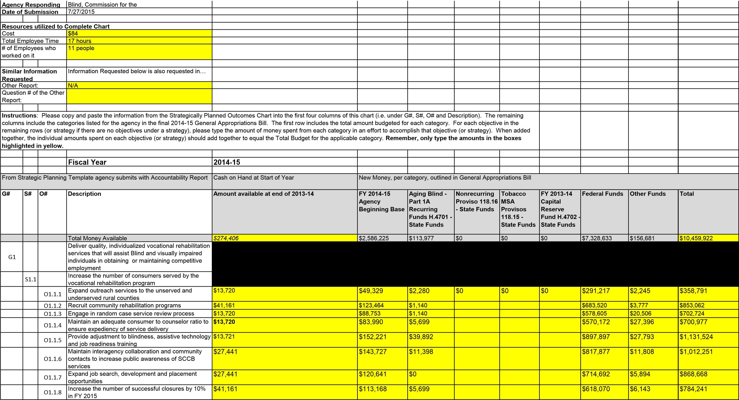
O1.1.9
Maintain 80% of competitive employment placements
at or above the minimum wage
$13,720
$71,526
$0
$456,219
$12,373
$553,838
G2
Provide adjustment to blindness and independent
living skills training to Blind and visually impaired
consumers
S2.1
Maintain consistent and quality individualized
independent living services
O2.1.1
Maintain community interaction and develop referral
sources in unserved and underserved rural counties
$13,720
$43,198
$2,280
$249,380
$2,245
$310,823
O2.1.2
Conduct home and community meetings to
coordinate individualized training
$0
$21,111
$19,376
$127,660
$10,054
$178,201
O2.1.3
Collaborate with nonprofit, social and human service
organizations to provide early intervention services
$0
$19,649
$13,677
$54,675
$7,097
$95,098
G3
Provide the administrative leadership necessary to
accomplish the agency mission
S3.1
Ensure that the job functions of all staff contribute to
the achievement of the agency's mission
O3.1.1
Maintain a diversified workforce
$13,720
$212,704
$2,849
$324,428
$4,138
$557,839
O3.1.2
Ensure the timely submission of EPMS documents
for all permanent employees
$13,720
$211,847
$2,849
$296,168
$4,183
$528,767
O3.1.3
Provide staff development training to improve
employee's skills
$21,953
$385,906
$2,849
$440,329
$4,954
$855,991
O3.1.4
Automate and maintain the integrity of agency
workflow data systems
$5,488
$744,991
$2,849
$207,724
$6,075
$967,127
Total Spent per Budget Category
$274,406
$2,586,225
$113,977
$0
$0
$0
$7,328,633
$156,681
$10,459,922
G#
S#
O#
Explanations or Additional Notes from Agency
(
Optional
)
all
all
all
SCCB does not capture expenditures at the objective
level. This information has been calculated using
data compiled by the senior management team on
how different divisions spend time on these
activities.
all
all
all

SCCB does not track funding by the year in which it is
received, with the exception of the State Allocation.
This is why only our State fund carryforward is used
in the first column of data in this chart.
all
all
all
Per a phone conference with Charles Appleby and
Jennifer Dobson on July 14th, we have spread the
actual expenditures for FY15, instead of the total
authorization.
Agency Responding Blind, Commission for the
Date of Submission 7/27/2015
Resources utilized to Complete Chart
Cost $114.07
Total Employee Time 3 Hours
# of Employees who 11 people
Similar Information Information Requested below is also requested in…
Other Report: N/A Question # of the Other
Instructions: Please type in the statute, regulation and proviso which provides a basis for the agency to pursue each goal, strategy and objective. Next to each statute, regulation and proviso type a short summary of the statute (if they agency previously listed the law in the Legal Standards Chart of the Restructuring Act, the agency can copy and paste the summary from there, which is also found in the Laws to Further Evaluate Chart of this Report). Type only one law per row. If multiple laws apply to a particular goal, strategy or objective, copy and paste that row as many times as needed to ensure you list each law that applies on a separate row.

From Strategic Planning Template agency submits with Accountability Report
G# S# O# Description Statute, Regulation,
Proviso
Deliver quality, individualized vocational rehabilitation 361.13 (a) Title I, Part B services that will assist Blind and visually impaired individuals in obtaining or maintaining competitive employment

G1
Increase the number of consumers served by the 361.13 (a) Title I, Part B vocational rehabilitation program

S1.1
Expand outreach services to the unserved and 361.13 (a) Title I, Part B underserved rural counties

O1.1.1
Summary of Statutory Requirement and/or Authority Granted
Under the State Vocational Rehabilitation Services Program (Program), the Secretary provides grants to assist States in operating statewide comprehensive, coordinated, effective, efficient, and accountable programs, each of which is—
- An integral part of a statewide workforce investment system; and
- Designed to assess, plan, develop, and provide vocational rehabilitation services for individuals with disabilities, consistent with their strengths, resources, priorities, concerns, abilities, capabilities, interests, and informed choice, so that they may prepare for and engage in gainful employment.
(Authority: Section 100(a)(2) of the Act; 29 U.S.C. 720(a)(2))
Under the State Vocational Rehabilitation Services Program (Program), the Secretary provides grants to assist States in operating statewide comprehensive, coordinated, effective, efficient, and accountable programs, each of which is—
- An integral part of a statewide workforce investment system; and
- Designed to assess, plan, develop, and provide vocational rehabilitation services for individuals with disabilities, consistent with their strengths, resources, priorities, concerns, abilities, capabilities, interests, and informed choice, so that they may prepare for and engage in gainful employment.
(Authority: Section 100(a)(2) of the Act; 29 U.S.C. 720(a)(2))
Under the State Vocational Rehabilitation Services Program (Program), the Secretary provides grants to assist States in operating statewide comprehensive, coordinated, effective, efficient, and accountable programs, each of which is—
- An integral part of a statewide workforce investment system; and
- Designed to assess, plan, develop, and provide vocational rehabilitation services for individuals with disabilities, consistent with their strengths, resources, priorities, concerns, abilities, capabilities, interests, and informed choice, so that they may prepare for and engage in gainful employment.
(Authority: Section 100(a)(2) of the Act; 29 U.S.C. 720(a)(2))

 |  | O1.1.2 | Recruit community rehabilitation programs | 361.13 (a) Title I, Part B | Under the State Vocational Rehabilitation Services Program (Program), the Secretary provides grants to assist States in operating statewide comprehensive, coordinated, effective, efficient, and accountable programs, each of which is—  - An integral part of a statewide workforce investment system; and  - Designed to assess, plan, develop, and provide vocational rehabilitation services for individuals with disabilities, consistent with their strengths, resources, priorities, concerns, abilities, capabilities, interests, and informed choice, so that they may prepare for and engage in gainful employment.  (Authority: Section 100(a)(2) of the Act; 29 U.S.C. 720(a)(2))
 |  | O1.1.3 | Engage in random case service review process | 361.13 (a) Title I, Part B | Under the State Vocational Rehabilitation Services Program (Program), the Secretary provides grants to assist States in operating statewide comprehensive, coordinated, effective, efficient, and accountable programs, each of which is—(a) An integral part of a statewide workforce investment system; and (b) Designed to assess, plan, develop, and provide vocational rehabilitation services for individuals with disabilities, consistent with their strengths, resources, priorities, concerns, abilities, capabilities, interests, and informed choice, so that they may prepare for and engage in gainful employment. (Authority: Section 100(a)(2) of the Act; 29 U.S.C. 720(a)(2))
 |  | O1.1.4 | Maintain an adequate consumer to counselor ratio to ensure expediency of service delivery | 361.13 (a) Title I, Part B | Under the State Vocational Rehabilitation Services Program (Program), the Secretary provides grants to assist States in operating statewide comprehensive, coordinated, effective, efficient, and accountable programs, each of which is—  - An integral part of a statewide workforce investment system; and  - Designed to assess, plan, develop, and provide vocational rehabilitation services for individuals with disabilities, consistent with their strengths, resources, priorities, concerns, abilities, capabilities, interests, and informed choice, so that they may prepare for and engage in gainful employment.  (Authority: Section 100(a)(2) of the Act; 29 U.S.C. 720(a)(2))
 |  | O1.1.5 | Provide adjustment to blindness, assistive technology and job readiness training | 361.13 (a) Title I, Part B | Under the State Vocational Rehabilitation Services Program (Program), the Secretary provides grants to assist States in operating statewide comprehensive, coordinated, effective, efficient, and accountable programs, each of which is—  - An integral part of a statewide workforce investment system; and  - Designed to assess, plan, develop, and provide vocational rehabilitation services for individuals with disabilities, consistent with their strengths, resources, priorities, concerns, abilities, capabilities, interests, and informed choice, so that they may prepare for and engage in gainful employment.  (Authority: Section 100(a)(2) of the Act; 29 U.S.C. 720(a)(2))
 |  | O1.1.6 | Maintain interagency collaboration and community contacts to increase public awareness of SCCB services | 361.13 (a) Title I, Part B | Under the State Vocational Rehabilitation Services Program (Program), the Secretary provides grants to assist States in operating statewide comprehensive, coordinated, effective, efficient, and accountable programs, each of which is—  - An integral part of a statewide workforce investment system; and  - Designed to assess, plan, develop, and provide vocational rehabilitation services for individuals with disabilities, consistent with their strengths, resources, priorities, concerns, abilities, capabilities, interests, and informed choice, so that they may prepare for and engage in gainful employment.  (Authority: Section 100(a)(2) of the Act; 29 U.S.C. 720(a)(2))

 |  | O1.1.7 | Expand job search, development and placement opportunities | 361.13 (a) Title I, Part B | Under the State Vocational Rehabilitation Services Program (Program), the Secretary provides grants to assist States in operating statewide comprehensive, coordinated, effective, efficient, and accountable programs, each of which is—  - An integral part of a statewide workforce investment system; and  - Designed to assess, plan, develop, and provide vocational rehabilitation services for individuals with disabilities, consistent with their strengths, resources, priorities, concerns, abilities, capabilities, interests, and informed choice, so that they may prepare for and engage in gainful employment.  (Authority: Section 100(a)(2) of the Act; 29 U.S.C. 720(a)(2))
 |  | O1.1.8 | Increase the number of successful closures by 10% in FY 2015 | 361.13 (a) Title I, Part B | Under the State Vocational Rehabilitation Services Program (Program), the Secretary provides grants to assist States in operating statewide comprehensive, coordinated, effective, efficient, and accountable programs, each of which is—  - An integral part of a statewide workforce investment system; and  - Designed to assess, plan, develop, and provide vocational rehabilitation services for individuals with disabilities, consistent with their strengths, resources, priorities, concerns, abilities, capabilities, interests, and informed choice, so that they may prepare for and engage in gainful employment.  (Authority: Section 100(a)(2) of the Act; 29 U.S.C. 720(a)(2))
 |  | O1.1.9 | Maintain 80% of competitive employment placements at or above the minimum wage | 361.13 (a) Title I, Part B | Under the State Vocational Rehabilitation Services Program (Program), the Secretary provides grants to assist States in operating statewide comprehensive, coordinated, effective, efficient, and accountable programs, each of which is—  - An integral part of a statewide workforce investment system; and  - Designed to assess, plan, develop, and provide vocational rehabilitation services for individuals with disabilities, consistent with their strengths, resources, priorities, concerns, abilities, capabilities, interests, and informed choice, so that they may prepare for and engage in gainful employment.  (Authority: Section 100(a)(2) of the Act; 29 U.S.C. 720(a)(2))
G2 |  |  | Provide adjustment to blindness and independent living skills training to Blind and visually impaired consumers | 361.13 (a) Title I, Part B | Under the State Vocational Rehabilitation Services Program (Program), the Secretary provides grants to assist States in operating statewide comprehensive, coordinated, effective, efficient, and accountable programs, each of which is—  - An integral part of a statewide workforce investment system; and  - Designed to assess, plan, develop, and provide vocational rehabilitation services for individuals with disabilities, consistent with their strengths, resources, priorities, concerns, abilities, capabilities, interests, and informed choice, so that they may prepare for and engage in gainful employment.  (Authority: Section 100(a)(2) of the Act; 29 U.S.C. 720(a)(2))
G2 |  |  | Provide adjustment to blindness and independent living skills training to Blind and visually impaired consumers | 34 CFR Part 367 | This program supports projects that (a) Provide any of the independent living (IL) services to older individuals who are blind that are described in §367.3(b); (b) Conduct activities that will improve or expand services for these individuals; and (c) Conduct activities to help improve public understanding of the problems of these individuals. (Authority: 29 U.S.C. 796k(a) and (b))
G2 |  |  | Provide adjustment to blindness and independent living skills training to Blind and visually impaired consumers | Chapter 6.1, Section 71296 1966) | Provides services to legally blind children between the ages of three and thirteen. The goal of the Children’s Services Program is to assist legally blind children and their families with adjustment to blindness, achievement of educational goals and the development of their maximum personal growth.
 | S2.1 |  | Maintain consistent and quality individualized independent living services | 361.13 (a) Title I, Part B | Under the State Vocational Rehabilitation Services Program (Program), the Secretary provides grants to assist States in operating statewide comprehensive, coordinated, effective, efficient, and accountable programs, each of which is—(a) An integral part of a statewide workforce investment system; and (b) Designed to assess, plan, develop, and provide vocational rehabilitation services for individuals with disabilities, consistent with their strengths, resources, priorities, concerns, abilities, capabilities, interests, and informed choice, so that they may prepare for and engage in gainful employment. (Authority: Section 100(a)(2) of the Act; 29 U.S.C. 720(a)(2))

 | S2.1 |  | Maintain consistent and quality individualized independent living services | 34 CFR Part 367 | This program supports projects that (a) Provide any of the independent living (IL) services to older individuals who are blind that are described in §367.3(b); (b) Conduct activities that will improve or expand services for these individuals; and (c) Conduct activities to help improve public understanding of the problems of these individuals. (Authority: 29 U.S.C. 796k(a) and (b))
 | S2.1 |  | Maintain consistent and quality individualized independent living services | Chapter 6.1, Section 71296 1966) | Provides services to legally blind children between the ages of three and thirteen. The goal of the Children’s Services Program is to assist legally blind children and their families with adjustment to blindness, achievement of educational goals and the development of their maximum personal growth.
 |  | O2.1.1 | Maintain community interaction and develop referral sources in unserved and underserved rural counties | 361.13 (a) Title I, Part B | Under the State Vocational Rehabilitation Services Program (Program), the Secretary provides grants to assist States in operating statewide comprehensive, coordinated, effective, efficient, and accountable programs, each of which is—  - An integral part of a statewide workforce investment system; and  - Designed to assess, plan, develop, and provide vocational rehabilitation services for individuals with disabilities, consistent with their strengths, resources, priorities, concerns, abilities, capabilities, interests, and informed choice, so that they may prepare for and engage in gainful employment.  (Authority: Section 100(a)(2) of the Act; 29 U.S.C. 720(a)(2))
 |  | O2.1.1 | Maintain community interaction and develop referral sources in unserved and underserved rural counties | 34 CFR Part 367 | This program supports projects that (a) Provide any of the independent living (IL) services to older individuals who are blind that are described in §367.3(b); (b) Conduct activities that will improve or expand services for these individuals; and (c) Conduct activities to help improve public understanding of the problems of these individuals. (Authority: 29 U.S.C. 796k(a) and (b))
 |  | O2.1.1 | Maintain community interaction and develop referral sources in unserved and underserved rural counties | Chapter 6.1, Section 71296 1966) | Provides services to legally blind children between the ages of three and thirteen. The goal of the Children’s Services Program is to assist legally blind children and their families with adjustment to blindness, achievement of educational goals and the development of their maximum personal growth.
 |  | O2.1.2 | Conduct home and community meetings to coordinate individualized training | 361.13 (a) Title I, Part B | Under the State Vocational Rehabilitation Services Program (Program), the Secretary provides grants to assist States in operating statewide comprehensive, coordinated, effective, efficient, and accountable programs, each of which is—  - An integral part of a statewide workforce investment system; and  - Designed to assess, plan, develop, and provide vocational rehabilitation services for individuals with disabilities, consistent with their strengths, resources, priorities, concerns, abilities, capabilities, interests, and informed choice, so that they may prepare for and engage in gainful employment.  (Authority: Section 100(a)(2) of the Act; 29 U.S.C. 720(a)(2))
 |  | O2.1.2 | Conduct home and community meetings to coordinate individualized training | 34 CFR Part 367 | This program supports projects that (a) Provide any of the independent living (IL) services to older individuals who are blind that are described in §367.3(b); (b) Conduct activities that will improve or expand services for these individuals; and (c) Conduct activities to help improve public understanding of the problems of these individuals. (Authority: 29 U.S.C. 796k(a) and (b))
 |  | O2.1.2 | Conduct home and community meetings to coordinate individualized training | Chapter 6.1, Section 71296 1966) | Provides services to legally blind children between the ages of three and thirteen. The goal of the Children’s Services Program is to assist legally blind children and their families with adjustment to blindness, achievement of educational goals and the development of their maximum personal growth.
 |  | O2.1.3 | Collaborate with nonprofit, social and human service organizations to provide early intervention services | Chapter 6.1, Section 71296 1966) | Provides services to legally blind children between the ages of three and thirteen. The goal of the Children’s Services Program is to assist legally blind children and their families with adjustment to blindness, achievement of educational goals and the development of their maximum personal growth.

G3 |  |  | Provide the administrative leadership necessary to accomplish the agency mission | 361.13 (a) Title I, Part B | Under the State Vocational Rehabilitation Services Program (Program), the Secretary provides grants to assist States in operating statewide comprehensive, coordinated, effective, efficient, and accountable programs, each of which is—  - An integral part of a statewide workforce investment system; and  - Designed to assess, plan, develop, and provide vocational rehabilitation services for individuals with disabilities, consistent with their strengths, resources, priorities, concerns, abilities, capabilities, interests, and informed choice, so that they may prepare for and engage in gainful employment.  (Authority: Section 100(a)(2) of the Act; 29 U.S.C. 720(a)(2))
 | S3.1 |  | Ensure that the job functions of all staff contribute to the achievement of the agency's mission | 361.13 (a) Title I, Part B | Under the State Vocational Rehabilitation Services Program (Program), the Secretary provides grants to assist States in operating statewide comprehensive, coordinated, effective, efficient, and accountable programs, each of which is—  - An integral part of a statewide workforce investment system; and  - Designed to assess, plan, develop, and provide vocational rehabilitation services for individuals with disabilities, consistent with their strengths, resources, priorities, concerns, abilities, capabilities, interests, and informed choice, so that they may prepare for and engage in gainful employment.  (Authority: Section 100(a)(2) of the Act; 29 U.S.C. 720(a)(2))
 |  | O3.1.1 | Maintain a diversified workforce | 361.13 (a) Title I, Part B | Under the State Vocational Rehabilitation Services Program (Program), the Secretary provides grants to assist States in operating statewide comprehensive, coordinated, effective, efficient, and accountable programs, each of which is—  - An integral part of a statewide workforce investment system; and  - Designed to assess, plan, develop, and provide vocational rehabilitation services for individuals with disabilities, consistent with their strengths, resources, priorities, concerns, abilities, capabilities, interests, and informed choice, so that they may prepare for and engage in gainful employment.  (Authority: Section 100(a)(2) of the Act; 29 U.S.C. 720(a)(2))
 |  | O3.1.2 | Ensure the timely submission of EPMS documents for all permanent employees | 361.13 (a) Title I, Part B | Under the State Vocational Rehabilitation Services Program (Program), the Secretary provides grants to assist States in operating statewide comprehensive, coordinated, effective, efficient, and accountable programs, each of which is—  - An integral part of a statewide workforce investment system; and  - Designed to assess, plan, develop, and provide vocational rehabilitation services for individuals with disabilities, consistent with their strengths, resources, priorities, concerns, abilities, capabilities, interests, and informed choice, so that they may prepare for and engage in gainful employment.  (Authority: Section 100(a)(2) of the Act; 29 U.S.C. 720(a)(2))
 |  | O3.1.3 | Provide staff development training to improve employee's skills | 361.13 (a) Title I, Part B | Under the State Vocational Rehabilitation Services Program (Program), the Secretary provides grants to assist States in operating statewide comprehensive, coordinated, effective, efficient, and accountable programs, each of which is—  - An integral part of a statewide workforce investment system; and  - Designed to assess, plan, develop, and provide vocational rehabilitation services for individuals with disabilities, consistent with their strengths, resources, priorities, concerns, abilities, capabilities, interests, and informed choice, so that they may prepare for and engage in gainful employment.  (Authority: Section 100(a)(2) of the Act; 29 U.S.C. 720(a)(2))

 |  | O3.1.4 | Automate and maintain the integrity of agency workflow data systems | 361.13 (a) Title I, Part B | Under the State Vocational Rehabilitation Services Program (Program), the Secretary provides grants to assist States in operating statewide comprehensive, coordinated, effective, efficient, and accountable programs, each of which is—  - An integral part of a statewide workforce investment system; and  - Designed to assess, plan, develop, and provide vocational rehabilitation services for individuals with disabilities, consistent with their strengths, resources, priorities, concerns, abilities, capabilities, interests, and informed choice, so that they may prepare for and engage in gainful employment.  (Authority: Section 100(a)(2) of the Act; 29 U.S.C. 720(a)(2))

Agency Responding |  | Blind, Commission for the
Date of Submission |  | 7/27/2015
Resources utilized to Complete Chart
Cost |  | $96
Total Employee Time |  | 3 hours
# of Employees who worked on it |  | 11 people
Similar Information Requested |  | Information Requested below is also requested in…
Other Report: |  | N/A
Question # of the Other Report:
Instructions: Below is a list of all the laws the agency said were related to it in the agency's 2015 Restructuring and Seven Year Plan Report. In the "Related, Impacted Goal, Strategy or Objective #" column, please type the goal, strategy or objective number which is related to or impacted by the law (i.e. G1, O1.1.1, etc.). If a particular law relates/impacts more than one goal, strategy or objective, make a separate row for each different Related, Impacted Goal, Strategy or Objective by copying and pasting the law to as many separate rows as needed. In the column, titled "Recommend Further Evaluation," please put a Y beside any laws the agency would like the Committee to review for further discussion and/or possibly recommend revision or elimination of in the Committee's Oversight Report. In the column, titled "Basis for Further Evaluation," please provide a brief explanation/basis for any laws which the agency would like the Committee to review by choosing one of the options available from the drop down menu.
NOTE: If the agency grouped individual laws together, but would like the Committee to perform further
evaluation of a law, the agency must add a row which states the specific law so it is clear what the agency wants the Committee to evaluate.
Related,  Impacted  Goal,  Strategy or  Objective#  (i.e. G1,  O1.1.1) | Statute/Regulation/P rovisos | Summary of Statutory Requirement and/or Authority Granted | Law Item # | Recommend  Further  Evaluation (Yes or leave blank) | Basis for Further Evaluation
G1 | 361.13 (a) Title I, Part  B | Under the State Vocational Rehabilitation Services Program (Program), the Secretary provides grants to assist States in operating statewide comprehensive, coordinated, effective, efficient, and accountable programs, each of which is—  - An integral part of a statewide workforce investment system; and  - Designed to assess, plan, develop, and provide vocational rehabilitation services for individuals with disabilities, consistent with their strengths, resources, priorities, concerns, abilities, capabilities, interests, and informed choice, so that they may prepare for and engage in gainful employment.  (Authority: Section 100(a)(2) of the Act; 29 U.S.C. 720(a)(2)) | 1

S1.1 | 361.13 (a) Title I, Part  B | Under the State Vocational Rehabilitation Services Program (Program), the Secretary provides grants to assist States in operating statewide comprehensive, coordinated, effective, efficient, and accountable programs, each of which is—  - An integral part of a statewide workforce investment system; and  - Designed to assess, plan, develop, and provide vocational rehabilitation services for individuals with disabilities, consistent with their strengths, resources, priorities, concerns, abilities, capabilities, interests, and informed choice, so that they may prepare for and engage in gainful employment.  (Authority: Section 100(a)(2) of the Act; 29 U.S.C. 720(a)(2)) | 1
O1.1.1 | 361.13 (a) Title I, Part  B | Under the State Vocational Rehabilitation Services Program (Program), the Secretary provides grants to assist States in operating statewide comprehensive, coordinated, effective, efficient, and accountable programs, each of which is—  - An integral part of a statewide workforce investment system; and  - Designed to assess, plan, develop, and provide vocational rehabilitation services for individuals with disabilities, consistent with their strengths, resources, priorities, concerns, abilities, capabilities, interests, and informed choice, so that they may prepare for and engage in gainful employment.  (Authority: Section 100(a)(2) of the Act; 29 U.S.C. 720(a)(2)) | 1
O1.1.2 | 361.13 (a) Title I, Part  B | Under the State Vocational Rehabilitation Services Program (Program), the Secretary provides grants to assist States in operating statewide comprehensive, coordinated, effective, efficient, and accountable programs, each of which is—  - An integral part of a statewide workforce investment system; and  - Designed to assess, plan, develop, and provide vocational rehabilitation services for individuals with disabilities, consistent with their strengths, resources, priorities, concerns, abilities, capabilities, interests, and informed choice, so that they may prepare for and engage in gainful employment.  (Authority: Section 100(a)(2) of the Act; 29 U.S.C. 720(a)(2)) | 1
O1.1.3 | 361.13 (a) Title I, Part  B | Under the State Vocational Rehabilitation Services Program (Program), the Secretary provides grants to assist States in operating statewide comprehensive, coordinated, effective, efficient, and accountable programs, each of which is—  - An integral part of a statewide workforce investment system; and  - Designed to assess, plan, develop, and provide vocational rehabilitation services for individuals with disabilities, consistent with their strengths, resources, priorities, concerns, abilities, capabilities, interests, and informed choice, so that they may prepare for and engage in gainful employment.  (Authority: Section 100(a)(2) of the Act; 29 U.S.C. 720(a)(2)) | 1

O1.1.4 | 361.13 (a) Title I, Part  B | Under the State Vocational Rehabilitation Services Program (Program), the Secretary provides grants to assist States in operating statewide comprehensive, coordinated, effective, efficient, and accountable programs, each of which is—  - An integral part of a statewide workforce investment system; and  - Designed to assess, plan, develop, and provide vocational rehabilitation services for individuals with disabilities, consistent with their strengths, resources, priorities, concerns, abilities, capabilities, interests, and informed choice, so that they may prepare for and engage in gainful employment.  (Authority: Section 100(a)(2) of the Act; 29 U.S.C. 720(a)(2)) | 1
O1.1.5 | 361.13 (a) Title I, Part  B | Under the State Vocational Rehabilitation Services Program (Program), the Secretary provides grants to assist States in operating statewide comprehensive, coordinated, effective, efficient, and accountable programs, each of which is—  - An integral part of a statewide workforce investment system; and  - Designed to assess, plan, develop, and provide vocational rehabilitation services for individuals with disabilities, consistent with their strengths, resources, priorities, concerns, abilities, capabilities, interests, and informed choice, so that they may prepare for and engage in gainful employment.  (Authority: Section 100(a)(2) of the Act; 29 U.S.C. 720(a)(2)) | 1
O1.1.6 | 361.13 (a) Title I, Part  B | Under the State Vocational Rehabilitation Services Program (Program), the Secretary provides grants to assist States in operating statewide comprehensive, coordinated, effective, efficient, and accountable programs, each of which is—  - An integral part of a statewide workforce investment system; and  - Designed to assess, plan, develop, and provide vocational rehabilitation services for individuals with disabilities, consistent with their strengths, resources, priorities, concerns, abilities, capabilities, interests, and informed choice, so that they may prepare for and engage in gainful employment.  (Authority: Section 100(a)(2) of the Act; 29 U.S.C. 720(a)(2)) | 1
O1.1.7 | 361.13 (a) Title I, Part  B | Under the State Vocational Rehabilitation Services Program (Program), the Secretary provides grants to assist States in operating statewide comprehensive, coordinated, effective, efficient, and accountable programs, each of which is—  - An integral part of a statewide workforce investment system; and  - Designed to assess, plan, develop, and provide vocational rehabilitation services for individuals with disabilities, consistent with their strengths, resources, priorities, concerns, abilities, capabilities, interests, and informed choice, so that they may prepare for and engage in gainful employment.  (Authority: Section 100(a)(2) of the Act; 29 U.S.C. 720(a)(2)) | 1

O1.1.8 | 361.13 (a) Title I, Part  B | Under the State Vocational Rehabilitation Services Program (Program), the Secretary provides grants to assist States in operating statewide comprehensive, coordinated, effective, efficient, and accountable programs, each of which is—  - An integral part of a statewide workforce investment system; and  - Designed to assess, plan, develop, and provide vocational rehabilitation services for individuals with disabilities, consistent with their strengths, resources, priorities, concerns, abilities, capabilities, interests, and informed choice, so that they may prepare for and engage in gainful employment.  (Authority: Section 100(a)(2) of the Act; 29 U.S.C. 720(a)(2)) | 1
O1.1.9 | 361.13 (a) Title I, Part  B | Under the State Vocational Rehabilitation Services Program (Program), the Secretary provides grants to assist States in operating statewide comprehensive, coordinated, effective, efficient, and accountable programs, each of which is—  - An integral part of a statewide workforce investment system; and  - Designed to assess, plan, develop, and provide vocational rehabilitation services for individuals with disabilities, consistent with their strengths, resources, priorities, concerns, abilities, capabilities, interests, and informed choice, so that they may prepare for and engage in gainful employment.  (Authority: Section 100(a)(2) of the Act; 29 U.S.C. 720(a)(2)) | 1
G2 | 361.13 (a) Title I, Part  B | Under the State Vocational Rehabilitation Services Program (Program), the Secretary provides grants to assist States in operating statewide comprehensive, coordinated, effective, efficient, and accountable programs, each of which is—  - An integral part of a statewide workforce investment system; and  - Designed to assess, plan, develop, and provide vocational rehabilitation services for individuals with disabilities, consistent with their strengths, resources, priorities, concerns, abilities, capabilities, interests, and informed choice, so that they may prepare for and engage in gainful employment.  (Authority: Section 100(a)(2) of the Act; 29 U.S.C. 720(a)(2)) | 1
S2.1 | 361.13 (a) Title I, Part  B | Under the State Vocational Rehabilitation Services Program (Program), the Secretary provides grants to assist States in operating statewide comprehensive, coordinated, effective, efficient, and accountable programs, each of which is—  - An integral part of a statewide workforce investment system; and  - Designed to assess, plan, develop, and provide vocational rehabilitation services for individuals with disabilities, consistent with their strengths, resources, priorities, concerns, abilities, capabilities, interests, and informed choice, so that they may prepare for and engage in gainful employment.  (Authority: Section 100(a)(2) of the Act; 29 U.S.C. 720(a)(2)) | 1

O2.1.1 | 361.13 (a) Title I, Part  B | Under the State Vocational Rehabilitation Services Program (Program), the Secretary provides grants to assist States in operating statewide comprehensive, coordinated, effective, efficient, and accountable programs, each of which is—  - An integral part of a statewide workforce investment system; and  - Designed to assess, plan, develop, and provide vocational rehabilitation services for individuals with disabilities, consistent with their strengths, resources, priorities, concerns, abilities, capabilities, interests, and informed choice, so that they may prepare for and engage in gainful employment.  (Authority: Section 100(a)(2) of the Act; 29 U.S.C. 720(a)(2)) | 1
O2.1.2 | 361.13 (a) Title I, Part  B | Under the State Vocational Rehabilitation Services Program (Program), the Secretary provides grants to assist States in operating statewide comprehensive, coordinated, effective, efficient, and accountable programs, each of which is—  - An integral part of a statewide workforce investment system; and  - Designed to assess, plan, develop, and provide vocational rehabilitation services for individuals with disabilities, consistent with their strengths, resources, priorities, concerns, abilities, capabilities, interests, and informed choice, so that they may prepare for and engage in gainful employment.  (Authority: Section 100(a)(2) of the Act; 29 U.S.C. 720(a)(2)) | 1
G3 | 361.13 (a) Title I, Part  B | Under the State Vocational Rehabilitation Services Program (Program), the Secretary provides grants to assist States in operating statewide comprehensive, coordinated, effective, efficient, and accountable programs, each of which is—  - An integral part of a statewide workforce investment system; and  - Designed to assess, plan, develop, and provide vocational rehabilitation services for individuals with disabilities, consistent with their strengths, resources, priorities, concerns, abilities, capabilities, interests, and informed choice, so that they may prepare for and engage in gainful employment.  (Authority: Section 100(a)(2) of the Act; 29 U.S.C. 720(a)(2)) | 1
S3.1 | 361.13 (a) Title I, Part  B | Under the State Vocational Rehabilitation Services Program (Program), the Secretary provides grants to assist States in operating statewide comprehensive, coordinated, effective, efficient, and accountable programs, each of which is—  - An integral part of a statewide workforce investment system; and  - Designed to assess, plan, develop, and provide vocational rehabilitation services for individuals with disabilities, consistent with their strengths, resources, priorities, concerns, abilities, capabilities, interests, and informed choice, so that they may prepare for and engage in gainful employment.  (Authority: Section 100(a)(2) of the Act; 29 U.S.C. 720(a)(2)) | 1

O3.1.1 | 361.13 (a) Title I, Part  B | Under the State Vocational Rehabilitation Services Program (Program), the Secretary provides grants to assist States in operating statewide comprehensive, coordinated, effective, efficient, and accountable programs, each of which is—  - An integral part of a statewide workforce investment system; and  - Designed to assess, plan, develop, and provide vocational rehabilitation services for individuals with disabilities, consistent with their strengths, resources, priorities, concerns, abilities, capabilities, interests, and informed choice, so that they may prepare for and engage in gainful employment.  (Authority: Section 100(a)(2) of the Act; 29 U.S.C. 720(a)(2)) | 1
O3.1.2 | 361.13 (a) Title I, Part  B | Under the State Vocational Rehabilitation Services Program (Program), the Secretary provides grants to assist States in operating statewide comprehensive, coordinated, effective, efficient, and accountable programs, each of which is—  - An integral part of a statewide workforce investment system; and  - Designed to assess, plan, develop, and provide vocational rehabilitation services for individuals with disabilities, consistent with their strengths, resources, priorities, concerns, abilities, capabilities, interests, and informed choice, so that they may prepare for and engage in gainful employment.  (Authority: Section 100(a)(2) of the Act; 29 U.S.C. 720(a)(2)) | 1
O3.1.3 | 361.13 (a) Title I, Part  B | Under the State Vocational Rehabilitation Services Program (Program), the Secretary provides grants to assist States in operating statewide comprehensive, coordinated, effective, efficient, and accountable programs, each of which is—  - An integral part of a statewide workforce investment system; and  - Designed to assess, plan, develop, and provide vocational rehabilitation services for individuals with disabilities, consistent with their strengths, resources, priorities, concerns, abilities, capabilities, interests, and informed choice, so that they may prepare for and engage in gainful employment.  (Authority: Section 100(a)(2) of the Act; 29 U.S.C. 720(a)(2)) | 1
O3.1.4 | 361.13 (a) Title I, Part  B | Under the State Vocational Rehabilitation Services Program (Program), the Secretary provides grants to assist States in operating statewide comprehensive, coordinated, effective, efficient, and accountable programs, each of which is—  - An integral part of a statewide workforce investment system; and  - Designed to assess, plan, develop, and provide vocational rehabilitation services for individuals with disabilities, consistent with their strengths, resources, priorities, concerns, abilities, capabilities, interests, and informed choice, so that they may prepare for and engage in gainful employment.  (Authority: Section 100(a)(2) of the Act; 29 U.S.C. 720(a)(2)) | 1

 | 361.13 (a) Title I, Part  B | Under the State Vocational Rehabilitation Services Program (Program), the Secretary provides grants to assist States in operating statewide comprehensive, coordinated, effective, efficient, and accountable programs, each of which is—  - An integral part of a statewide workforce investment system; and  - Designed to assess, plan, develop, and provide vocational rehabilitation services for individuals with disabilities, consistent with their strengths, resources, priorities, concerns, abilities, capabilities, interests, and informed choice, so that they may prepare for and engage in gainful employment.  (Authority: Section 100(a)(2) of the Act; 29 U.S.C. 720(a)(2)) | 1
G2 | 34 CFR Part 367 | This program supports projects that (a) Provide any of the independent living (IL) services to older individuals who are blind that are described in §367.3(b); (b) Conduct activities that will improve or expand services for these individuals; and (c) Conduct activities to help improve public understanding of the problems of these individuals. (Authority: 29 U.S.C. 796k(a) and (b)) | 2
S2.1 | 34 CFR Part 367 | This program supports projects that (a) Provide any of the independent living (IL) services to older individuals who are blind that are described in §367.3(b); (b) Conduct activities that will improve or expand services for these individuals; and (c) Conduct activities to help improve public understanding of the problems of these individuals. (Authority: 29 U.S.C. 796k(a) and (b)) | 2
O2.1.1 | 34 CFR Part 367 | This program supports projects that (a) Provide any of the independent living (IL) services to older individuals who are blind that are described in §367.3(b); (b) Conduct activities that will improve or expand services for these individuals; and (c) Conduct activities to help improve public understanding of the problems of these individuals. (Authority: 29 U.S.C. 796k(a) and (b)) | 2
O2.1.2 | 34 CFR Part 367 | This program supports projects that (a) Provide any of the independent living (IL) services to older individuals who are blind that are described in §367.3(b); (b) Conduct activities that will improve or expand services for these individuals; and (c) Conduct activities to help improve public understanding of the problems of these individuals. (Authority: 29 U.S.C. 796k(a) and (b)) | 2
G2 | Chapter 6.1, Section 71-296 1966) | Provides services to legally blind children between the ages of three and thirteen. The goal of the Children’s Services Program is to assist legally blind children and their families with adjustment to blindness, achievement of educational goals and the development of their maximum personal growth. | 3
S2.1 | Chapter 6.1, Section 71-296 1966) | Provides services to legally blind children between the ages of three and thirteen. The goal of the Children’s Services Program is to assist legally blind children and their families with adjustment to blindness, achievement of educational goals and the development of their maximum personal growth. | 3
O2.1.1 | Chapter 6.1, Section 71-296 1966) | Provides services to legally blind children between the ages of three and thirteen. The goal of the Children’s Services Program is to assist legally blind children and their families with adjustment to blindness, achievement of educational goals and the development of their maximum personal growth. | 3
O2.1.2 | Chapter 6.1, Section 71-296 1966) | Provides services to legally blind children between the ages of three and thirteen. The goal of the Children’s Services Program is to assist legally blind children and their families with adjustment to blindness, achievement of educational goals and the development of their maximum personal growth. | 3
O2.1.3 | Chapter 6.1, Section 71-296 1966) | Provides services to legally blind children between the ages of three and thirteen. The goal of the Children’s Services Program is to assist legally blind children and their families with adjustment to blindness, achievement of educational goals and the development of their maximum personal growth. | 3

Agency Responding |  |  | Blind, Commission for the
Date of Submission |  |  | 7/27/2015
Resources utilized to Complete Chart
Cost |  |  | $452
Total Employee Time |  |  | 13 hours
# of Employees who |  |  | 12 people
Similar  Reque | Infor sted | mation | Information Requested below is also requested  in…
Other | Report | : | N/A
Questi | on # o | f the Other
Instruc objectiv the col | tions: e. U umn, " | Please list what the agency considers the most potential negative impact to the public that may occur as a result of the agency not accomplishing each objective. Under the column, "Most Potential Negative Impact," type the most potential negative impact to the public that may occur as a result of the agency not accomplishing the nder the column, "Level Requires Outside Help," type the level at which the agency considers the potential negative impact too big to handle internally. Under the column, "Outside Help to Request," type the entities to whom the agency would reach out if the potential negative impact rises to a level that is too big to handle internally. Under Level Requires Inform G.A.," type the level at which the agency thinks the General Assembly should be put on notice of level at which potential negative impact has risen. Under column, "3 G.A. Options," type three options for what the General Assembly could do to help resolve the issue once it was on notice.
From S  G# | trateg  S# | ic Plannin  O# | g Template agency submitted in its 2013-14 Description | Most Potential Negative Impact | 3 G.A. Options | Level Requires Outside Help | Outside Help to Request | Level Requires Inform G.A.
G1 |  |  | Deliver quality, individualized vocational rehabilitation services that will assist Blind and visually impaired individuals in obtaining or maintaining competitive employment
 | S1.1 |  | Increase the number of consumers served by the vocational rehabilitation program
 |  | O1.1.1 | Expand outreach services to the unserved and underserved rural counties | Blind and visually impaired citizens of SC will be unable to obtain the disability adjustment and employment services needed to live independently and/or rejoin the workforce. This will result in undue burdens on families, local communities, charities, and will result in additional dependence of government programs such as food stamps, Medicaid, housing, etc. | 1. Consider additional funding to increase services in rural counties. 2. Consider legislation that encourages and incentivises South Carolina businesses to hire persons who are blind or visually impaired in rural counties. 3. Consider providing state funds to rural communities to improve accessibility to blind and visually impaired individuals in the form of audible traffic islands, safe sidewalks, and Braille markers in public areas. | When SCCB is unable to respond to citizens with visual impairments in rural counties due to lack of resources. | SCCB partners with other state Vocational Rehabilitation Agencies in the region and across the nation, as well as the  Rehabilitation Services Administration, and seeks out technical assistance and training support. | When no outside assistance can be found and funding does not exist for SCCB to expand services to help all citizens with visual impairments in the state of SC.
 |  | O1.1.2 | Recruit community rehabilitation programs | Lack of existing community partnerships and programs limits services and resources that could assist consumers in reaching employment, independence, and self-sufficiency. | 1. Consider additional funding for VR services provided by SCCB. 2. Consider start-up or establishment grants for community rehabilitation programs to support and partner with SCCB in providing services. 3. Consider legislation and funding that would require local education agencies to develop school to work transition job placement and supported employment partnerships with SCCB. | When SCCB no longer has any options to provide services through community rehabilitation programs in the local communities. | Contact agencies within the community who currently partner with SCCB and coordinate contacts with other community rehabilitation programs. | When no community programs will partner with SCCB.
 |  | O1.1.3 | Engage in random case service review process | Without case record reviews SCCB management would be unable to ensure the quality, consistency, effectiveness, and level of compliance with state and federal laws. | 1. Consider additional funds to upgrade automated system to reduce paperwork requirements. 2. Consider funds for additional quality assurance staff. 3. Consider utilizing SCCB case record review data in legislative communications to promote public confidence in the effectiveness and understanding of the program. | When consistency among expectations and provided services no longer exists and consumer numbers are drastically dropping, it would be time to ask for help. | There are no outside resources to assist with this situation. | When the agency can no longer assure the General Assembly of the quality and effectiveness of services in compliance with state and federal laws.
 |  | O1.1.4 | Maintain an adequate consumer to counselor ratio to ensure expediency of service delivery | Vocational Rehabilitation effectiveness, quality, compliance, and outcomes decrease as Client to VR Counselor ratios exceed normal ranges. This limits the number of consumers who achieve quality employment outcomes and reach independence and self-sufficiency. Citizens who are blind are forced to become dependent on other government programs, community charities, or their families. | 1. Consider funds to place more VR Counselors in the field and reduce caseload sizes in high need areas.  2. Consider funding for SCCB to offer a competitive salary consistent with the professional educational requirements for VR Counselors to improve recruitment and retention. 3. Consider legislation that would require state funded public technical and community colleges to partner with SCCB in the development of short term demand driven training programs that result in jobs for blind individuals. | When Client to VR Counselor ratios exceed research based industry standards and turnover increases due to burnout. | There are no outside resources to assist with this situation. | When the agency can no longer hire or retain staff.
 |  | O1.1.5 | Provide adjustment to blindness, assistive technology and job readiness training | Without this training, a person with visual impairments is unable to obtain employment that matches their skill level and is often unable to live at home alone, thus creating the burden on families, communities, and government programs to support the individual. | 1. Consider additional funds for creation of job readiness training sites. 2. Consider additional funds for upgrading and obtaining the most up to date A.T. devices. 3. Consider legislation that encourages and incentivises South Carolina businesses to hire persons who are blind or visually impaired. | When SCCB can no longer provide all of the necessary services to a person experiencing a visual impairment. | SCCB would need to reach out to community agencies for training assistance. | When there is no assistance forthcoming from community agencies and consumer needs cannot be met by SCCB.

 |  | O1.1.6 | Maintain interagency collaboration and community contacts to increase public awareness of SCCB services | Without strong interagency collaboration and contacts that increase the public awareness of SCCB, blind and visually impaired citizens may not achieve employment, independence, and self-sufficiency resulting in stress on families, communities, and other government programs. | 1. Consider additional funding for a public awareness campaign designed to increase the public's awareness of SCCB. 2. Consider legislation that encourages interagency collaboration and partnerships to facilitate coordinated service provision. 3. Consider legislation that would require state funded public technical and community colleges to partner with SCCB in the | When SCCB is unable to respond to citizens with visual impairments due to lack of resources it would be time to reach out for assistance. | The first step would be to contact other state agencies who serve persons with disabilities. Next would be to contact non-profit and nearby agencies who might also offer assistance. Last would be to contact larger agencies such as Lions Club or Helen Keller National Center to request assistance. | When no outside assistance can be found and funding does not exist for SCCB to expand services to help all citizens with visual impairments in the state of SC.
 |  | O1.1.7 | Expand job search, development and placement opportunities | Without job search, job development, and job placement resources available, SCCB is unable to effectively connect job ready blind consumers with job vacancies. This limits the number of consumers who achieve quality employment outcomes and reach independence and self-sufficiency. Citizens who are blind are forced to become dependent on other government programs, community charities, or their families. | 1. Consider additional funds for creation of job readiness training sites. 2. Consider additional funds for SCCB to hire and expand Job Placement and Job Coaching staff. 3. Consider legislation that encourages and incentivises South Carolina businesses to hire persons who are blind or visually impaired. | When employers refuse to hire blind consumers no matter how many services SCCB provides or how much training is offered. | SCCB would reach out to local employment agencies and businesses to develop opportunities for consumers. | When SCCB has exhausted all efforts to create opportunities with businesses.
 |  | O1.1.8 | Increase the number of successful closures by 10% in FY 2015 | Success is measured by the number of consumers who reach an employment outcome and increase their independence and self-sufficiency. The most negative impact would be the result of SCCB consumers being unable to obtain employment and increase independence and self-sufficiency. | 1. Consider legislation that encourages and incentivises South Carolina businesses to hire persons who are blind or visually impaired. 2. Consider providing additional funding for a public awareness campaign that creates an expectation of employment for citizens who are blind and connects them with  SCCB. 3. Provide funding to expand rural services. | When employers refuse to hire blind consumers no matter how many services SCCB provides or how much training is offered. | SCCB would reach out to local employment agencies and businesses to develop opportunities for consumers. | When SCCB has exhausted all efforts to create opportunities with businesses.
 |  | O1.1.9 | Maintain 80% of competitive employment placements at or above the minimum wage | If SCCB is unable to assist blind consumers in obtaining quality employment at or above the minimum wage, consumers will continue to be dependent on families, charities, and/or other government welfare programs. They will not maximize their independence and self-sufficiency. | 1. Consider legislation that encourages and incentivises South Carolina businesses to hire persons who are blind or visually impaired. 2. Consider legislation making it against state labor laws to pay less than minimum wage to any employee doing the same job as someone making minimum wage or higher in the same workplace. 3. Consider legislation that would make state government agencies model employers of qualified blind individuals by creating an expedited hiring process for blind individuals who meet the minimum qualifications for state vacancies. (Utah & California Model) | When employers refuse to hire, or competitively compensate blind consumers no matter how many services SCCB provides or how much training is offered. | SCCB would reach out to local employment agencies and businesses to develop opportunities for consumers. | When SCCB has exhausted all efforts to create opportunities and businesses within the communities of SC will not respond.
G2 |  |  | Provide adjustment to blindness and independent living skills training to Blind and visually impaired consumers
 | S2.1 |  | Maintain consistent and quality individualized independent living services
 |  | O2.1.1 | Maintain community interaction and develop referral sources in unserved and underserved rural counties | Blind and visually impaired citizens of SC will be unable to obtain the disability adjustment and employment services needed to live independently and/or rejoin the workforce. This will result in undue burdens on families, local communities, charities, and will result in additional dependence of government programs such as food stamps, Medicaid, housing, etc. | 1. Consider additional funding for rural services.  2. Consider funding to state agencies in rural counties to assist in expanding services. 3. Consider legislation requiring rural communities to be accessible to the visually impaired with audible traffic islands, safe sidewalks, and Braille markers to identify public areas to assist those who SCCB is unable to serve. | When SCCB is unable to respond to citizens with visual impairments due to lack of resources it would be time to reach out for assistance. | The first step would be to contact other state agencies who serve persons with disabilities. Next would be to contact non-profit and nearby agencies who might also offer assistance. Last would be to contact larger agencies such as Lions Club or Helen Keller National Center to request assistance. | When no outside assistance can be found and funding does not exist for SCCB to expand services to help all citizens with visual impairments in the state of SC.
 |  | O2.1.2 | Conduct home and community meetings to coordinate individualized training | Without home and community meetings it would not be possible to determine the needs of consumers and individualized training could not happen. This would leave consumers unable to maintain their independence and place greater burdens on their communities and families. | 1. Consider additional funding for rural services.  2. Consider funding to state agencies in rural counties to assist in expanding services. 3. Consider legislation requiring rural communities to be accessible to the visually impaired with audible traffic islands, safe sidewalks, and Braille markers to identify public areas to assist those who SCCB is unable to serve. | When SCCB is unable to respond to citizens with visual impairments due to lack of resources it would be time to reach out for assistance. | The first step would be to contact other state agencies who serve persons with disabilities. Next would be to contact non-profit and nearby agencies who might also offer assistance. | When no outside assistance can be found and funding does not exist for SCCB to expand services to help all citizens with visual impairments in the state of SC.
 |  | O2.1.3 | Collaborate with nonprofit, social and human service organizations to provide early intervention services | Blind and visually impaired children would grow up without the tools they need to succeed in society and in school. This would leave children with a visual impairment totally dependent upon their families, communities, charities, and government welfare programs. It would also mean these children would not receive an appropriate education and would be unable to become contributing taxpayers or independent citizens. | 1. Consider additional funding for rural services.  2. Consider funding to state agencies in rural counties to assist in expanding services. 3. Consider legislation requiring rural communities to be accessible to the visually impaired with audible traffic islands, safe sidewalks, and Braille markers to identify public areas to assist those who SCCB is unable to serve. | When SCCB is unable to respond to citizens with visual impairments due to lack of resources it would be time to reach out for assistance. | The first step would be to contact other state agencies who serve persons with disabilities. Next would be to contact non-profit and nearby agencies who might also offer assistance. Last would be to contact larger agencies such as the Helen Keller National Center to request assistance. | When no outside assistance can be found and funding does not exist for SCCB to expand services to help all citizens with visual impairments in the state of SC.
G3 |  |  | Provide the administrative leadership necessary to accomplish the agency mission
 | S3.1 |  | Ensure that the job functions of all staff contribute to the achievement of the agency's mission

 |  | O3.1.1 | Maintain a diversified workforce | Without a diversified workforce the agency could be viewed as discriminatory, and would not benefit from a diversity of experience, thinking, and problem solving. SCCB would also not have a diversified cultural base in staff to meet the diversity of consumers. This would reduce the number of consumers served which would place that burden on the taxpayers and families. | 1. Consider additional funds to place more VR Counselors in the field and reduce caseload sizes in high need areas. 2. Consider additional funding for SCCB to offer competitive salaries for highly trained and educated VR Counselors to encourage recruitment and retention. 3. Consider legislation that would make state government agencies model employers of qualified blind individuals by creating an expedited hiring process for blind individuals who meet the minimum qualifications for state vacancies. (Utah & California Model) | When qualified candidates from a diverse background cannot be hired due to low pay, high caseloads, high travel time, and current counselors are unable to keep up with the demand due to the vacancies. | Contact local employment agencies and advertise vacancies anywhere possible in print and online. | When the agency can no longer hire  or retain staff due to lack of responses to vacancy postings.
 |  | O3.1.2 | Ensure the timely submission of EPMS documents for all permanent employees | Failure to maintain employee performance standards and accountability would negatively affect SCCB's ability to meet its mandated mission, maintain high quality and effective services, and quality employment outcomes for blind citizens. | 1. Consider adjusting evaluation requirements so after the first year of service the employee changes to the state fiscal year and all permanent employees are reviewed once a year at the same time based on their program. (Each internal program is assigned a month for evaluations.) 2. Consider moving all state employee performance management tools to an internet based automated system such as SCEIS. 3. Consider funding for state agencies to obtain technical assistance on how to improve agency effectiveness and productivity through the design of impactful performance review tools. | When there is no longer any connection between an employee's performance plan and reviews and their contribution to the agency's mission, vision, and outcome measures. | There are no outside resources to assist with this situation. | When the agency can no longer hire  or retain staff due to lack of responses to vacancy postings.
 |  | O3.1.3 | Provide staff development training to improve employee's skills | The VR profession is an ever changing research and development based profession, lack of staff development and training results in staff not being current with industry trends, best practices, innovations, or research findings. Consumers who are not served in the most up to date manner will be unable to meet the qualifications for available employment opportunities and will be unable to remain self-sufficient as technology changes rapidly. | 1. Consider funding for specialized staff training to allow for professional growth and better service to consumers. 2. Consider expanding agencies authority to send staff to national and regional professional conferences. 3. Consider funding for high definition video conferencing to expand training while decreasing travel time and travel costs. | When staff is unable to answer questions posed by consumers, unable to train or offer training on the latest technology, and is unable to renew their specific licensures due to lack of ongoing development, it is time for help. | Reach out to other state agencies and online for free and low cost training opportunities for staff to build their skills. | When staff is unable to maintain licensures and are not able to provide up to date services to the consumers.
 |  | O3.1.4 | Automate and maintain the integrity of agency workflow data systems | Without automated systems it is more difficult and time consuming to maintain accuracy and accountability in record keeping. This also affects the integrity of the programs and requires more staff hours to complete a job. More staff hours would translate into the need for a greater percentage of funding to go to salaries and benefits which in turn would reduce funding to provide services to consumers. | 1. Consider additional funds to upgrade automated system to reduce paperwork requirements. 2. Consider funds for additional IT staff to support innovation of work flow technology. 3. Consider funding to enable state agencies to explore innovative technologies to improve data management, security, and program outcome reporting. | When automated systems become outdated and no longer operate efficiently but there are no funds to upgrade the system or train staff on new systems then it would be time to ask for help. | Develop relationships with software providers to negotiate upgrades and trainings. | When automated systems no longer function in a way that allows SCCB to operate efficiently.

Agency Responding |  | Blind, Commission for the
Date of Submission |  | 7/27/2015
Resources utilized to Complete Chart
Cost |  | $84
Total Employee Time |  | 2 hours
# of Employees who worked on it |  | 11 people
Similar Information Requested |  | Information Requested below is also requested in…
Other Report: |  | N/A
Question # of the Other Report:
Instructions: In this Chart please list all external or internal reviews, audits, investigations or studies (“Reviews”) of the agency during the past five (5) fiscal years. If a particular Review relates/impacts more than one goal, strategy or objective, make a separate row for each different Associated Goal, Strategy and Objective by copying and pasting the Review to as many separate rows as needed. Please remember to provide copies of the report from the Review and any other information generated by the entity performing the Review (in word/excel if available, if not, please scan in .pdf version). NOTE: Responses are not limited to the number of rows below that have borders around them, please list all that are applicable.
Review Item # | Matter(s) or Issue(s) Under  Review | Reason Review was Initiated (outside request, internal policy, etc.) | Was Reviewing Entity External or Internal? | Entity Performing the  Review | Date Review Began  (MM/DD/YYYY) | Date Review Ended  (MM/DD/YYYY) | Associated Goal, Strategy or Objective # which relates to the matter/issue under review (only one per row)
1 | Vocational Rehab Grant | Single Audit Act of 1996 | External | SAO | 7/27/2014 | 3/16/2015 | O1.1.1
2 | Vocational Rehab Grant | Single Audit Act of 1996 | External | SAO | 7/27/2014 | 3/16/2015 | O1.1.2
3 | Vocational Rehab Grant | Single Audit Act of 1996 | External | SAO | 7/27/2014 | 3/16/2015 | O1.1.3
4 | Vocational Rehab Grant | Single Audit Act of 1996 | External | SAO | 7/27/2014 | 3/16/2015 | O1.1.4
5 | Vocational Rehab Grant | Single Audit Act of 1996 | External | SAO | 7/27/2014 | 3/16/2015 | O1.1.5
6 | Vocational Rehab Grant | Single Audit Act of 1996 | External | SAO | 7/27/2014 | 3/16/2015 | O1.1.6
7 | Vocational Rehab Grant | Single Audit Act of 1996 | External | SAO | 7/27/2014 | 3/16/2015 | O1.1.7
8 | Vocational Rehab Grant | Single Audit Act of 1996 | External | SAO | 7/27/2014 | 3/16/2015 | O1.1.8
9 | Vocational Rehab Grant | Single Audit Act of 1996 | External | SAO | 7/27/2014 | 3/16/2015 | O1.1.9
10 | Vocational Rehab Grant | Single Audit Act of 1996 | External | SAO | 7/27/2014 | 3/16/2015 | O2.1.1
11 | Vocational Rehab Grant | Single Audit Act of 1996 | External | SAO | 7/27/2014 | 3/16/2015 | O2.1.2
12 | Vocational Rehab Grant | Single Audit Act of 1996 | External | SAO | 7/27/2014 | 3/16/2015 | O2.1.3
13 | Vocational Rehab Grant | Single Audit Act of 1996 | External | SAO | 7/27/2014 | 3/16/2015 | O3.1.1
14 | Vocational Rehab Grant | Single Audit Act of 1996 | External | SAO | 7/27/2014 | 3/16/2015 | O3.1.2
15 | Vocational Rehab Grant | Single Audit Act of 1996 | External | SAO | 7/27/2014 | 3/16/2015 | O3.1.3
16 | Vocational Rehab Grant | Single Audit Act of 1996 | External | SAO | 7/27/2014 | 3/16/2015 | O3.1.4
17 | Vocational Rehab Grant | Single Audit Act of 1996 | External | SAO | 7/1/2013 | 7/27/2014 | O1.1.1
18 | Vocational Rehab Grant | Single Audit Act of 1996 | External | SAO | 7/1/2013 | 7/27/2014 | O1.1.2
19 | Vocational Rehab Grant | Single Audit Act of 1996 | External | SAO | 7/1/2013 | 7/27/2014 | O1.1.3
20 | Vocational Rehab Grant | Single Audit Act of 1996 | External | SAO | 7/1/2013 | 7/27/2014 | O1.1.4
21 | Vocational Rehab Grant | Single Audit Act of 1996 | External | SAO | 7/1/2013 | 7/27/2014 | O1.1.5
22 | Vocational Rehab Grant | Single Audit Act of 1996 | External | SAO | 7/1/2013 | 7/27/2014 | O1.1.6
23 | Vocational Rehab Grant | Single Audit Act of 1996 | External | SAO | 7/1/2013 | 7/27/2014 | O1.1.7
24 | Vocational Rehab Grant | Single Audit Act of 1996 | External | SAO | 7/1/2013 | 7/27/2014 | O1.1.8
25 | Vocational Rehab Grant | Single Audit Act of 1996 | External | SAO | 7/1/2013 | 7/27/2014 | O1.1.9
26 | Vocational Rehab Grant | Single Audit Act of 1996 | External | SAO | 7/1/2013 | 7/27/2014 | O2.1.1

27 | Vocational Rehab Grant | Single Audit Act of 1996 | External | SAO | 7/1/2013 | 7/27/2014 | O2.1.2
28 | Vocational Rehab Grant | Single Audit Act of 1996 | External | SAO | 7/1/2013 | 7/27/2014 | O2.1.3
29 | Vocational Rehab Grant | Single Audit Act of 1996 | External | SAO | 7/1/2013 | 7/27/2014 | O3.1.1
30 | Vocational Rehab Grant | Single Audit Act of 1996 | External | SAO | 7/1/2013 | 7/27/2014 | O3.1.2
31 | Vocational Rehab Grant | Single Audit Act of 1996 | External | SAO | 7/1/2013 | 7/27/2014 | O3.1.3
32 | Vocational Rehab Grant | Single Audit Act of 1996 | External | SAO | 7/1/2013 | 7/27/2014 | O3.1.4
33 | Vocational Rehab Grant | Single Audit Act of 1996 | External | SAO | 7/3/2012 | 6/6/2013 | O1.1.1
34 | Vocational Rehab Grant | Single Audit Act of 1996 | External | SAO | 7/3/2012 | 6/6/2013 | O1.1.2
35 | Vocational Rehab Grant | Single Audit Act of 1996 | External | SAO | 7/3/2012 | 6/6/2013 | O1.1.3
36 | Vocational Rehab Grant | Single Audit Act of 1996 | External | SAO | 7/3/2012 | 6/6/2013 | O1.1.4
37 | Vocational Rehab Grant | Single Audit Act of 1996 | External | SAO | 7/3/2012 | 6/6/2013 | O1.1.5
38 | Vocational Rehab Grant | Single Audit Act of 1996 | External | SAO | 7/3/2012 | 6/6/2013 | O1.1.6
39 | Vocational Rehab Grant | Single Audit Act of 1996 | External | SAO | 7/3/2012 | 6/6/2013 | O1.1.7
40 | Vocational Rehab Grant | Single Audit Act of 1996 | External | SAO | 7/3/2012 | 6/6/2013 | O1.1.8
41 | Vocational Rehab Grant | Single Audit Act of 1996 | External | SAO | 7/3/2012 | 6/6/2013 | O1.1.9
42 | Vocational Rehab Grant | Single Audit Act of 1996 | External | SAO | 7/3/2012 | 6/6/2013 | O2.1.1
43 | Vocational Rehab Grant | Single Audit Act of 1996 | External | SAO | 7/3/2012 | 6/6/2013 | O2.1.2
44 | Vocational Rehab Grant | Single Audit Act of 1996 | External | SAO | 7/3/2012 | 6/6/2013 | O2.1.3
45 | Vocational Rehab Grant | Single Audit Act of 1996 | External | SAO | 7/3/2012 | 6/6/2013 | O3.1.1
46 | Vocational Rehab Grant | Single Audit Act of 1996 | External | SAO | 7/3/2012 | 6/6/2013 | O3.1.2
47 | Vocational Rehab Grant | Single Audit Act of 1996 | External | SAO | 7/3/2012 | 6/6/2013 | O3.1.3
48 | Vocational Rehab Grant | Single Audit Act of 1996 | External | SAO | 7/3/2012 | 6/6/2013 | O3.1.4
49 | Vocational Rehab Grant | Single Audit Act of 1996 | External | SAO | 2/1/2012 | 5/24/2012 | O1.1.1
50 | Vocational Rehab Grant | Single Audit Act of 1996 | External | SAO | 2/1/2012 | 5/24/2012 | O1.1.2
51 | Vocational Rehab Grant | Single Audit Act of 1996 | External | SAO | 2/1/2012 | 5/24/2012 | O1.1.3
52 | Vocational Rehab Grant | Single Audit Act of 1996 | External | SAO | 2/1/2012 | 5/24/2012 | O1.1.4
53 | Vocational Rehab Grant | Single Audit Act of 1996 | External | SAO | 2/1/2012 | 5/24/2012 | O1.1.5
54 | Vocational Rehab Grant | Single Audit Act of 1996 | External | SAO | 2/1/2012 | 5/24/2012 | O1.1.6
55 | Vocational Rehab Grant | Single Audit Act of 1996 | External | SAO | 2/1/2012 | 5/24/2012 | O1.1.7
56 | Vocational Rehab Grant | Single Audit Act of 1996 | External | SAO | 2/1/2012 | 5/24/2012 | O1.1.8
57 | Vocational Rehab Grant | Single Audit Act of 1996 | External | SAO | 2/1/2012 | 5/24/2012 | O1.1.9
58 | Vocational Rehab Grant | Single Audit Act of 1996 | External | SAO | 2/1/2012 | 5/24/2012 | O2.1.1
59 | Vocational Rehab Grant | Single Audit Act of 1996 | External | SAO | 2/1/2012 | 5/24/2012 | O2.1.2
60 | Vocational Rehab Grant | Single Audit Act of 1996 | External | SAO | 2/1/2012 | 5/24/2012 | O2.1.3
61 | Vocational Rehab Grant | Single Audit Act of 1996 | External | SAO | 2/1/2012 | 5/24/2012 | O3.1.1
62 | Vocational Rehab Grant | Single Audit Act of 1996 | External | SAO | 2/1/2012 | 5/24/2012 | O3.1.2
63 | Vocational Rehab Grant | Single Audit Act of 1996 | External | SAO | 2/1/2012 | 5/24/2012 | O3.1.3
64 | Vocational Rehab Grant | Single Audit Act of 1996 | External | SAO |  | 5/24/2012 | O3.1.4
65 | Review of HR Exception Procedures | Internal Policy | External | Budget & Control Board |  | 11/10/2014 | O1.1.1
66 | Review of HR Exception Procedures | Internal Policy | External | Budget & Control Board |  | 11/10/2014 | O1.1.2
67 | Review of HR Exception Procedures | Internal Policy | External | Budget & Control Board |  | 11/10/2014 | O1.1.3

68 | Review of HR Exception Procedures | Internal Policy | External | Budget & Control Board |  | 11/10/2014 | O1.1.4
69 | Review of HR Exception Procedures | Internal Policy | External | Budget & Control Board |  | 11/10/2014 | O1.1.5
70 | Review of HR Exception Procedures | Internal Policy | External | Budget & Control Board |  | 11/10/2014 | O1.1.6
71 | Review of HR Exception Procedures | Internal Policy | External | Budget & Control Board |  | 11/10/2014 | O1.1.7
72 | Review of HR Exception Procedures | Internal Policy | External | Budget & Control Board |  | 11/10/2014 | O1.1.8
73 | Review of HR Exception Procedures | Internal Policy | External | Budget & Control Board |  | 11/10/2014 | O1.1.9
74 | Review of HR Exception Procedures | Internal Policy | External | Budget & Control Board |  | 11/10/2014 | O2.1.1
75 | Review of HR Exception Procedures | Internal Policy | External | Budget & Control Board |  | 11/10/2014 | O2.1.2
76 | Review of HR Exception Procedures | Internal Policy | External | Budget & Control Board |  | 11/10/2014 | O2.1.3
77 | Review of HR Exception Procedures | Internal Policy | External | Budget & Control Board |  | 11/10/2014 | O3.1.1
78 | Review of HR Exception Procedures | Internal Policy | External | Budget & Control Board |  | 11/10/2014 | O3.1.2
79 | Review of HR Exception Procedures | Internal Policy | External | Budget & Control Board |  | 11/10/2014 | O3.1.3
80 | Review of HR Exception Procedures | Internal Policy | External | Budget & Control Board |  | 11/10/2014 | O3.1.4
81 | AUP |  | External | Rogers and Laban,  CPA | 7/24/2012 | 7/3/2013
82 | AUP |  | External | SAO | 6/30/2013 | 10/14/2014
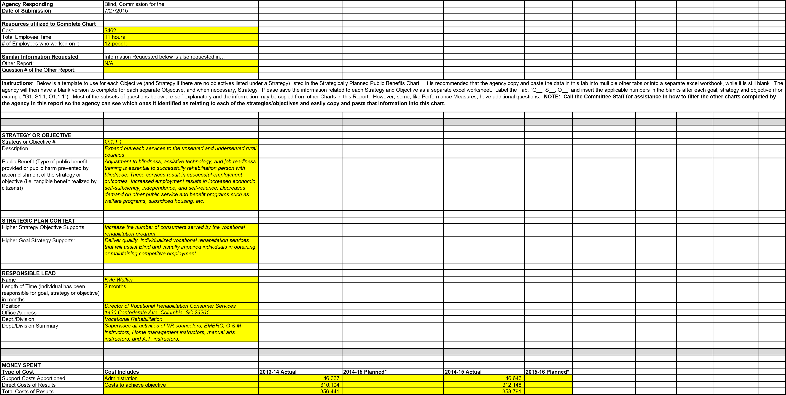
By Major Program Area in 2014-15 | Amount available at end of 2013-14 | FY 2014-15 Agency Beginning Base | Aging Blind - Part 1A Recurring Funds H.4701 - State Funds | Nonrecurring Proviso 118.16 - State Funds | Tobacco MSA  Provisos 118.15 - State Funds | FY 2013-14 Capital  Reserve Fund H.4702 - State Funds | Federal Funds | Other Funds | Total
 | $31,923 | $61,495 | $3,000 | $0 | $0 | $0 | $337,667 | $4,206 | $434,085
*SCCB does not capture costs in this manner. Based on historical data, SCCB is using 13% as the percent of total costs that are Support Costs. SCCB does not plan expenditures in this manner. Based on a phone conference with Charles Appleby and Jennifer Dobson on July 14th, we are leaving the planning columns blank and attaching our spending plan for FY16. It is by functional area in our agency.
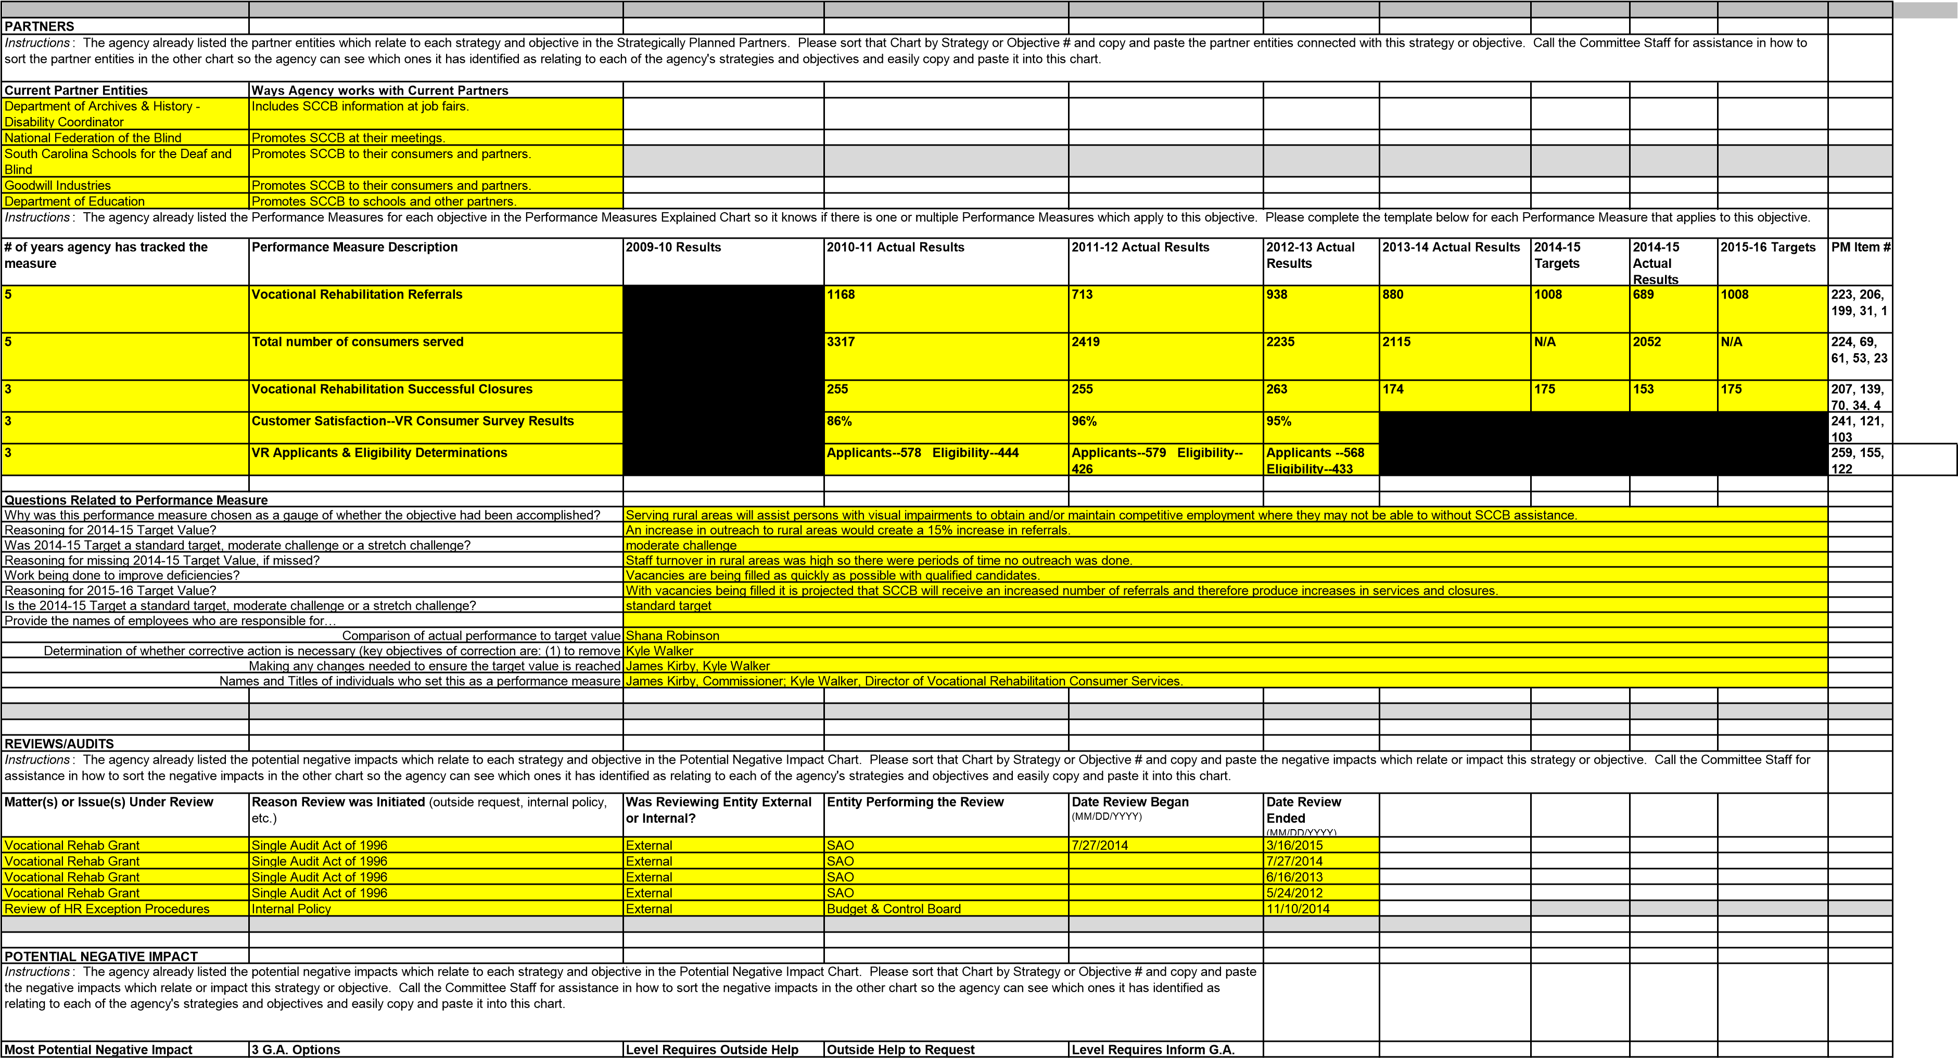

Blind and visually impaired citizens of SC will be unable to obtain the disability adjustment and employment services needed to live independently and/or rejoin the workforce. This will result in undue burdens on families, local communities,  charities, and will result in additional  dependence of government programs such as food stamps, Medicaid, housing, etc. | 1. Consider additional funding to increase services in rural counties. 2. Consider legislation that encourages and incentivises South Carolina businesses to hire persons who are blind or visually impaired in rural counties. 3. Consider providing state funds to rural communities to improve accessibility to blind and visually impaired individuals in the form of audible traffic islands, safe sidewalks, and Braille markers in public areas. | When SCCB is unable to respond to citizens with visual impairments in rural counties due to lack of resources. | SCCB partners with other state Vocational Rehabilitation Agencies in the region and across the nation, as well as the Rehabilitation Services Administration, and seeks out technical assistance and training support. | When no outside assistance can be found and funding does not exist for SCCB to expand services to help all citizens with visual impairments in the state of SC.
LAWS AS BASIS
Instructions: The agency already listed the Laws which support each strategy and objective in the Strategic Plan-Laws as Basis Chart. Please sort that Chart by Strategy or Objective # and copy and paste the laws which relate or impact this strategy or objective. Call the Committee Staff for assistance in how to sort the laws in the other chart so the agency can see which ones it has identified as relating to or impacting each of the agency's strategies and objectives and easily copy and paste it into this chart.
Statute, Regulation, Proviso | Summary of Statutory Requirement and/or Authority Granted
361.13 (a) Title I, Part B | Under the State Vocational Rehabilitation Services Program (Program), the Secretary provides grants to assist States in operating statewide comprehensive, coordinated, effective, efficient, and accountable programs, each of which is—  - An integral part of a statewide workforce investment system; and  - Designed to assess, plan, develop, and provide vocational rehabilitation services for individuals with disabilities, consistent with their strengths, resources, priorities, concerns, abilities, capabilities, interests, and informed choice, so that they may prepare for and engage in gainful employment.  (Authority: Section 100(a)(2) of the Act; 29 U.S.C. 720(a)(2))
LAWS TO FURTHER EVALUATE
Instructions: The agency already listed the Laws to further evaluate in the Laws to Further Evaluate Chart. Please sort that Chart by Strategy or Objective # and copy and paste the laws which relate or impact this strategy or objective which the agency recommended the Committee further evaluate. Call the Committee Staff for assistance in how to sort the laws in the other chart so the agency can see which ones it has identified as relating to or impacting each of the agency's strategies and objectives and easily copy and paste it into this chart.
Statute/Regulation/Provisos | Summary of Statutory Requirement and/or Authority Granted | Law Item # | Recommend Further Evaluation (Yes or leave blank) | Basis for Further Evaluation
N/A
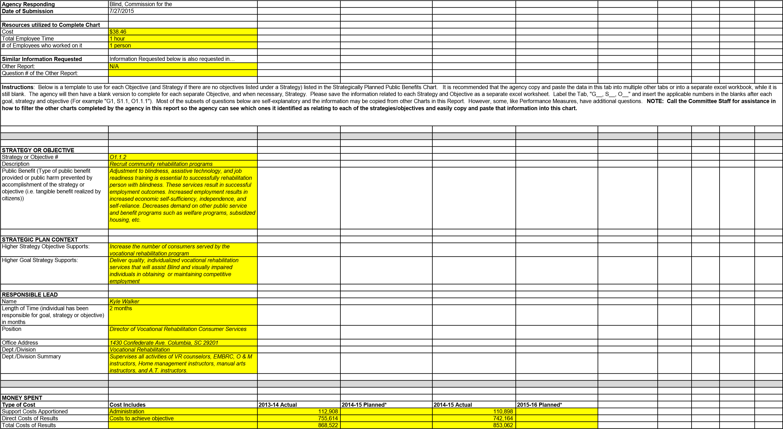
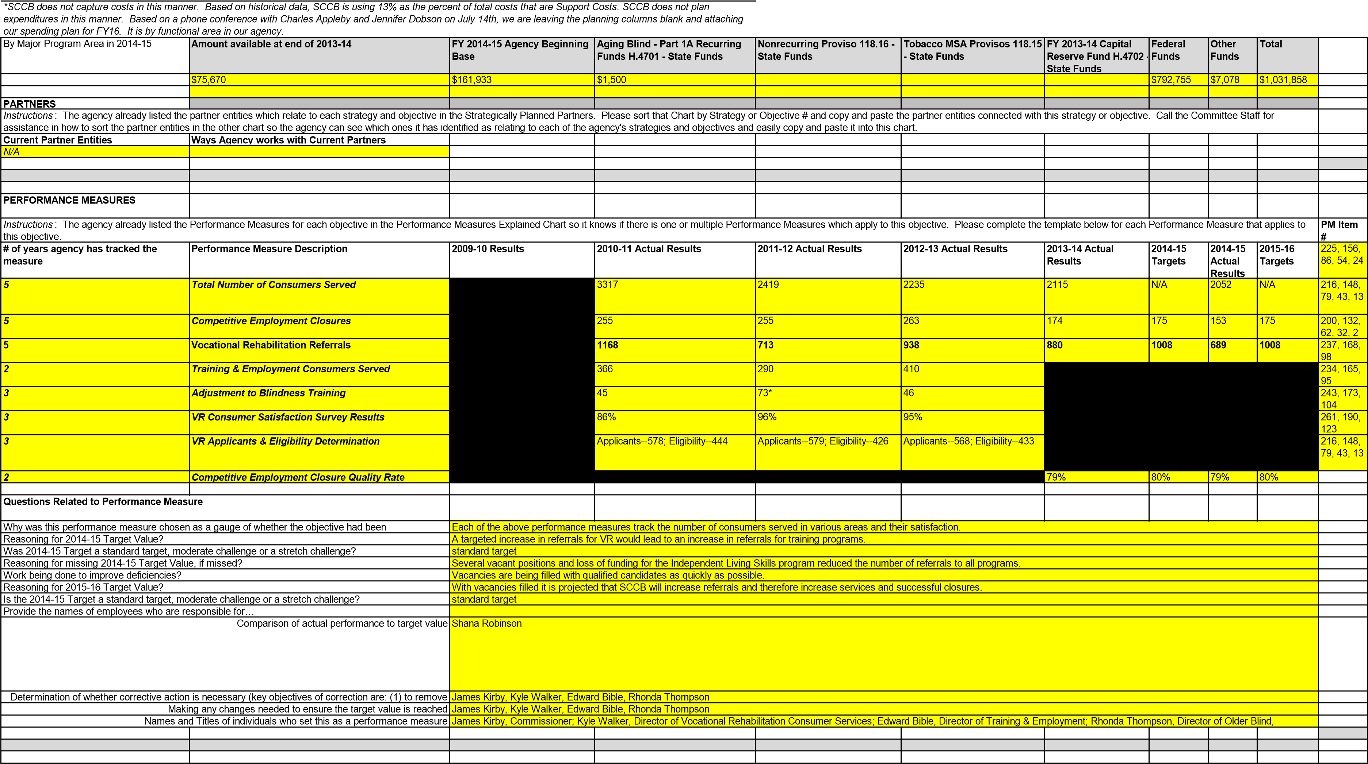
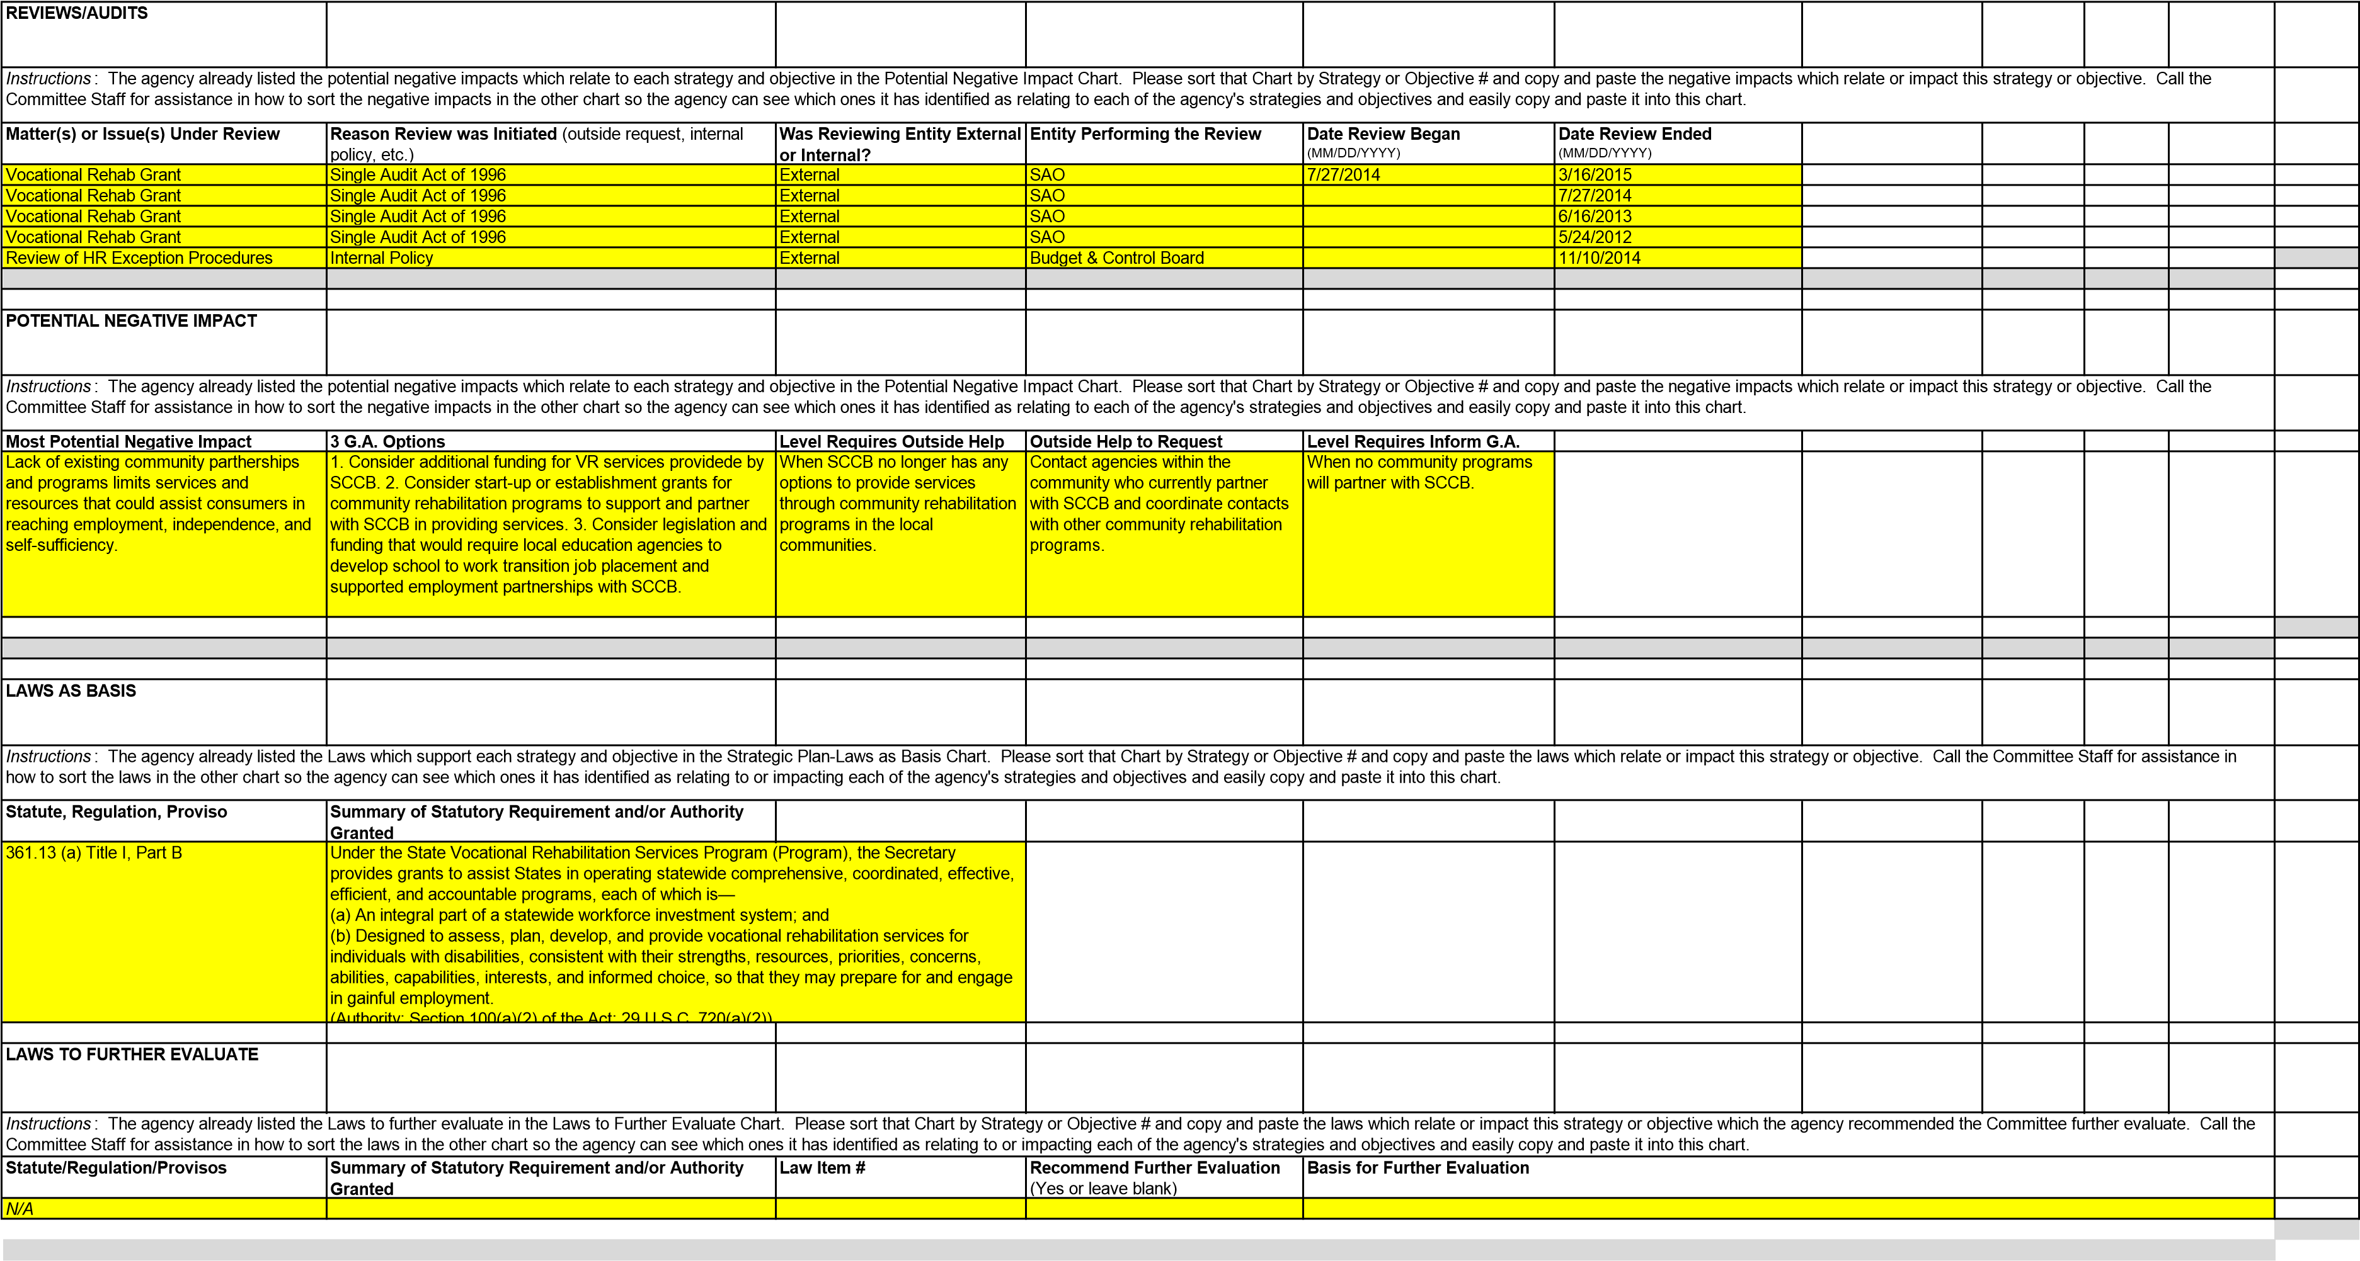
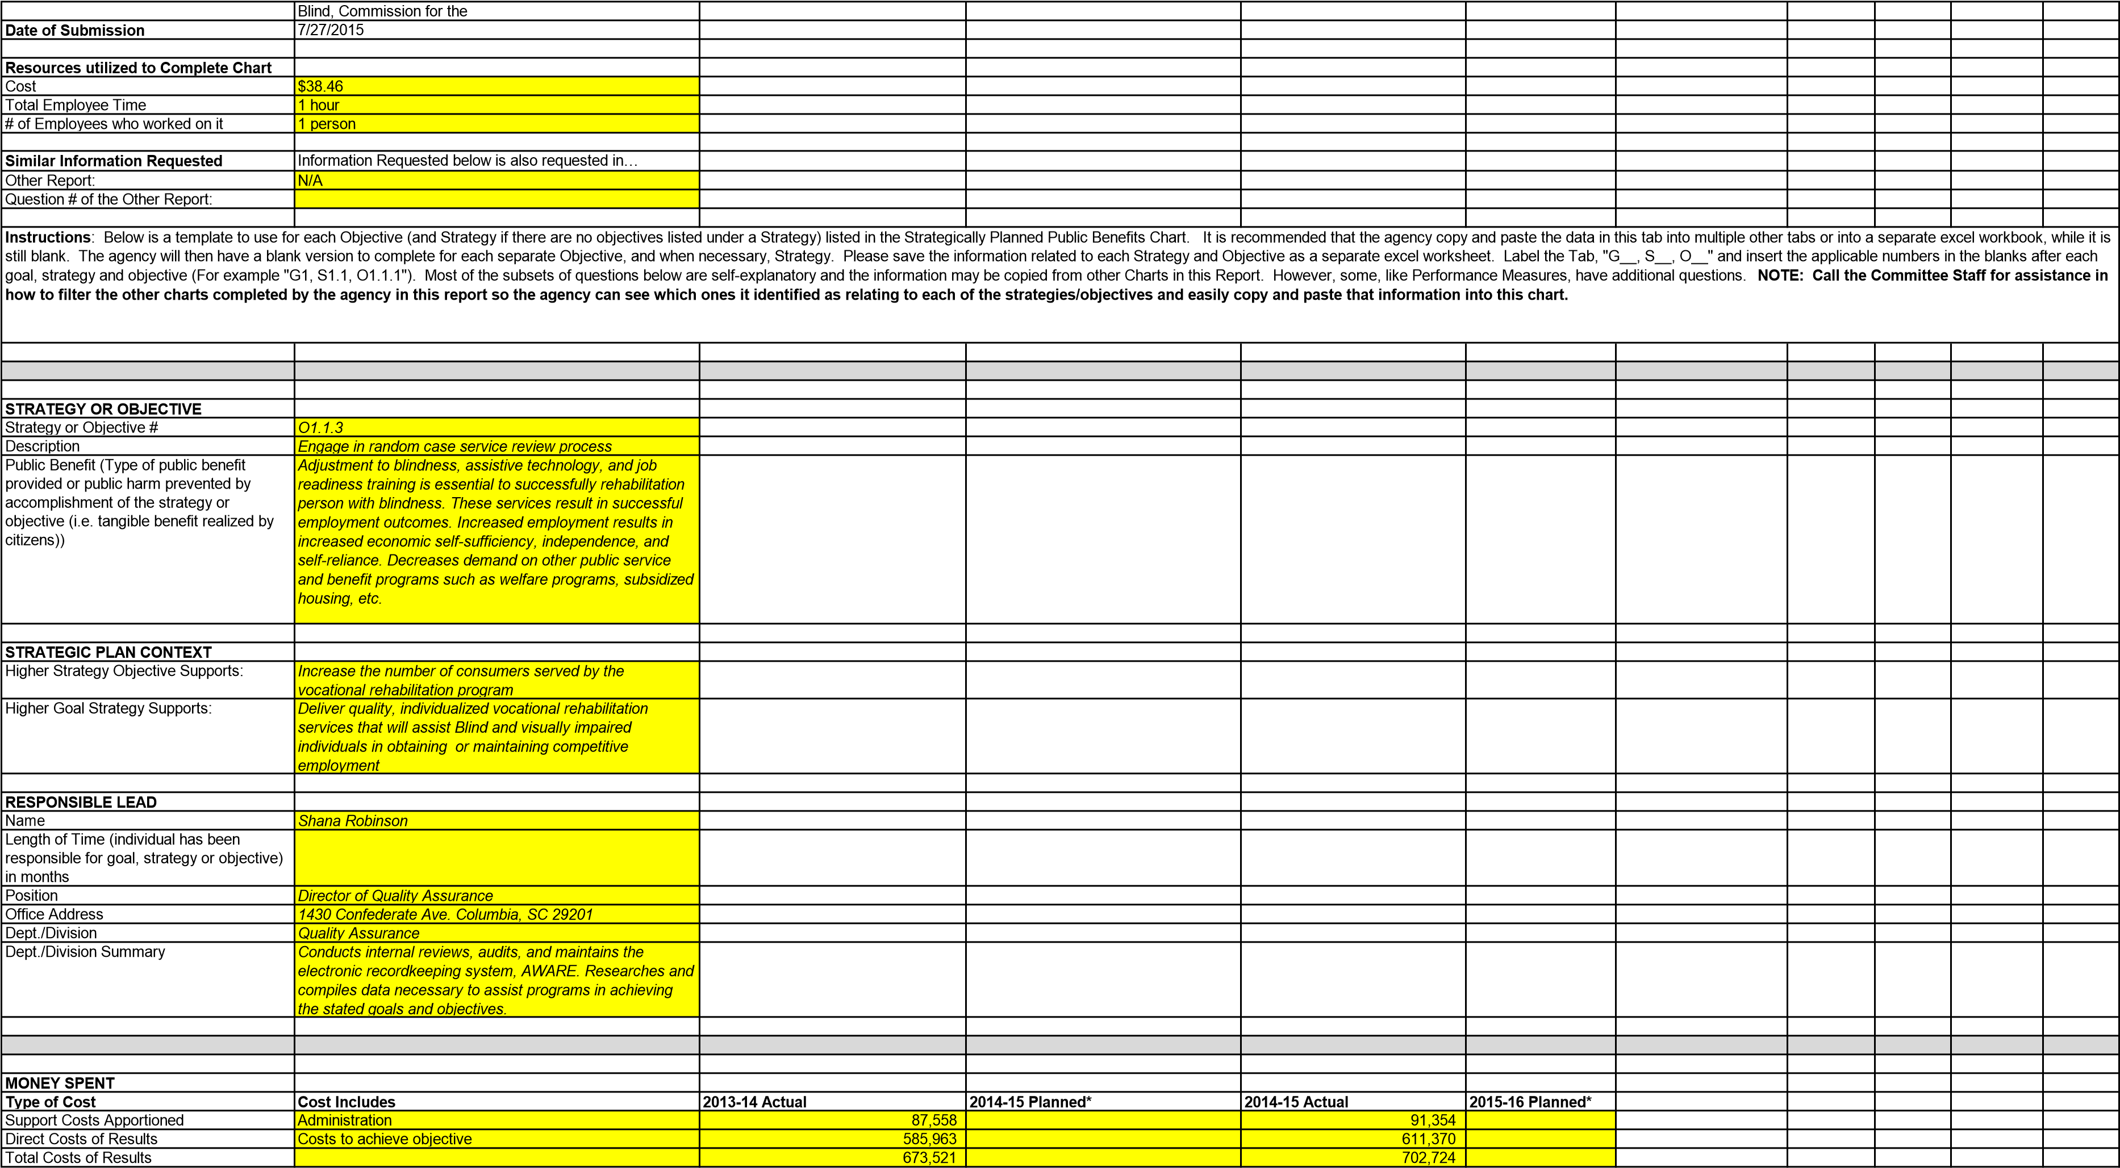
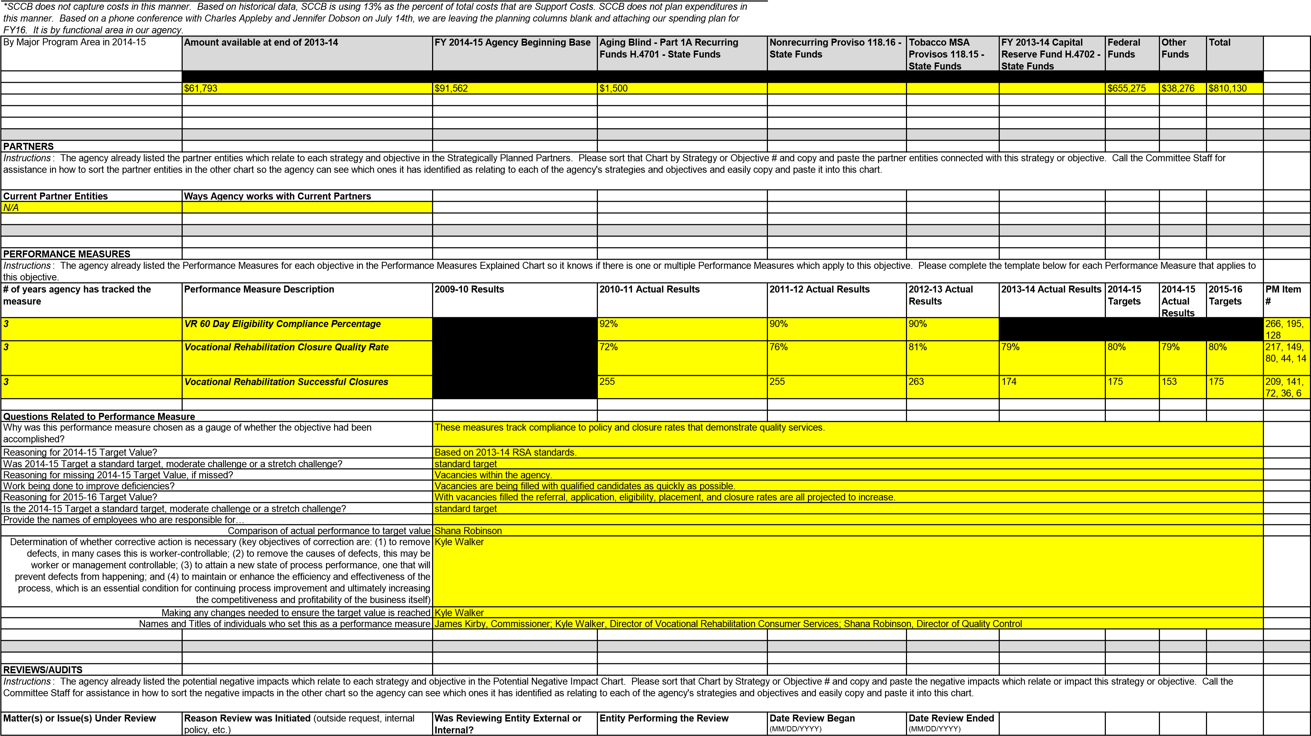
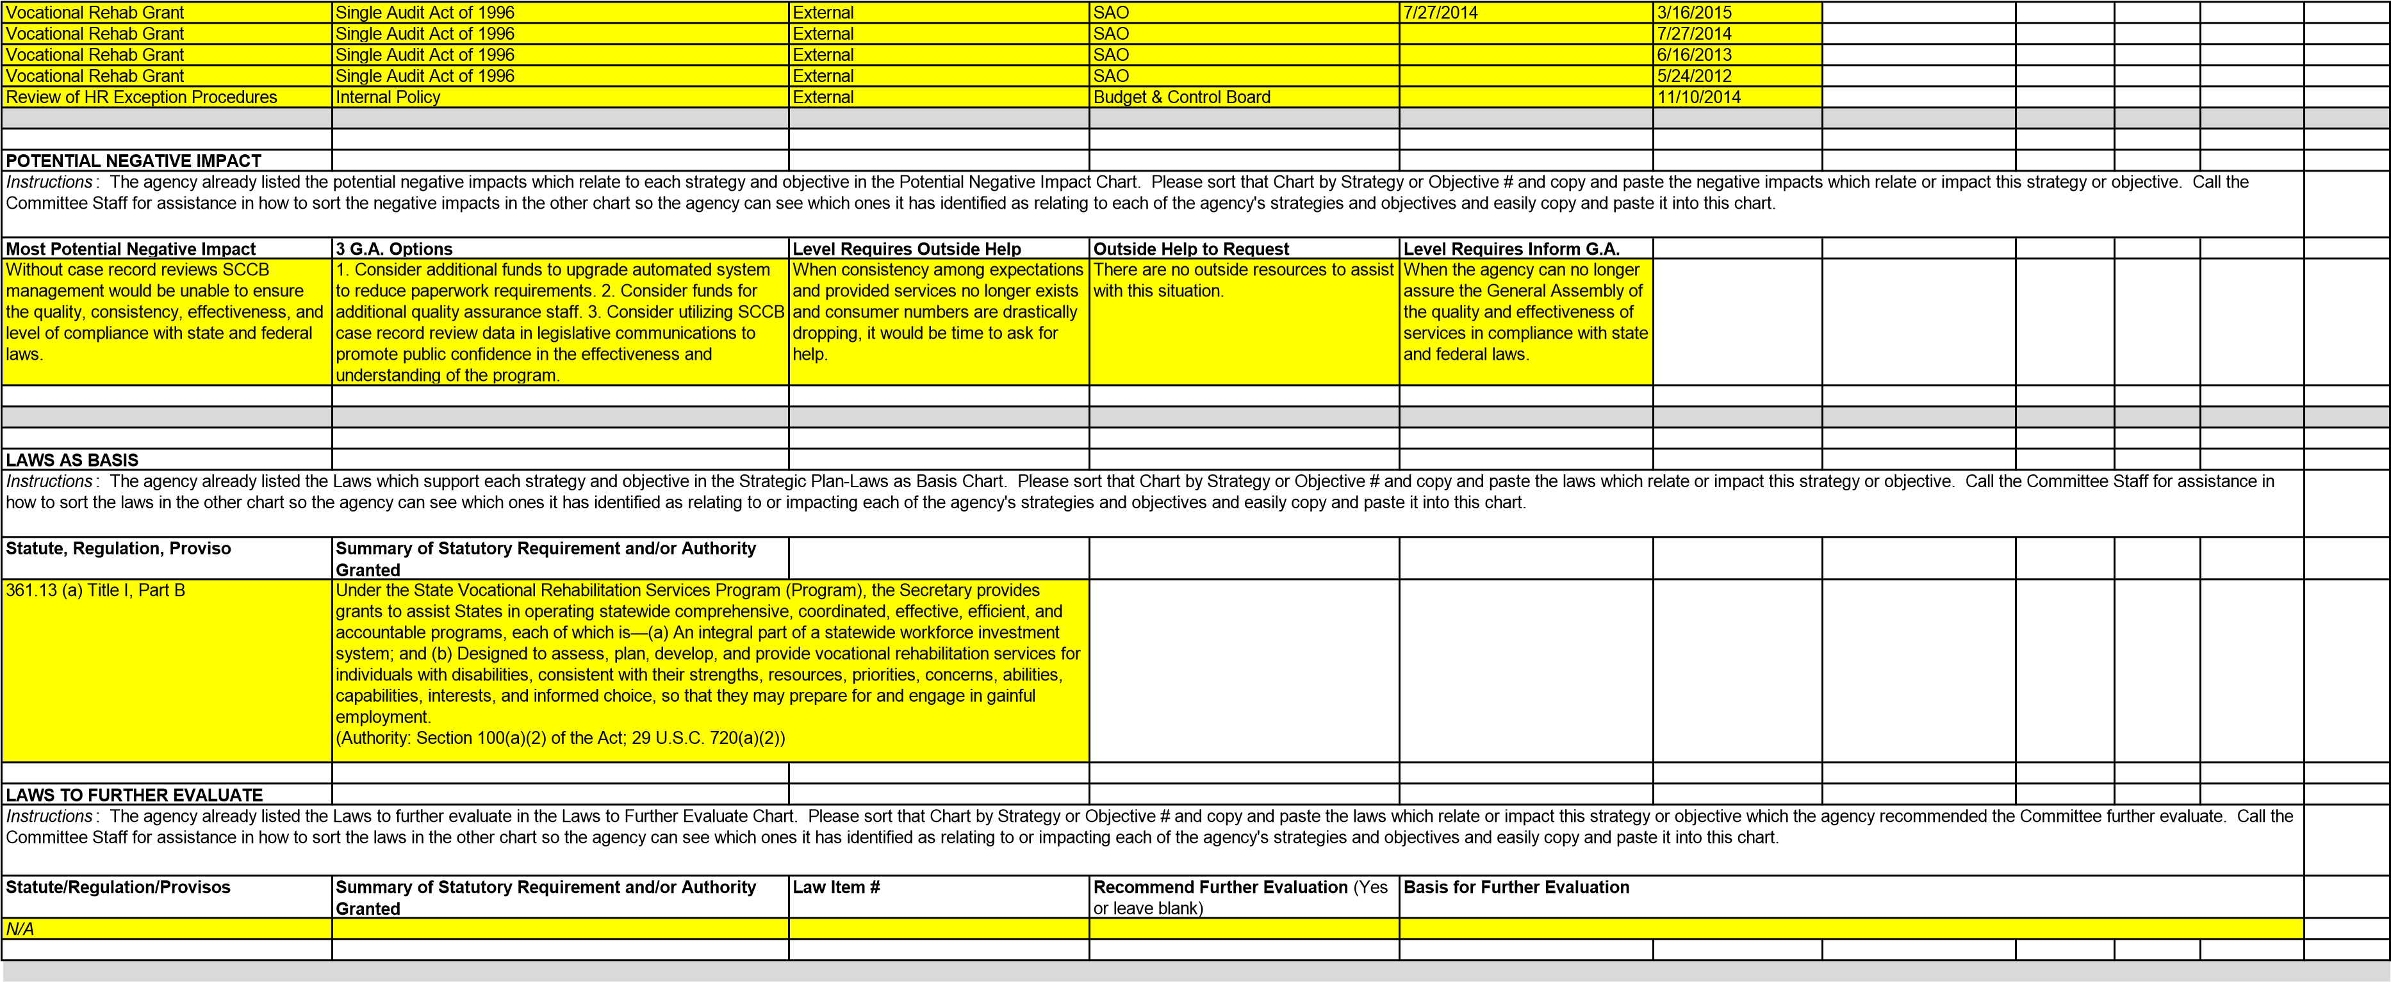
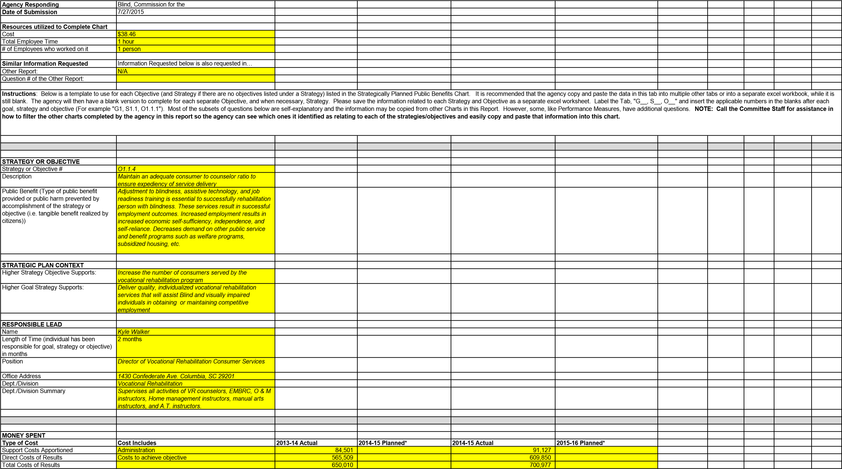
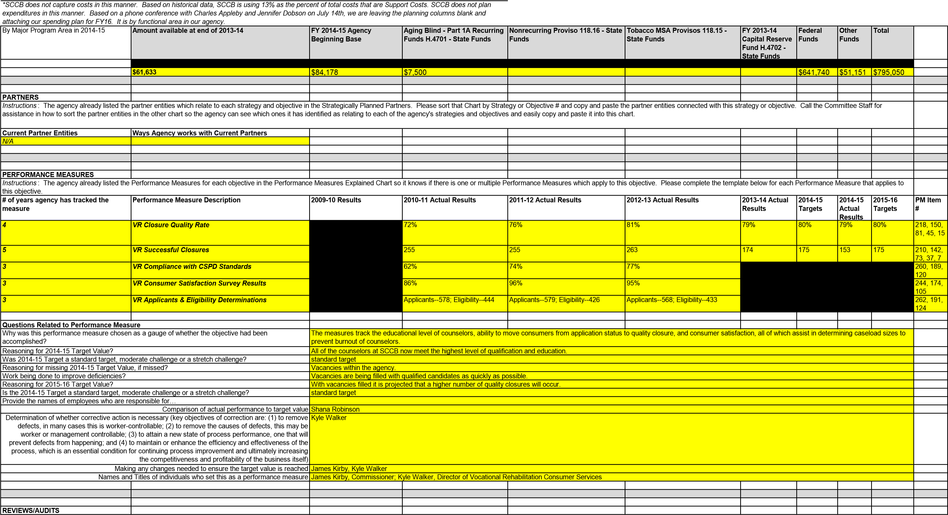
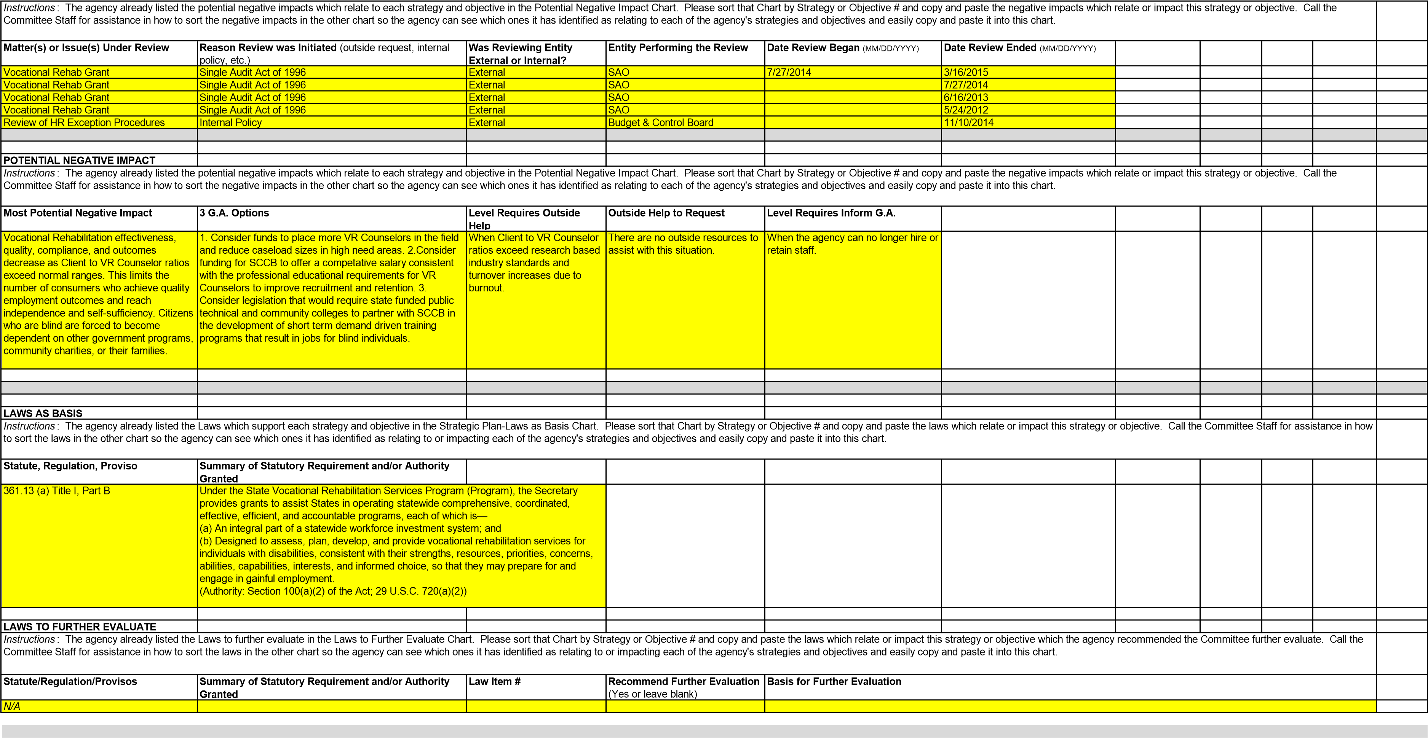
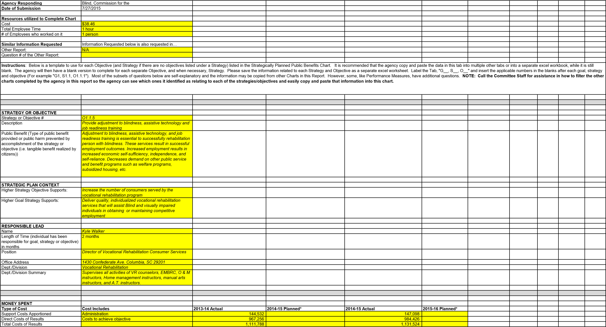
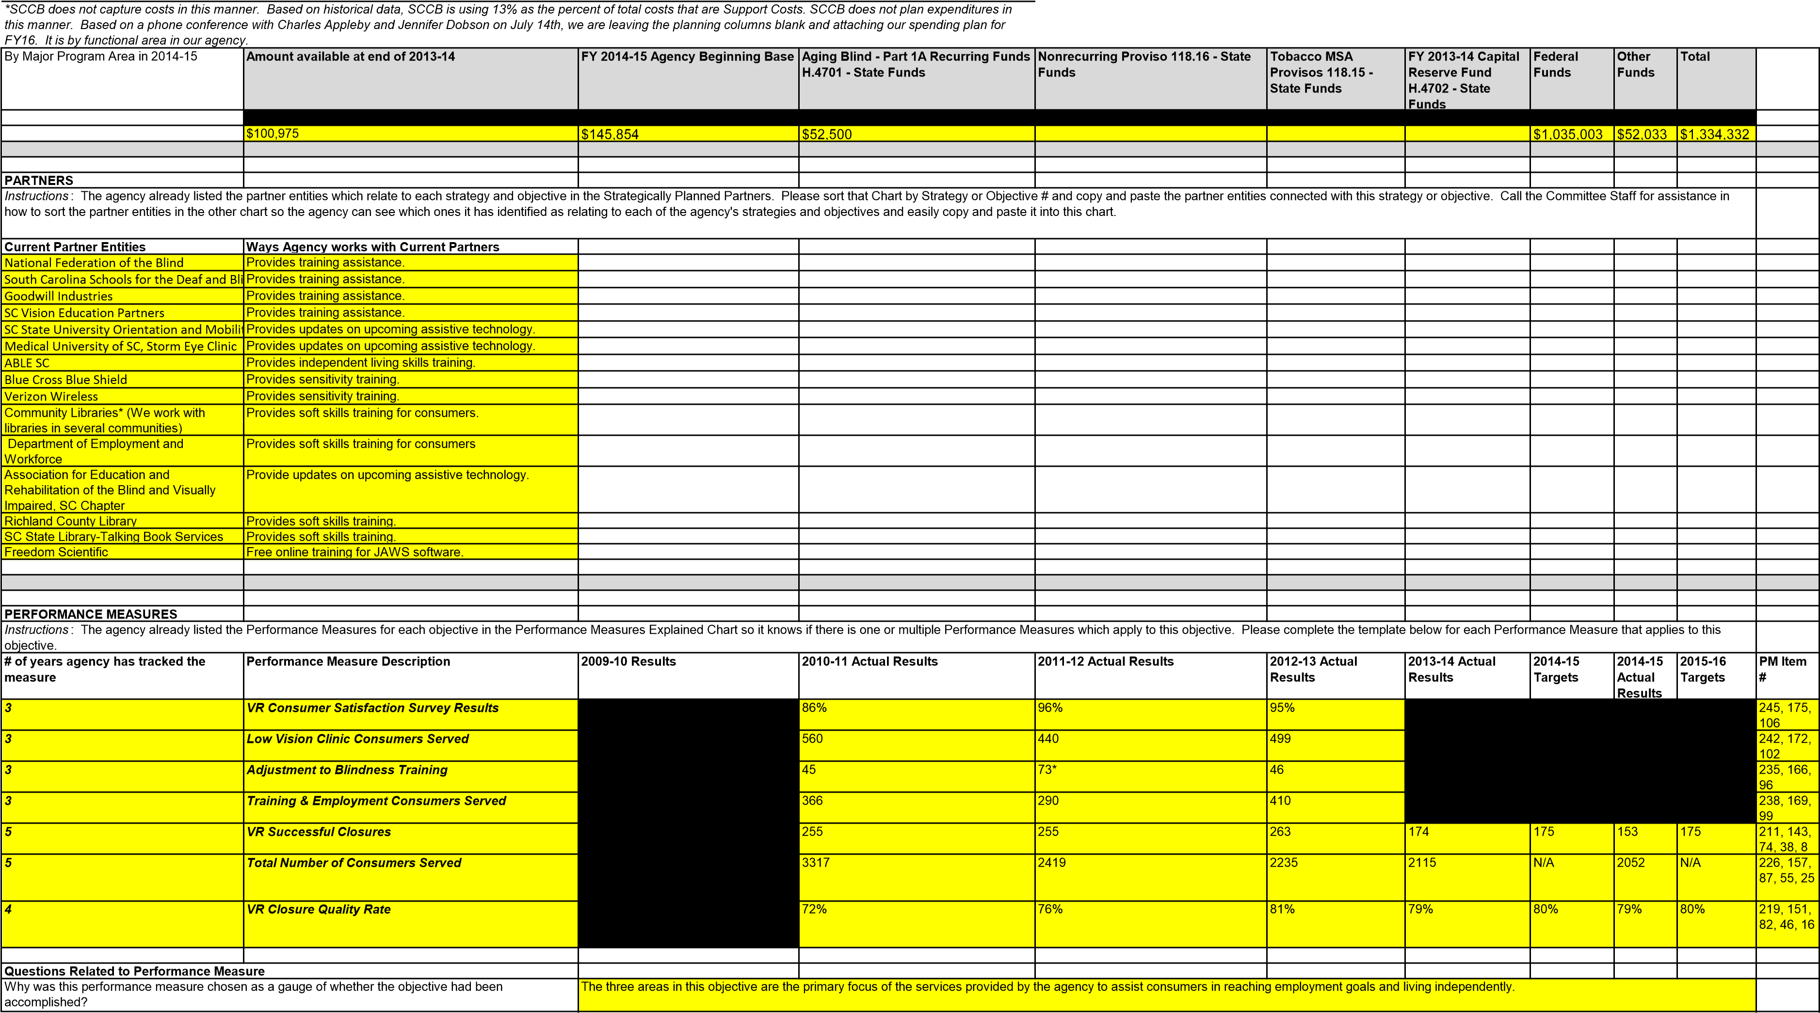

Reasoning for 2014-15 Target Value? |  | To comply with RSA standards.
Was 2014-15 Target a standard target, moderate challenge or a stretch challenge? |  | standard target
Reasoning for missing 2014-15 Target Value, if missed? |  | Vacancies within the agency.
Work being done to improve deficiencies? |  | Vacancies are being filled with qualified candidates as quickly as possible.
Reasoning for 2015-16 Target Value? |  | With vacancies filled it is projected that SCCB will increase consumers served and successful closures.
Is the 2014-15 Target a standard target, moderate challenge or a stretch challenge? |  | standard target
Provide the names of employees who are responsible for…
Comparison of actual performance to target value |  | Shana Robinson
Determination of whether corrective action is necessary (key objectives of correction are: (1) to remove defects, in many cases this is worker-controllable; (2) to remove the causes of defects, this may be worker or management controllable; (3) to attain a new state of process performance, one that will prevent defects from happening; and (4) to maintain or enhance the efficiency and effectiveness of the process, which is an essential condition for continuing process improvement and ultimately increasing  the competitiveness and profitability of the business itself) |  | Kyle Walker, Edward Bible, Rhonda Thompson
Making any changes needed to ensure the target value is reached |  | Kyle Walker, Edward Bible, Rhonda Thompson
 | Names and Titles of individuals who set this as a performance measure |  |  | James Kirby, Commissioner; Edward Bible, Director of Training & Employment; Rhonda Thompson, Director of Older Blind, Children's Services, and Low Vision Clinics; Shana Robinson, Director of Quality
REVIEWS/AUDITS
Instructions: The agency already listed the potential negative impacts which relate to each strategy and objective in the Potential Negative Impact Chart. Please sort that Chart by Strategy or Objective # and copy and paste the negative impacts which relate or impact this strategy or objective. Call the Committee Staff for assistance in how to sort the negative impacts in the other chart so the agency can see which ones it has identified as relating to each of the agency's strategies and objectives and easily copy and paste it into this chart.
Matter(s) or Issue(s) Under Review | Reason Review was Initiated (outside request, internal policy, etc.) | Was Reviewing Entity External or Internal? | Entity Performing the Review | Date Review Began (MM/DD/YYYY) | Date Review Ended  (MM/DD/YYYY)
Vocational Rehab Grant | Single Audit Act of 1996 | External | SAO | 7/27/2014 | 3/16/2015
Vocational Rehab Grant | Single Audit Act of 1996 | External | SAO |  | 7/27/2014
Vocational Rehab Grant | Single Audit Act of 1996 | External | SAO |  | 6/16/2013
Vocational Rehab Grant | Single Audit Act of 1996 | External | SAO |  | 5/24/2012
Review of HR Exception Procedures | Internal Policy | External | Budget & Control Board |  | 11/10/2014
POTENTIAL NEGATIVE IMPACT
Instructions: The agency already listed the potential negative impacts which relate to each strategy and objective in the Potential Negative Impact Chart. Please sort that Chart by Strategy or Objective # and copy and paste the negative impacts which relate or impact this strategy or objective. Call the Committee Staff for assistance in how to sort the negative impacts in the other chart so the agency can see which ones it has identified as relating to each of the agency's strategies and objectives and easily copy and paste it into this chart.
Most Potential Negative Impact | 3 G.A. Options | Level Requires Outside Help | Outside Help to Request | Level Requires Inform G.A.
Without this training, a person with visual impairments is unable to obtain employment that matches their skill level and is often unable to live at home alone, thus creating the burden on families, communities, and government programs to support the individual. | 1. Consider additional funds for creation of job readiness training sites. 2. Consider additional funds for upgrading and obtaining the most up to date A.T. devices. 3. Consider legislation that encourages and incentivises South Carolina businesses to hire persons who are blind or visually impaired. | When SCCB can no longer provide all of the necessary services to a person experiencing a visual impairment. | SCCB would need to reach out to community agencies for training assistance. | When there is no assistance forthcoming from community agencies and consumer needs cannot be met by SCCB.
LAWS AS BASIS
Instructions: The agency already listed the Laws which support each strategy and objective in the Strategic Plan-Laws as Basis Chart. Please sort that Chart by Strategy or Objective # and copy and paste the laws which relate or impact this strategy or objective. Call the Committee Staff for assistance in how to sort the laws in the other chart so the agency can see which ones it has identified as relating to or impacting each of the agency's strategies and objectives and easily copy and paste it into this chart.
Statute, Regulation, Proviso | Summary of Statutory Requirement and/or Authority Granted
361.13 (a) Title I, Part B | Under the State Vocational Rehabilitation Services Program (Program), the Secretary provides grants to assist States in operating statewide comprehensive, coordinated, effective, efficient, and accountable programs, each of which is—  - An integral part of a statewide workforce investment system; and  - Designed to assess, plan, develop, and provide vocational rehabilitation services for individuals with disabilities, consistent with their strengths, resources, priorities, concerns, abilities, capabilities, interests, and informed choice, so that they may prepare for and engage in gainful employment.  (Authority: Section 100(a)(2) of the Act; 29 U.S.C. 720(a)(2))
LAWS TO FURTHER EVALUATE
Instructions: The agency already listed the Laws to further evaluate in the Laws to Further Evaluate Chart. Please sort that Chart by Strategy or Objective # and copy and paste the laws which relate or impact this strategy or objective which the agency recommended the Committee further evaluate. Call the Committee Staff for assistance in how to sort the laws in the other chart so the agency can see which ones it has identified as relating to or impacting each of the agency's strategies and objectives and easily copy and paste it into this chart.
Statute/Regulation/Provisos | Summary of Statutory Requirement and/or Authority Granted | Law Item # | Recommend Further Evaluation (Yes or leave blank) | Basis for Further Evaluation
N/A

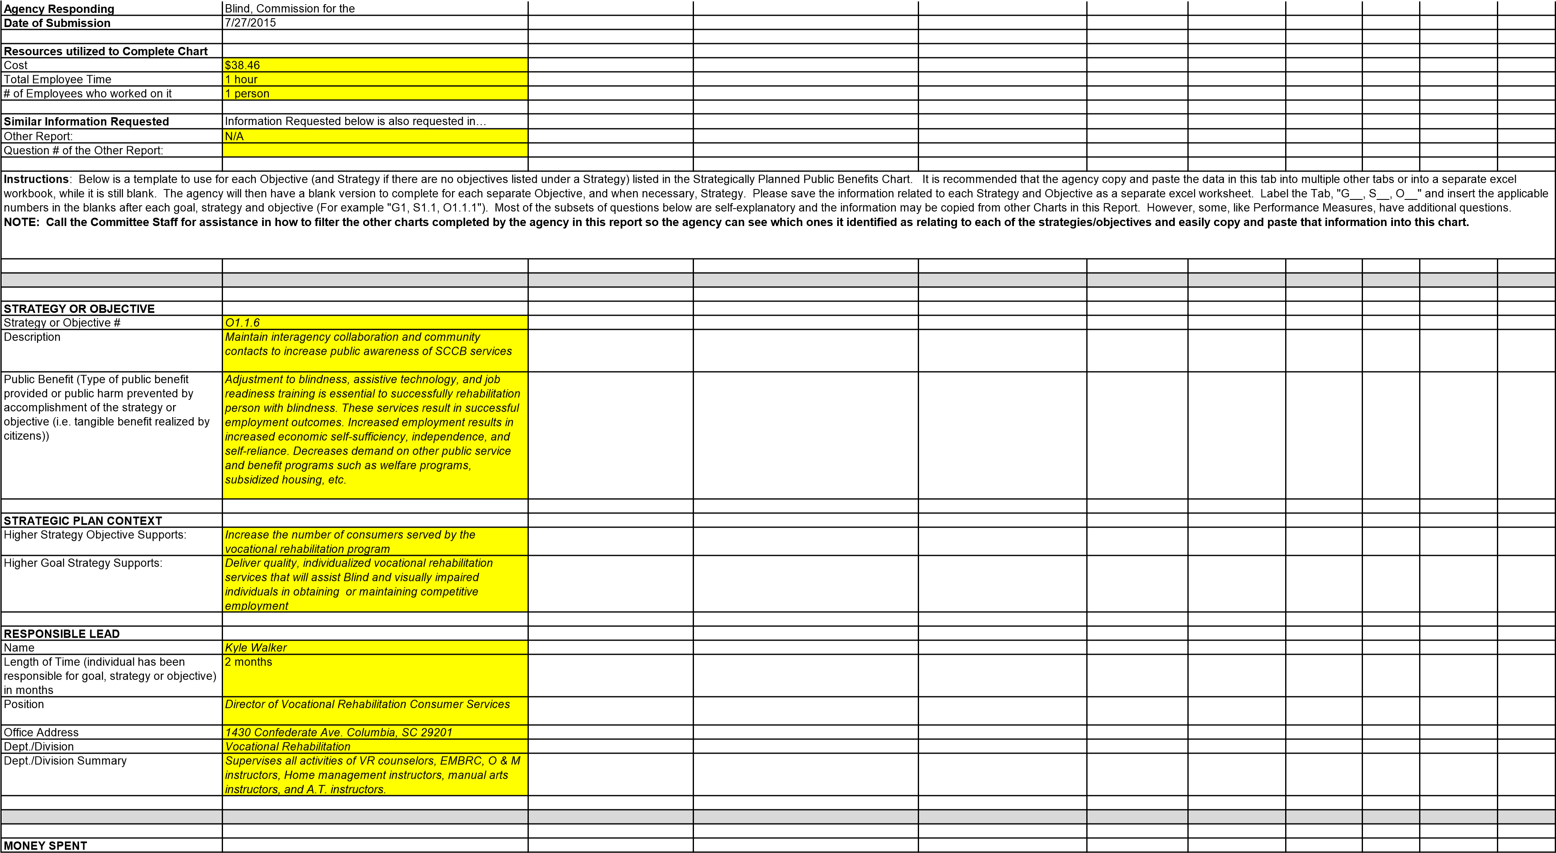
Type of Cost | Cost Includes | 2013-14 Actual | 2014-15 Planned* | 2014-15 Actual | 2015-16 Planned*
Support Costs Apportioned | Administration | 133,443 |  | 131,593
Direct Costs of Results | Costs to achieve objective | 893,043 |  | 880,658
Total Costs of Results |  | 1,026,486 |  | 1,012,251
*SCCB does not capture costs in this manner. Based on historical data, SCCB is using 13% as the percent of total costs that are Support Costs. SCCB does not plan expenditures in this manner. Based on a phone conference with Charles Appleby and Jennifer Dobson on July 14th, we are leaving the planning columns blank and attaching our spending plan for FY16. It is by functional area in our agency.
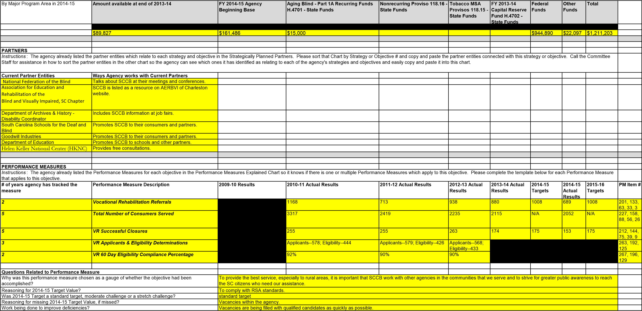
REVIEWS/AUDITS
Matter(s) or Issue(s) Under Review
Reason Review was Initiated
(outside request, internal
policy, etc.)
Was Reviewing Entity
External or Internal?
Entity Performing the Review
Date Review Began
MM/DD/YYYY
)
(
Date Review
Ended
MM/DD/YYYY
(
)
Vocational Rehab Grant
Single Audit Act of 1996
External
SAO
7/27/2014
3/16/2015
Vocational Rehab Grant
Single Audit Act of 1996
External
SAO
7/27/2014
Vocational Rehab Grant
Single Audit Act of 1996
External
SAO
6/16/2013
Vocational Rehab Grant
Single Audit Act of 1996
External
SAO
5/24/2012
Review of HR Exception Procedures
Internal Policy
External
Budget & Control Board
11/10/2014
POTENTIAL NEGATIVE IMPACT
Most Potential Negative Impact
3
G.A. Options
Level Requires Outside Help
Outside Help to Request
Level Requires Inform G.A.
Without strong interagency collaboration
and contacts that increase the public
awareness of SCCB, blind and visually
impaired citizens may not achieve
employment, independence, and self-
sufficiency resulting in stress on families,
communities, and other government
programs.
. Consider additional funding for a public awareness
1
campaign designed to increase the public's awareness of
SCCB. 2. Consider legislation that encourages interagency
collaboration and partnerships to facilitate coordinated
service provision. 3. Consider legislation that would require
state funded public technical and community colleges to
partner with SCCB in the development of short term
demand driven training programs that result in jobs for
blind individuals.
When SCCB is unable to
respond to citizens with visual
impairments due to lack of
resources it would be time to
reach out for assistance.
The first step would be to contact other
state agencies who serve persons with
disabilities. Next would be to contact non-
profit and nearby agencies who might also
offer assistance. Last would be to contact
larger agencies such as Lions Club or
Helen Keller National Center to request
assistance.
When no outside assistance
can be found and funding does
not exist for SCCB to expand
services to help all citizens with
visual impairments in the state
of SC.
When no outside
assistance can be
found and funding
does not exist for
SCCB to expand
services to help all
citizens with visual
impairments in the
state of SC.
LAWS AS BASIS
Statute, Regulation, Proviso
Summary of Statutory Requirement and/or Authority
Granted
361.13 (a)
Title I, Part B
Instructions
the Commit
tee Staff for
s which relate or imp
ve # and copy and paste the law
Please sort that Chart by Strategy or Objecti
tegic Plan-Laws as Basis Chart.
e Laws which support each strategy and objective in the Stra
The agency already listed th
act this strategy or
:
objective. Call
easily copy and paste it into this
her chart so the agency can see which ones it has identified
assistance in how to sort the laws in the ot
f the agency's strategies and objectives and
chart.
as relating to or impacting each o
Making any changes needed to ensure the target value is reached
Kyle Walker, Edward Bible, Rhonda Thompson
Names and Titles of individuals who set this as a performance measure
James Kirby, Commissioner; Edward Bible, Director of Training & Employment; Rhonda Thompson, Director of Older Blind, Children's Services, and Low Vision Clinics; Kyle Walker,
Instructions
d objective in the Potential Negat
e potential negative impacts which relate to each strategy an
y or objective.
this strateg
elate or impact
ve impacts which r
and paste the negati
Strategy or Objective # and copy
ive Impact Chart. Please sort that Chart by
The agency already listed th
:
nto this chart.
y copy and paste it i
rategies and objectives and easil
entified as relating to each of the agency's st
ncy can see which ones it has id
how to sort the negative impacts in the other chart so the age
Call the Committee Staff for assistance in
Instructions
ve impacts which r
:
and paste the negati
The agency already listed th
e potential negative impacts which relate to each strategy an
d objective in the Potential Negat
ive Impact Chart. Please sort that Chart by
y or objective.
this strateg
Strategy or Objective # and copy
elate or impact
entified as relating to each of the agency's st
Call the Committee Staff for assistance in
how to sort the negative impacts in the other chart so the age
ncy can see which ones it has id
rategies and objectives and easil
y copy and paste it i
nto this chart.
Under the State Vocational Rehabilitation Services Program (Program), the Secretary
provides grants to assist States in operating statewide comprehensive, coordinated,
effective, efficient, and accountable programs, each of which is—
(
a) An integral part of a statewide workforce investment system; and
b) Designed to assess, plan, develop, and provide vocational rehabilitation services for
(
individuals with disabilities, consistent with their strengths, resources, priorities, concerns,
abilities, capabilities, interests, and informed choice, so that they may prepare for and
engage in gainful employment.
(
Authority: Section 100(a)(2) of the Act; 29 U.S.C.
720(a)(2))
Provide the names of employees who are responsible for…
Comparison of actual performance to target value
Shana Robinson
Determination of whether corrective action is necessary (key objectives of correction are: (1) to remove

defects, in many cases this is worker-controllable; (2) to remove the causes of defects, this may be

worker or management controllable; (3) to attain a new state of process performance, one that will
prevent defects from happening; and (4) to maintain or enhance the efficiency and effectiveness of the

process, which is an essential condition for continuing process improvement and ultimately increasing
the competitiveness and profitability of the business itself)
Kyle Walker, Edward Bible, Rhonda Thompson
Reasoning for 2015-16 Target Value?
With vacancies filled it is projected that referrals will increase which will also provide an increase in services and closures.
Is the 2014-15 Target a standard target, moderate challenge or a stretch challenge?
standard target

LAWS TO FURTHER EVALUATE
Instructions: The agency already listed the Laws to further evaluate in the Laws to Further Evaluate Chart. Please sort that Chart by Strategy or Objective # and copy and paste the laws which relate or impact this strategy or objective which the agency recommended the Committee further evaluate. Call the Committee Staff for assistance in how to sort the laws in the other chart so the agency can see which ones it has identified as relating to or impacting each of the agency's strategies and objectives and easily copy and paste it into this chart.
Statute/Regulation/Provisos | Summary of Statutory Requirement and/or Authority Granted | Law Item # | Recommend Further Evaluation (Yes or leave blank) | Basis for Further Evaluation
N/A

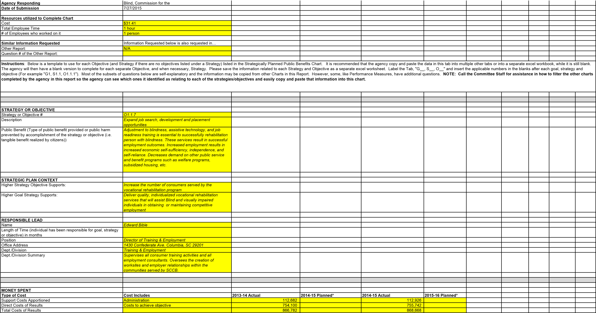
*SCCB does not capture costs in this manner. Based on historical data, SCCB is using 13% as the percent of total costs that are Support Costs. SCCB does not plan expenditures in this manner. Based on a phone conference with Charles Appleby and Jennifer Dobson on July 14th, we are leaving the planning columns blank and attaching our spending plan for FY16. It is by functional area in our agency.

By Major Program Area in 2014-15 | Amount available at end of 2013-14 | FY 2014-15 Agency Beginning Base | Aging Blind - Part 1A  Recurring Funds H.4701 - State  Funds | Nonrecurring Proviso 118.16 - State Funds | Tobacco MSA  Provisos 118.15 - State Funds | FY 2013-14  Capital Reserve  Fund H.4702 -  State Funds | Federal  Funds | Other Funds | Total
 | $77,008 | $143,699 | $0 |  |  |  | $825,580 | $11,016 | $1,046,287
PARTNERS
Instructions: The agency already listed the partner entities which relate to each strategy and objective in the Strategically Planned Partners. Please sort that Chart by Strategy or Objective # and copy and paste the partner entities connected with this strategy or objective. Call the Committee Staff for assistance in how to sort the partner entities in the other chart so the agency can see which ones it has identified as relating to each of the agency's strategies and objectives and easily copy and paste it into this chart.
Current Partner Entities | Ways Agency works with Current Partners
Goodwill Industries | Offers job placement assistance.
Blue Cross Blue Shield | OJT and placement opportunities.
Verizon Wireless | OJT and placement opportunities.
Office of Federal Contract Compliance Programs | Provides information and contacts for federal job placement opportunities.
Department of Employment and Workforce | Job placement assistance
National Employment Team (NET)-South East Region | Job placement assistance
Medical University of SC, Storm Eye Clinic | internships
SC State Museum | internships
South Carolina Vocational Rehabilitation Department | Job placement assistance
McKissick Museum/Library | Job placement assistance
USC-Thomas Cooper Library | Job placement assistance
Association for Education and Rehabilitation of the Blind and  Visually Impaired, SC Chapter | Job placement assistance
SC State University Assistive Technology Program--USC School of Medicine | internships
Anderson Mayors Committee | Job placement assistance
Richland- Columbia Mayor’s Committee on Employment of  People with Disabilities | Job placement assistance
SC Governor’s Committee | Job placement assistance
Spartanburg Mayor Committee | Job placement assistance
Summerville Mayor’s Committee | Job placement assistance
American Red Cross -Non-Profit | internships
United Way 211-Non Profit | internships
VA Hospital -Non Profit | Job placement assistance
Harvest Hope Food Bank -Non Profit | internships
Richland County Library | Job search
SC State Library-Talking Book Services | internships
Greater Charleston Call Center Alliance-Division of Charleston  Chamber of Commerce | Job placement assistance
SC Liaison Industrial Group | Job placement assistance
PERFORMANCE MEASURES

Instructions: The agency already listed the Performance Measures for each objective in the Performance Measures Explained Chart so it knows if there is one or multiple Performance Measures which apply to this objective. Please complete the template below for each Performance Measure that applies to this objective.
# of years agency has tracked the measure | Performance Measure Description | 2009-10 Results | 2010-11 Actual Results | 2011-12 Actual Results | 2012-13 Actual  Results | 2013-14 Actual  Results | 2014-15  Targets | 2014-15  Actual  Results | 2015-16  Targets | PM Item #
3 | Training & Employment Consumers Served |  | 366 | 290 | 410 |  |  |  |  | 239, 170,  100
3 | VR Consumer Satisfaction Survey Results |  | 86% | 96% | 95% |  |  |  |  | 246, 176,  107
5 | VR Successful Closures |  | 255 | 255 | 263 | 174 | 175 | 153 | 175 | 213, 145,  76, 40, 10
4 | VR Closure Quality Rate |  | 72% | 76% | 81% | 79% | 80% | 79% | 80% | 220, 152,  83, 47, 17
1 | Vocational Rehabilitation Placements by Occupation |  | Professional (26%),  Clerical/Sales (22%), Service  (30%), Agricultural (2%),  Processing (3%), Machine  Trades (2%), Benchwork (3%),  Structural (6%), Miscellaneous  (6%) | Professional (13%),  Clerical/Sales (17%), Service  (18%), Agricultural (4%),  Processing (4%), Machine  Trades (2%), Benchwork (5%),  Structural (7%), Miscellaneous  (27%) | Professional (17%),  Clerical/Sales (19%),  Service (25%),  Agricultural (5%),  Processing (0%),  Machine Trades (3%),  Benchwork (1%),  Structural (5%),  Miscellaneous (25%) |  |  |  |  | 232, 163,  93
Questions Related to Performance Measure
Why was this performance measure chosen as a gauge of whether the objective had been accomplished? |  | These measures show the number of consumers who were placed in employment, the type of employment, and consumer satisfaction with services received.
Reasoning for 2014-15 Target Value? |  | To comply with RSA standards.
Was 2014-15 Target a standard target, moderate challenge or a stretch challenge? Reasoning for missing 2014-15 Target Value, if missed? |  | standard target  Vacancies within the agency.
Work being done to improve deficiencies? Reasoning for 2015-16 Target Value? |  | Vacancies are being filled with qualified candidates as quickly as possible.  With vacancies filled it is projected that SCCB will received more referrals which will result in a higher number of quality closures.
Is the 2014-15 Target a standard target, moderate challenge or a stretch challenge?  Provide the names of employees who are responsible for… |  | standard target
Comparison of actual performance to target value |  | Shana Robinson
Determination of whether corrective action is necessary (key objectives of correction are: (1) to remove defects, in many cases this is worker-controllable; (2) to remove the causes of defects, this may be worker or management controllable; (3) to attain a new state of process performance, one that will prevent defects from happening; and (4) to maintain or enhance the efficiency and effectiveness of the process, which is an essential condition for continuing process improvement and ultimately increasing  the competitiveness and profitability of the business itself) |  | Edward Bible, Kyle Walker
Making any changes needed to ensure the target value is reached |  | Edward Bible, Kyle Walker
Names an | d Titles of individuals who set this as a performance measure | James Kirby, Commissioner; Edward | Bible, Director of Training & Empl | oyment; Kyle Walker, Director of V | R Consumer Services
REVIEWS/AUDITS
Instructions: The agency already listed the potential negative impacts which relate to each strategy and objective in the Potential Negative Impact Chart. Please sort that Chart by Strategy or Objective # and copy and paste the negative impacts which relate or impact this strategy or objective. Call the Committee Staff for assistance in how to sort the negative impacts in the other chart so the agency can see which ones it has identified as relating to each of the agency's strategies and objectives and easily copy and paste it into this chart.
Matter(s) or Issue(s) Under Review | Reason Review was Initiated (outside request, internal policy, etc.) | Was Reviewing Entity External or Internal? | Entity Performing the Review | Date Review Began (MM/DD/YYYY) | Date Review Ended  (MM/DD/YYYY)
Vocational Rehab Grant | Single Audit Act of 1996 | External | SAO | 7/27/2014 | 3/16/2015
Vocational Rehab Grant | Single Audit Act of 1996 | External | SAO |  | 7/27/2014
Vocational Rehab Grant | Single Audit Act of 1996 | External | SAO |  | 6/16/2013
Vocational Rehab Grant | Single Audit Act of 1996 | External | SAO |  | 5/24/2012
Review of HR Exception Procedures | Internal Policy | External | Budget & Control Board |  | 11/10/2014
POTENTIAL NEGATIVE IMPACT
Instructions: The agency already listed the potential negative impacts which relate to each strategy and objective in the Potential Negative Impact Chart. Please sort that Chart by Strategy or Objective # and copy and paste the negative impacts which relate or impact this strategy or objective. Call the Committee Staff for assistance in how to sort the negative impacts in the other chart so the agency can see which ones it has identified as relating to each of the agency's strategies and objectives and easily copy and paste it into this chart.
Most Potential Negative Impact | 3 G.A. Options | Level Requires Outside Help | Outside Help to Request | Level Requires Inform G.A.
Without job search, job development, and job placement resources
available, SCCB is unable to effectively connect job ready blind
consumers with job vacancies. This limits the number of
consumers who achieve quality employment outcomes and reach
independence and self-sufficiency. Citizens who are blind are
forced to become dependent on other government programs,
community charities, or their families.
1
. Consider additional funds for creation of job readiness
training sites. 2. Consider additional funds for SCCB to hire
and expand Job Placement and Job Coaching staff. 3.
Consider legislation that encourages and incentivises South

Carolina businesses to hire persons who are blind or
visually impaired.
When employers refuse to hire blind
consumers no matter how many
services SCCB provides or how
much training is offered.
SCCB would reach out to local
employment agencies and
businesses to develop
opportunties for consumers.
When SCCB has exhausted all
efforts to create opportunities with
businesses.
LAWS AS BASIS
Statute, Regulation, Proviso
Summary of Statutory Requirement and/or Authority
Granted
361.13 (a)
Title I, Part B
LAWS TO FURTHER EVALUATE
Statute/Regulation/Provisos
Summary of Statutory Requirement and/or Authority
Granted
Law Item #
Recommend Further
Evaluation
(
Yes or leave blank)
N/A
Instructions
egy or Objective # and copy and p
ch strategy and objective in the Strategic Plan-Laws as Basis
The agency already listed the Laws which support ea
:
how to sort
sistance in
ttee Staff for as
ve. Call the Commi
t this strategy or objecti
aste the laws which relate or impac
Chart. Please sort that Chart by Strat
the laws in the other chart so the agency can see which ones it has
and paste it into this chart.
ategies and objectives and easily copy
identified as relating to or impacting each of the agency's str
Instructions
impact this strategy or objective which the agency recommended the Committee further evaluate. Call the Committee
and paste the laws which relate or
:
The agency already listed the Laws to further evaluat
e in the Laws to Further Evaluate Chart. Please sort that Cha
rt by Strategy or Objective # and copy
es and objectives and easily copy
mpacting each of the agency's strategi
Staff for assistance in how to sort the laws in the other chart so the
agency can see which ones it has identified as relating to or i
and paste it into this chart.
Basis for Further Evaluation
Under the State Vocational Rehabilitation Services Program
(Program), the Secretary provides
grants to assist States in operating statewide comprehensiv
e, coordinated, effective, efficient, and
accountable programs, each of which is—
em; and
a) An integral part of a statewide workforce investment syst
(
al rehabilitation services for
b) Designed to assess, plan, develop, and provide vocation
(
individuals with disabilities, consistent with their strengths, r
esources, priorities, concerns,
abilities, capabilities, interests, and informed choice, so that
they may prepare for and engage in
gainful employment.
(
Authority: Section 100(a)(2) of the Act; 29 U.S.C.
720(a)(2))
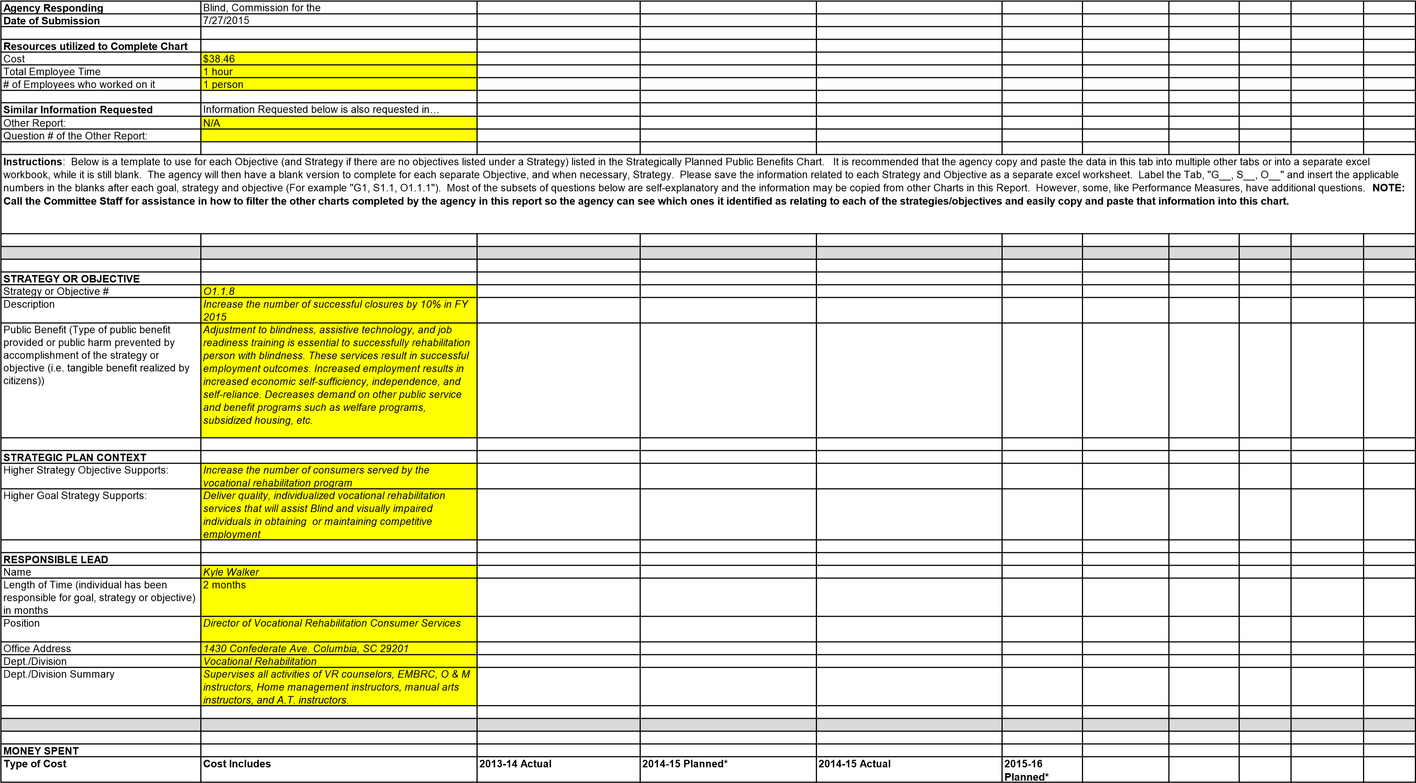
Support Costs Apportioned | Administration | 104,675 |  | 101,951
Direct Costs of Results | Costs to achieve objective | 700,516 |  | 682,290
Total Costs of Results |  | 805,191 |  | 784,241
*SCCB does not capture costs in this manner. Based on historical data, SCCB is using 13% as the percent of total costs that are Support Costs. SCCB does not plan expenditures in this manner. Based on a phone conference with Charles Appleby and Jennifer Dobson on July 14th, we are leaving the planning columns blank and attaching our spending plan for FY16. It is by functional area in our agency.
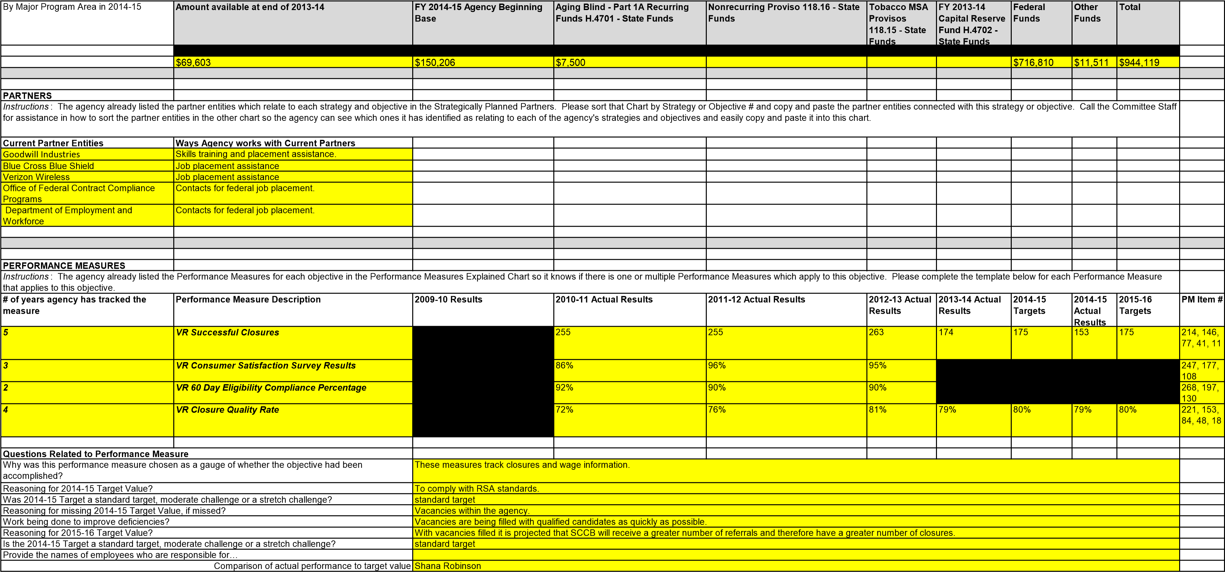
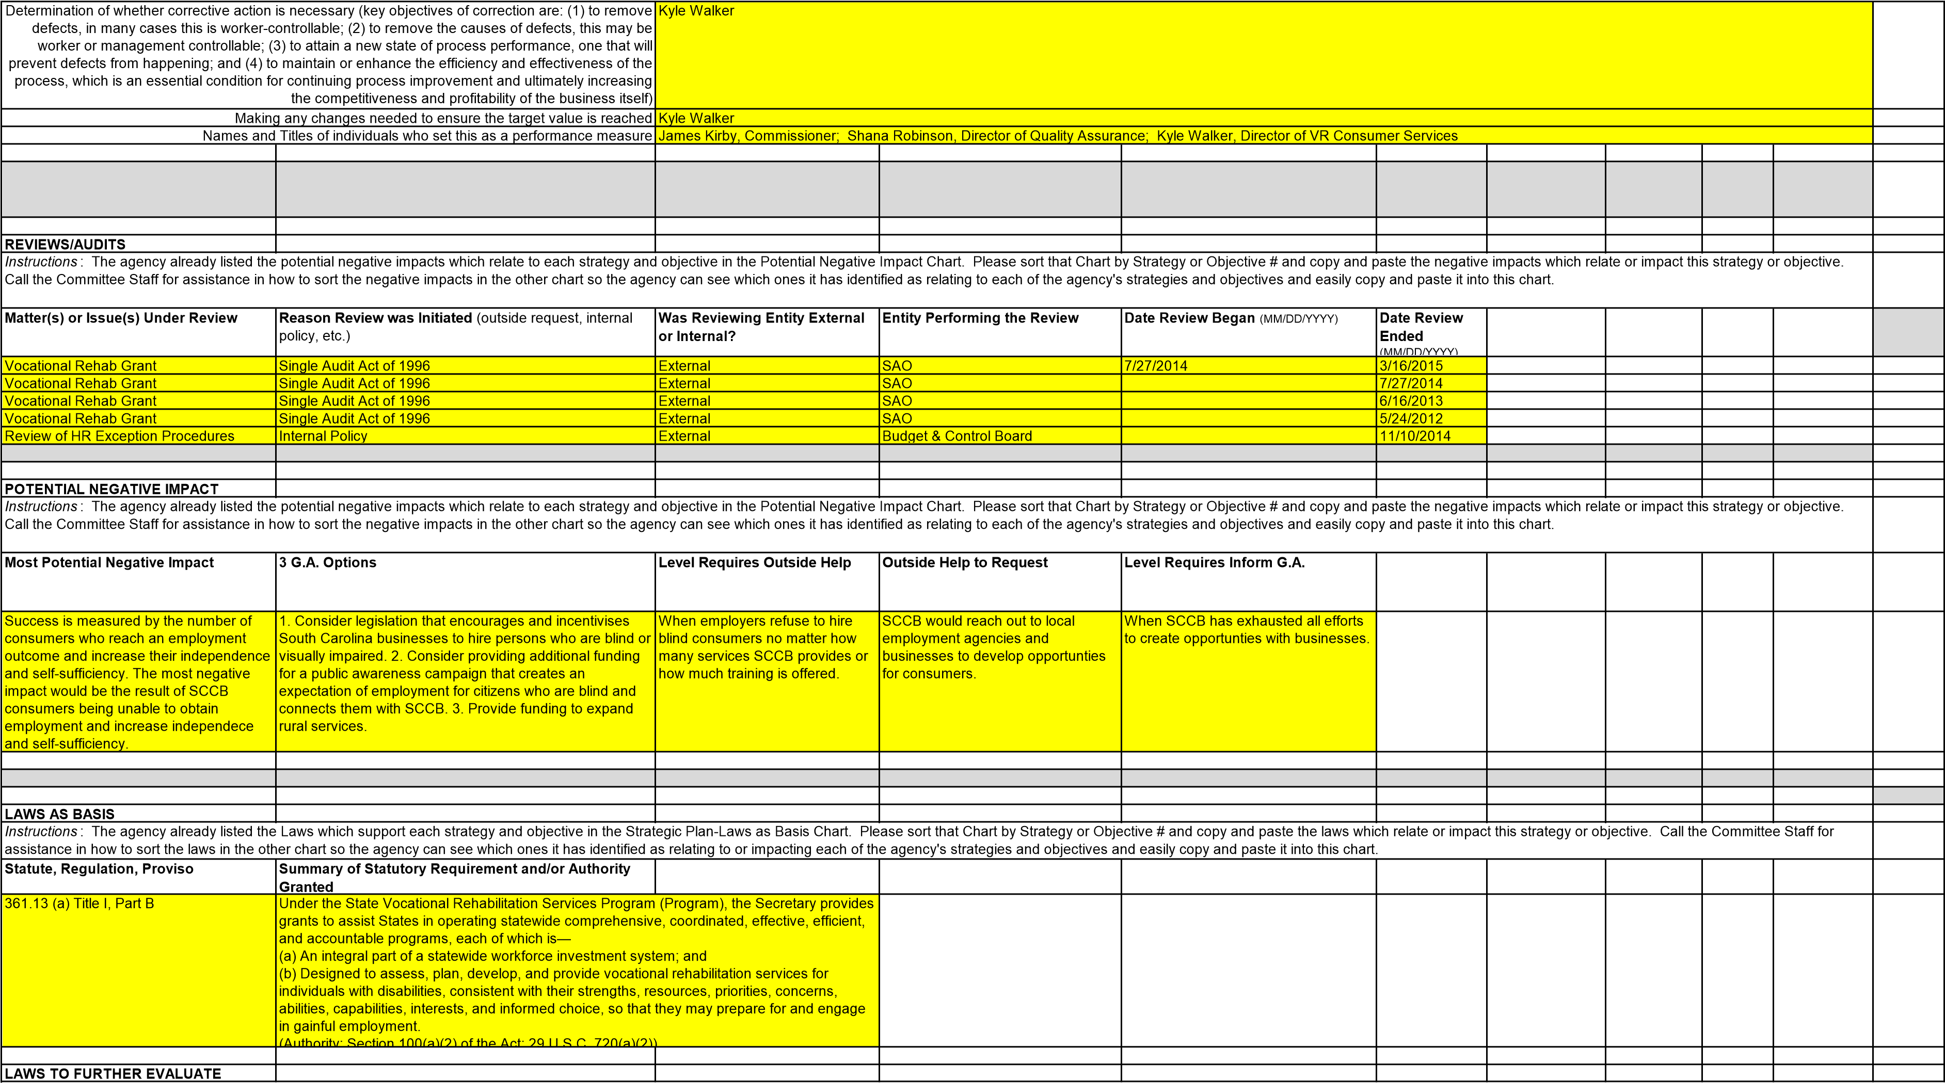

Instructions: The agency already listed the Laws to further evaluate in the Laws to Further Evaluate Chart. Please sort that Chart by Strategy or Objective # and copy and paste the laws which relate or impact this strategy or objective which the agency recommended the Committee further evaluate. Call the Committee Staff for assistance in how to sort the laws in the other chart so the agency can see which ones it has identified as relating to or impacting each of the agency's strategies and objectives and easily copy and paste it into this chart.
Statute/Regulation/Provisos | Summary of Statutory Requirement and/or Authority Granted | Law Item # | Recommend Further Evaluation (Yes or leave blank) | Basis for Further Evaluation
N/A

Agency Responding | Blind, Commission for the
Date of Submission | 7/27/2015
Resources utilized to Complete Chart
Cost | $38.46
Total Employee Time | 1 hour
# of Employees who worked on it | 1 person
Similar Information Requested Information Requested below is also requested in…
Other Report: | N/A
Question # of the Other Report:
Instructions: Below is a template to use for each Objective (and Strategy if there are no objectives listed under a Strategy) listed in the Strategically Planned Public Benefits Chart. It is recommended that the agency copy and paste the data in this tab into multiple other tabs or into a separate excel workbook, while it is still blank. The agency will then have a blank version to complete for each separate Objective, and when necessary, Strategy. Please save the information related to each Strategy and Objective as a separate excel worksheet. Label the Tab, "G__, S__, O__" and insert the applicable numbers in the blanks after each goal, strategy and objective (For example "G1, S1.1, O1.1.1"). Most of the subsets of questions below are self-explanatory and the information may be copied from other Charts in this Report. However, some, like Performance Measures, have additional questions. NOTE: Call the Committee Staff for assistance in how to filter the other charts completed by the agency in this report so the agency can see which ones it identified as relating to each of the strategies/objectives and easily copy and paste that information into this chart.

STRATEGY OR OBJECTIVE
Description | Maintain 80% of competitive employment placements at or above the minimum wage
Public Benefit (Type of public benefit provided or public harm prevented by accomplishment of the strategy or objective (i.e. tangible benefit realized by citizens)) | Adjustment to blindness, assistive technology, and job readiness training is essential to successfully rehabilitation person with blindness. These services result in successful employment outcomes. Increased employment results in increased economic self-sufficiency, independence, and self-reliance. Decreases demand on other public service and benefit programs such as welfare programs, subsidized housing, etc.
Strategy or Objective # O1.1.9
STRATEGIC PLAN CONTEXT
Higher Strategy Objective Supports: | Increase the number of consumers served by the vocational rehabilitation program art
Higher Goal Strategy Supports: | Deliver quality, individualized vocational rehabilitation services that will assist Blind and visually impaired individuals in obtaining or maintaining competitive employment
RESPONSIBLE LEAD
Length of Time (individual has been responsible for goal, strategy or objective) in months | 2 months
Position | Director of Vocational Rehabilitation Consumer Services
Office Address | 1430 Confederate Ave. Columbia, SC 29201
Dept./Division | Vocational Rehabilitation
Dept./Division Summary | Supervises all activities of VR counselors, EMBRC, O & M instructors, Home management instructors, manual arts instructors, and A.T. instructors.
Name Kyle Walker
MONEY SPENT
Type of Cost | Cost Includes | 2013-14 Actual | 2014-15 Planned* | 2014-15 Actual | 2015-16 Planned*
Support Costs Apportioned | Administration | 69,500 |  | 71,999
Direct Costs of Results | Costs to achieve objective | 465,112 |  | 481,839
Total Costs of Results 534,612 553,838
*SCCB does not capture costs in this manner. Based on historical data, SCCB is using 13% as the percent of total costs that are Support Costs. SCCB does not plan expenditures in this manner. Based on a phone conference with Charles Appleby and Jennifer Dobson on July 14th, we are leaving the planning columns blank and attaching our spending plan for FY16. It is by functional area in our agency.
By Major Program Area in 2014-15 | Amount available at end of 2013-14 | FY 2014-15 Agency Beginning Base | Aging Blind - Part 1A Recurring Funds H.4701 - State Funds | Nonrecurring Proviso 118.16 - State Funds | Tobacco MSA Provisos 118.15 - State Funds | FY 2013-14  Capital Reserve  Fund H.4702 -  State Funds | Federal Funds | Other Funds | Total
 | $48,819 | $78,703 | $0 |  |  |  | $519,654 | $23,097 | $647,176
PARTNERS
Instructions: The agency already listed the partner entities which relate to each strategy and objective in the Strategically Planned Partners. Please sort that Chart by Strategy or Objective # and copy and paste the partner entities connected with this strategy or objective. Call the Committee Staff for assistance in how to sort the partner entities in the other chart so the agency can see which ones it has identified as relating to each of the agency's strategies and objectives and easily copy and paste it into this chart.
Current Partner Entities | Ways Agency works with Current Partners
Goodwill Industries | Training and placement
Blue Cross Blue Shield | Placement
Verizon Wireless | Placement
Office of Federal Contract Compliance  Programs | Provides information on companies with federal contracts who must meet the
National Federation of the Blind | Offers IDL training to rural and underserved areas which allows consumers the opportunity to maintain employment.
Social Security Administration/Work Incen | Provides work incentives to encourage employment for t consumers.
Copy and Paste from Strategically Planned Partners Chart | Copy and Paste from Strategically Planned Partners Chart

PERFORMANCE MEASURES
Instructions: The agency already listed the Performance Measures for each objective in the Performance Measures Explained Chart so it knows if there is one or multiple Performance Measures which apply to this objective. Please complete the template below for each Performance Measure that applies to this objective.
# of years agency has tracked the measure | Performance Measure Description | 2009-10 Results | 2010-11 Actual Results | 2011-12 Actual Results | 2012-13 Actual Results | 2013-14 Actual  Results | 2014-15  Targets | 2014-15  Actual  Results | 2015-16  Targets | PM Item #
4 | VR Closure Quality Rate |  | 72% | 76% | 81% | 79% | 80% | 79% | 80% | 222, 154,  85, 49, 19
5 | VR Successful Closures |  | 255 | 255 | 263 | 174 | 175 | 153 | 175 | 215, 147,  78, 42, 12
3 | Vocational Rehabilitation Placements by Occupation |  | Professional (26%), Clerical/Sales (22%), Service (30%), Agricultural  (2%), Processing (3%), Machine  Trades (2%), Benchwork (3%),  Structural (6%), Miscellaneous (6%) | Professional (13%), Clerical/Sales (17%), Service (18%), Agricultural  (4%), Processing (4%), Machine  Trades (2%), Benchwork (5%),  Structural (7%), Miscellaneous (27%) | Professional (17%), Clerical/Sales (19%), Service (25%), Agricultural  (5%), Processing (0%), Machine  Trades (3%), Benchwork (1%),  Structural (5%), Miscellaneous (25%) |  |  |  |  | 233, 164,  94
3 | VR Consumer Satisfaction Survey Results |  | 86% | 96% | 95% |  |  |  |  | 248, 178,  109
3 | SC Average Earnings vs. Blind Licensed Vendor Average Earnings |  | SC Average Earnings of $33,163 compared to Blind Licensed Vendor Average Earnings of $30,909 - Vendor Earnings were 7% higher than SC Average Earnings | SC Average Earnings of $36,637 compared to Blind Licensed Vendor Average Earnings of $36,106 - Vendor Earnings were 1.4% lower than SC Average Earnings | SC Average Earnings of $38,700 compared to Blind Licensed Vendor Average Earnings of $41,423 - Vendor Earnings were 7% higher than  SC Average Earnings |  |  |  |  | 240, 171,  101
Questions Related to Performance Measure
Why was this performance measure chosen as a gauge of whether the objective had been accomplished? | These measures track closures and wage information.
Reasoning for 2014-15 Target Value? | To comply with RSA standards.
Was 2014-15 Target a standard target, moderate challenge or a stretch challenge? Reasoning for missing 2014-15 Target Value, if missed? | standard target  Vacancies within the agency.
Work being done to improve deficiencies? Vacancies are being filled with qualified candidates as quickly as possible.
Reasoning for 2015-16 Target Value? | With vacancies filled it is projected that SCCB will receive a greater number of referrals and therefore have a greater number of closures.
Is the 2014-15 Target a standard target, moderate challenge or a stretch challenge? | standard target
Provide the names of employees who are responsible for…
Comparison of actual performance to target value | Shana Robinson
Determination of whether corrective action is necessary (key objectives of correction are: (1) to remove defects, in many cases this is worker-controllable; (2) to remove the causes of defects, this may be worker or management controllable; (3) to attain a new state of process performance, one that will prevent defects from happening; and (4) to maintain or enhance the efficiency and effectiveness of the process, which is an essential condition for continuing process improvement and ultimately increasing  the competitiveness and profitability of the business itself) | Kyle Walker
Making any changes needed to ensure the target value is reached | Kyle Walker
Names and Titles of individuals who set this as a performance measure James Kirby, Commissioner; Shana Robinson, Director of Quality Assurance; Kyle Walker, Director of VR Consumer Services

REVIEWS/AUDITS
Instructions: The agency already listed the potential negative impacts which relate to each strategy and objective in the Potential Negative Impact Chart. Please sort that Chart by Strategy or Objective # and copy and paste the negative impacts which relate or impact this strategy or objective. Call the Committee Staff for assistance in how to sort the negative impacts in the other chart so the agency can see which ones it has identified as relating to each of the agency's strategies and objectives and easily copy and paste it into this chart.
Matter(s) or Issue(s) Under Review | Reason Review was Initiated (outside request, internal policy, etc.) | Was Reviewing Entity External or Internal? | Entity Performing the Review | Date Review Began (MM/DD/YYYY) | Date Review Ended (MM/DD/YYYY)
Vocational Rehab Grant | Single Audit Act of 1996 | External | SAO | 7/27/2014 | 3/16/2015
Vocational Rehab Grant | Single Audit Act of 1996 | External | SAO |  | 7/27/2014
Vocational Rehab Grant | Single Audit Act of 1996 | External | SAO |  | 6/16/2013
Vocational Rehab Grant | Single Audit Act of 1996 | External | SAO |  | 5/24/2012
Review of HR Exception Procedures | Internal Policy | External | Budget & Control Board |  | 11/10/2014
POTENTIAL NEGATIVE IMPACT
Instructions: The agency already listed the potential negative impacts which relate to each strategy and objective in the Potential Negative Impact Chart. Please sort that Chart by Strategy or Objective # and copy and paste the negative impacts which relate or impact this strategy or objective. Call the Committee Staff for assistance in how to sort the negative impacts in the other chart so the agency can see which ones it has identified as relating to each of the agency's strategies and objectives and easily copy and paste it into this chart.
Most Potential Negative Impact | 3 G.A. Options | Level Requires Outside Help | Outside Help to Request | Level Requires Inform G.A.
If SCCB is unable to assist blind consumers in obtaining quality employment at or above the minimum wage, consumers will continue to be dependent on families, charities, and/or other government welfare programs. They will not maximize their independence and self-sufficiency. | 1. Consider legislation that encourages and incentivises South Carolina businesses to hire persons who are blind or visually impaired. 2. Consider legislation making it against state labor laws to pay less than minimum wage to any employee doing the same job as someone making minimum wage or higher in the same workplace. 3. Consider legislation that would make state government agencies model employers of qualified blind individuals by creating an expedited hiring process for blind individuals who meet the minimum qualifications for state vacancies.  (Utah & California Model) | When employers refuse to hire, or competitively compensate blind consumers no matter how many services SCCB provides or how much training is offered. | SCCB would reach out to local employment agencies and businesses to develop opportunities for consumers. | When SCCB has exhausted all efforts to create opportunities and businesses within the communities of SC will not respond.

LAWS AS BASIS
Instructions: The agency already listed the Laws which support each strategy and objective in the Strategic Plan-Laws as Basis Chart. Please sort that Chart by Strategy or Objective # and copy and paste the laws which relate or impact this strategy or objective. Call the Committee Staff for assistance in how to sort the laws in the other chart so the agency can see which ones it has identified as relating to or impacting each of the agency's strategies and objectives and easily copy and paste it into this chart.
Statute, Regulation, Proviso | Summary of Statutory Requirement and/or Authority Granted
361.13 (a) Title I, Part B | Under the State Vocational Rehabilitation Services Program (Program), the Secretary provides grants to assist States in operating statewide comprehensive, coordinated, effective, efficient, and accountable programs, each of which is— (a) An integral part of a statewide workforce investment system; and  (b) Designed to assess, plan, develop, and provide vocational rehabilitation services for individuals with disabilities, consistent with their strengths, resources, priorities, concerns, abilities, capabilities, interests, and informed choice, so that they may prepare for and engage in gainful employment.
(Authority: Section 100(a)(2) of the Act; 29 U.S.C. 720(a)(2))
LAWS TO FURTHER EVALUATE
Instructions: The agency already listed the Laws to further evaluate in the Laws to Further Evaluate Chart. Please sort that Chart by Strategy or Objective # and copy and paste the laws which relate or impact this strategy or objective which the agency recommended the Committee further evaluate. Call the Committee Staff for assistance in how to sort the laws in the other chart so the agency can see which ones it has identified as relating to or impacting each of the agency's strategies and objectives and easily copy and paste it into this chart.
Statute/Regulation/Provisos | Summary of Statutory Requirement and/or Authority Granted | Law Item # | Recommend Further Evaluation (Yes or leave blank) | Basis for Further Evaluation
N/A

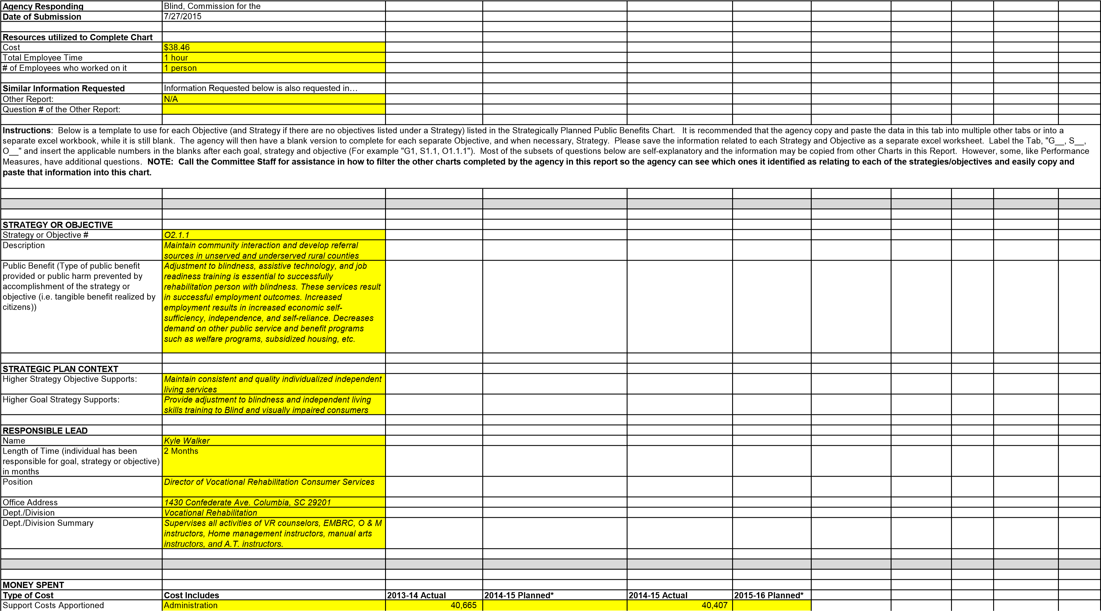
Direct Costs of Results | Costs to achieve objective | 272,143 |  | 270,416
Total Costs of Results |  | 312,808 |  | 310,823
*SCCB does not capture costs in this manner. Based on historical data, SCCB is using 13% as the percent of total costs that are Support Costs. SCCB does not plan expenditures in this manner. Based on a phone conference with Charles Appleby and Jennifer Dobson on July 14th, we are leaving the planning columns blank and attaching our spending plan for FY16. It is by functional area in our agency.
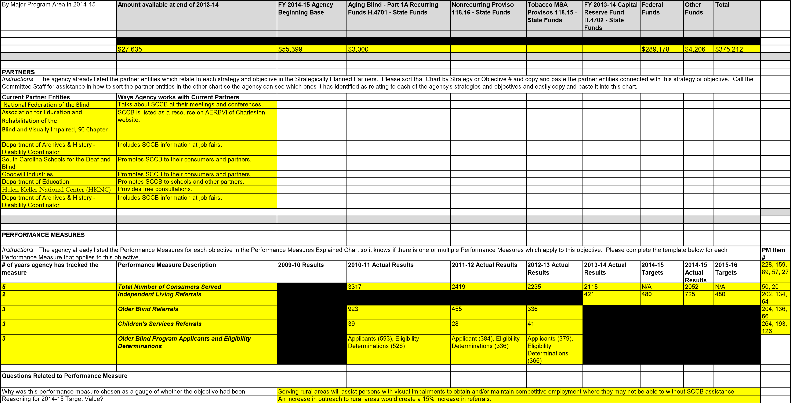
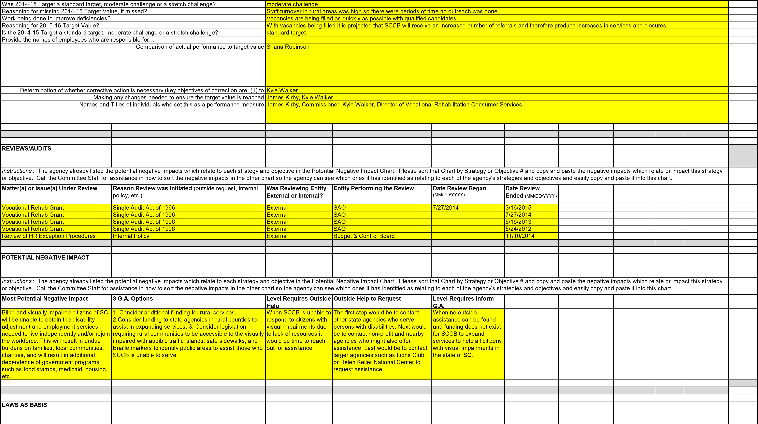

Instructions: The agency already listed the Laws which support each strategy and objective in the Strategic Plan-Laws as Basis Chart. Please sort that Chart by Strategy or Objective # and copy and paste the laws which relate or impact this strategy or objective. Call the Committee Staff for assistance in how to sort the laws in the other chart so the agency can see which ones it has identified as relating to or impacting each of the agency's strategies and objectives and easily copy and paste it into this chart.
Statute, Regulation, Proviso | Summary of Statutory Requirement and/or Authority Granted
361.13 (a) Title I, Part B | Under the State Vocational Rehabilitation Services Program (Program), the  Secretary provides grants to assist States in operating statewide comprehensive, coordinated, effective, efficient, and accountable programs, each of which is—  - An integral part of a statewide workforce investment system; and  - Designed to assess, plan, develop, and provide vocational rehabilitation services for individuals with disabilities, consistent with their strengths, resources, priorities, concerns, abilities, capabilities, interests, and informed choice, so that they may prepare for and engage in gainful employment.  (Authority: Section 100(a)(2) of the Act; 29 U.S.C. 720(a)(2))
34 CFR Part 367 | This program supports projects that (a) Provide any of the independent living (IL) services to older individuals who are blind that are described in §367.3(b); (b) Conduct activities that will improve or expand services for these individuals; and (c) Conduct activities to help improve public understanding of the problems of these individuals. (Authority: 29 U.S.C. 796k(a) and (b))
Chapter 6.1, Section 71-296 1966) | Provides services to legally blind children between the ages of three and thirteen. The goal of the Children’s Services Program is to assist legally blind children and their families with adjustment to blindness, achievement of educational goals and the development of their maximum personal growth.
LAWS TO FURTHER EVALUATE
Instructions: The agency already listed the Laws to further evaluate in the Laws to Further Evaluate Chart. Please sort that Chart by Strategy or Objective # and copy and paste the laws which relate or impact this strategy or objective which the agency recommended the
Committee further evaluate. Call the Committee Staff for assistance in how to sort the laws in the other chart so the agency can see which ones it has identified as relating to or impacting each of the agency's strategies and objectives and easily copy and paste it into this chart.
Statute/Regulation/Provisos | Summary of Statutory Requirement and/or Authority Granted | Law Item # | Recommend Further Evaluation (Yes or leave blank) | Basis for Further Evaluation
N/A

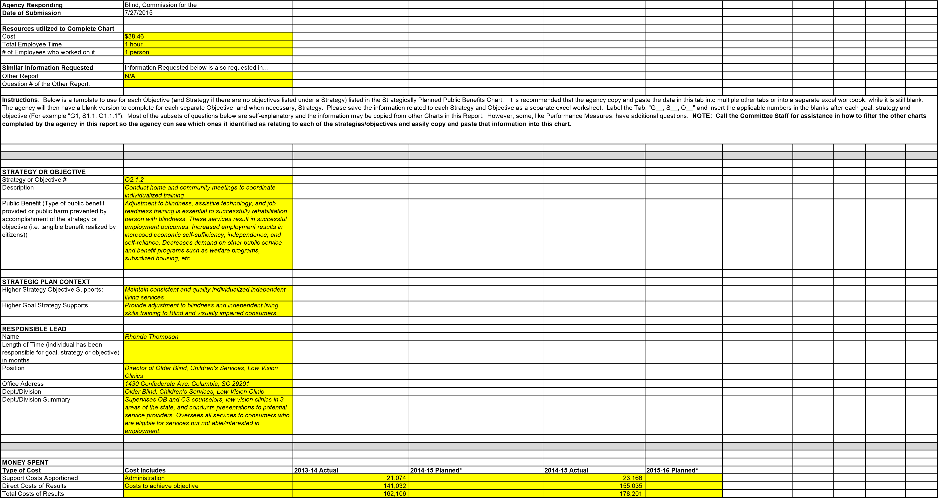
*SCCB does not capture costs in this manner. Based on historical data, SCCB is using 13% as the percent of total costs that are Support Costs. SCCB does not plan expenditures in this manner. Based on a phone conference with Charles Appleby and Jennifer Dobson on July 14th, we are leaving the planning columns blank and attaching our spending plan for FY16. It is by functional area in our agency.
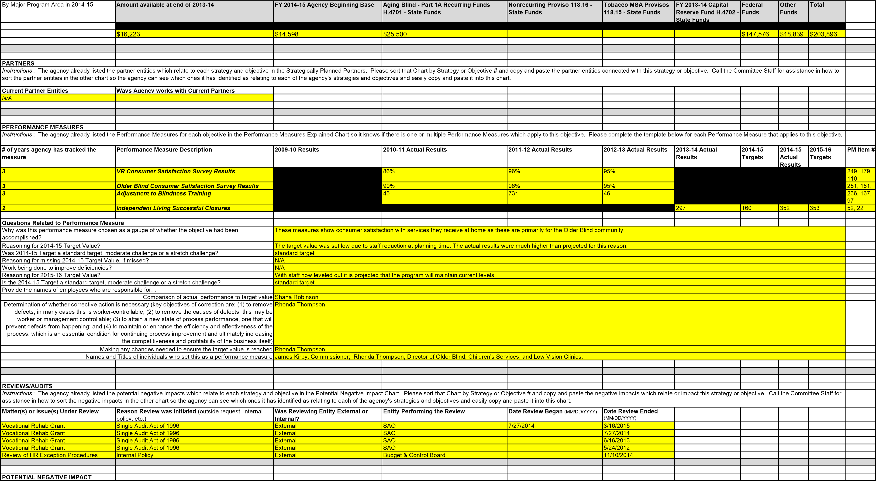
Instructions: The agency already listed the potential negative impacts which relate to each strategy and objective in the Potential Negative Impact Chart. Please sort that Chart by Strategy or Objective # and copy and paste the negative impacts which relate or impact this strategy or objective. Call the Committee Staff for assistance in how to sort the negative impacts in the other chart so the agency can see which ones it has identified as relating to each of the agency's strategies and objectives and easily copy and paste it into this chart.
Most Potential Negative Impact | 3 G.A. Options | Level Requires Outside Help | Outside Help to Request | Level Requires Inform G.A.
Without home and community meetings it would not be possible to determine the needs of consumers and individualized training could not happen. This would leave consumers unable to maintain their independence and place greater burdens on their communities and families. | 1. Consider additional funding for rural services. 2. Consider funding to state agencies in rural counties to assist in expanding services. 3. Consider legislation requiring rural communities to be accessible to the visually impaired with audible traffic islands, safe sidewalks, and Braille markers to identify public areas to assist those who SCCB is unable to serve. | When SCCB is unable to respond to citizens with visual impairments due to lack of resources it would be time to reach out for assistance. | The first step would be to contact other state agencies who serve persons with disabilities. Next would be to contact non-profit and nearby agencies who might also offer assistance. | When no outside assistance can be found and funding does not exist for SCCB to expand services to help all citizens with visual impairments in the state of SC.
LAWS AS BASIS
Instructions: The agency already listed the Laws which support each strategy and objective in the Strategic Plan-Laws as Basis Chart. Please sort that Chart by Strategy or Objective # and copy and paste the laws which relate or impact this strategy or objective. Call the Committee Staff for assistance in how to sort the laws in the other chart so the agency can see which ones it has identified as relating to or impacting each of the agency's strategies and objectives and easily copy and paste it into this chart.
Statute, Regulation, Proviso | Summary of Statutory Requirement and/or Authority Granted
361.13 (a) Title I, Part B | Under the State Vocational Rehabilitation Services Program (Program), the Secretary provides grants to assist States in operating statewide comprehensive, coordinated, effective, efficient, and accountable programs, each of which is—  - An integral part of a statewide workforce investment system; and  - Designed to assess, plan, develop, and provide vocational rehabilitation services for individuals with disabilities, consistent with their strengths, resources, priorities, concerns, abilities, capabilities, interests, and informed choice, so that they may prepare for and engage in gainful employment.  (Authority: Section 100(a)(2) of the Act; 29 U.S.C. 720(a)(2))
34 CFR Part 367 | This program supports projects that (a) Provide any of the independent living (IL) services to older individuals who are blind that are described in §367.3(b); (b) Conduct activities that will improve or expand services for these individuals; and (c) Conduct activities to help improve public understanding of the problems of these individuals. (Authority: 29 U.S.C. 796k(a) and (b))
Chapter 6.1, Section 71-296 1966) | Provides services to legally blind children between the ages of three and thirteen. The goal of the Children’s Services Program is to assist legally blind children and their families with adjustment to blindness, achievement of educational goals and the development of their maximum personal growth.
LAWS TO FURTHER EVALUATE
Instructions: The agency already listed the Laws to further evaluate in the Laws to Further Evaluate Chart. Please sort that Chart by Strategy or Objective # and copy and paste the laws which relate or impact this strategy or objective which the agency recommended the Committee further evaluate. Call the Committee Staff for assistance in how to sort the laws in the other chart so the agency can see which ones it has identified as relating to or impacting each of the agency's strategies and objectives and easily copy and paste it into this chart.
Statute/Regulation/Provisos | Summary of Statutory Requirement and/or Authority Granted | Law Item # | Recommend Further Evaluation (Yes or leave blank) | Basis for Further Evaluation
N/A

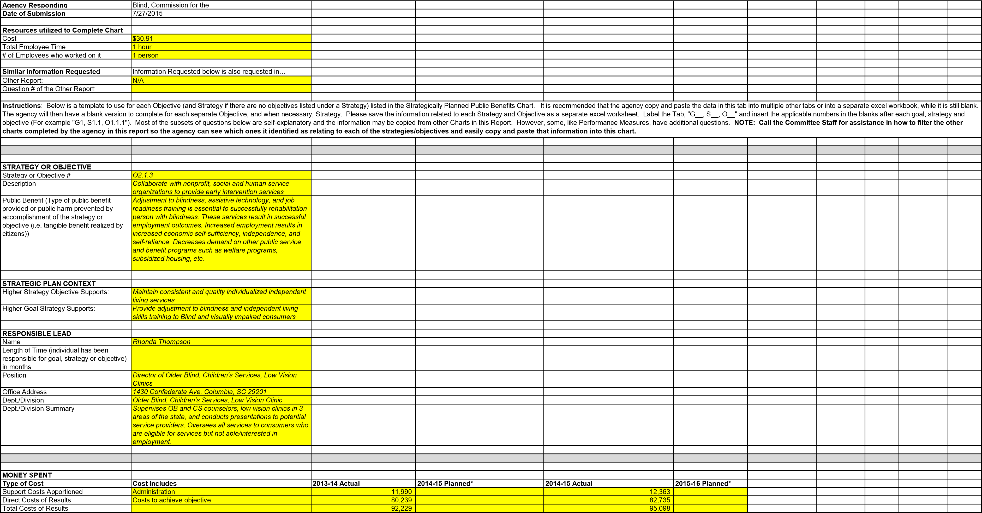
*SCCB does not capture costs in this manner. Based on historical data, SCCB is using 13% as the percent of total costs that are Support Costs. SCCB does not plan expenditures in this manner. Based on a phone conference with Charles Appleby and Jennifer Dobson on July 14th, we are leaving the planning columns blank and attaching our spending plan for FY16. It is by functional area in our agency.
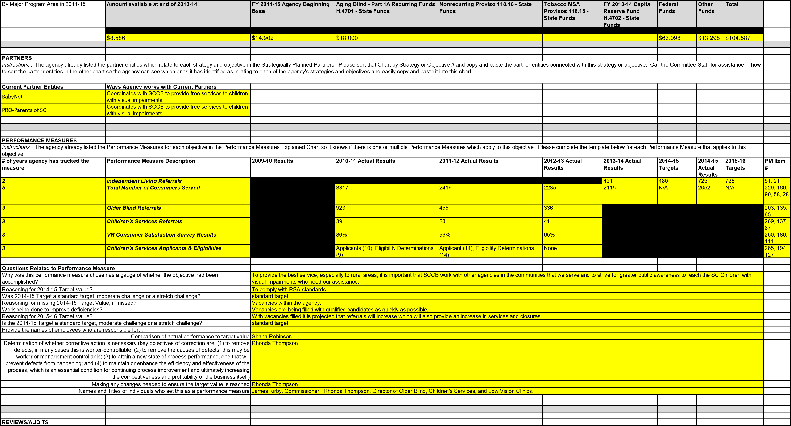
Instructions: The agency already listed the potential negative impacts which relate to each strategy and objective in the Potential Negative Impact Chart. Please sort that Chart by Strategy or Objective # and copy and paste the negative impacts which relate or impact this strategy or objective. Call the Committee Staff for assistance in how to sort the negative impacts in the other chart so the agency can see which ones it has identified as relating to each of the agency's strategies and objectives and easily copy and paste it into this chart.
Matter(s) or Issue(s) Under Review | Reason Review was Initiated (outside request, internal policy, etc.) | Was Reviewing Entity External or Internal? | Entity Performing the Review | Date Review Began (MM/DD/YYYY) | Date Review Ended  (MM/DD/YYYY)
Vocational Rehab Grant | Single Audit Act of 1996 | External | SAO | 7/27/2014 | 3/16/2015
Vocational Rehab Grant | Single Audit Act of 1996 | External | SAO |  | 7/27/2014
Vocational Rehab Grant | Single Audit Act of 1996 | External | SAO |  | 6/16/2013
Vocational Rehab Grant | Single Audit Act of 1996 | External | SAO |  | 5/24/2012
Review of HR Exception Procedures | Internal Policy | External | Budget & Control Board |  | 11/10/2014
POTENTIAL NEGATIVE IMPACT
Instructions: The agency already listed the potential negative impacts which relate to each strategy and objective in the Potential Negative Impact Chart. Please sort that Chart by Strategy or Objective # and copy and paste the negative impacts which relate or impact this strategy or objective. Call the Committee Staff for assistance in how to sort the negative impacts in the other chart so the agency can see which ones it has identified as relating to each of the agency's strategies and objectives and easily copy and paste it into this chart.
Most Potential Negative Impact | 3 G.A. Options | Level Requires Outside Help | Outside Help to Request | Level Requires Inform G.A.
Blind and visually impaired children would grow up without the tools they need to succeed in society and in school. This would leave children with a visual impairment totally dependent upon their families, communities, charities, and government welfare programs. It would also mean these children would not receive an appropriate education and would be unable to become contributing taxpayers or independent citizens. | 1. Consider additional funding for rural services. 2. Consider funding to state agencies in rural counties to assist in expanding services. 3. Consider legislation requiring rural communities to be accessible to the visually impaired with audible traffic islands, safe sidewalks, and Braille markers to identify public areas to assist those who SCCB is unable to serve. | When SCCB is unable to respond to citizens with visual impairments due to lack of resources it would be time to reach out for assistance. | The first step would be to contact other state agencies who serve persons with disabilities. Next would be to contact nonprofit and nearby agencies who might also offer assistance. Last would be to contact larger agencies such as the Helen Keller National Center to request assistance. | When no outside assistance can be found and funding does not exist for SCCB to expand services to help all citizens with visual impairments in the state of SC.
LAWS AS BASIS
Instructions: The agency already listed the Laws which support each strategy and objective in the Strategic Plan-Laws as Basis Chart. Please sort that Chart by Strategy or Objective # and copy and paste the laws which relate or impact this strategy or objective. Call the Committee Staff for assistance in how to sort the laws in the other chart so the agency can see which ones it has identified as relating to or impacting each of the agency's strategies and objectives and easily copy and paste it into this chart.
Statute, Regulation, Proviso | Summary of Statutory Requirement and/or Authority Granted
Chapter 6.1, Section 71-296 1966) | Provides services to legally blind children between the ages of three and thirteen. The goal of the Children’s Services Program is to assist legally blind children and their families with adjustment to blindness, achievement of educational goals and the development of their maximum personal growth.
LAWS TO FURTHER EVALUATE
Instructions: The agency already listed the Laws to further evaluate in the Laws to Further Evaluate Chart. Please sort that Chart by Strategy or Objective # and copy and paste the laws which relate or impact this strategy or objective which the agency recommended the Committee further evaluate. Call the Committee Staff for assistance in how to sort the laws in the other chart so the agency can see which ones it has identified as relating to or impacting each of the agency's strategies and objectives and easily copy and paste it into this chart.
Statute/Regulation/Provisos | Summary of Statutory Requirement and/or Authority Granted | Law Item # | Recommend Further Evaluation (Yes or leave blank) | Basis for Further Evaluation
N/A

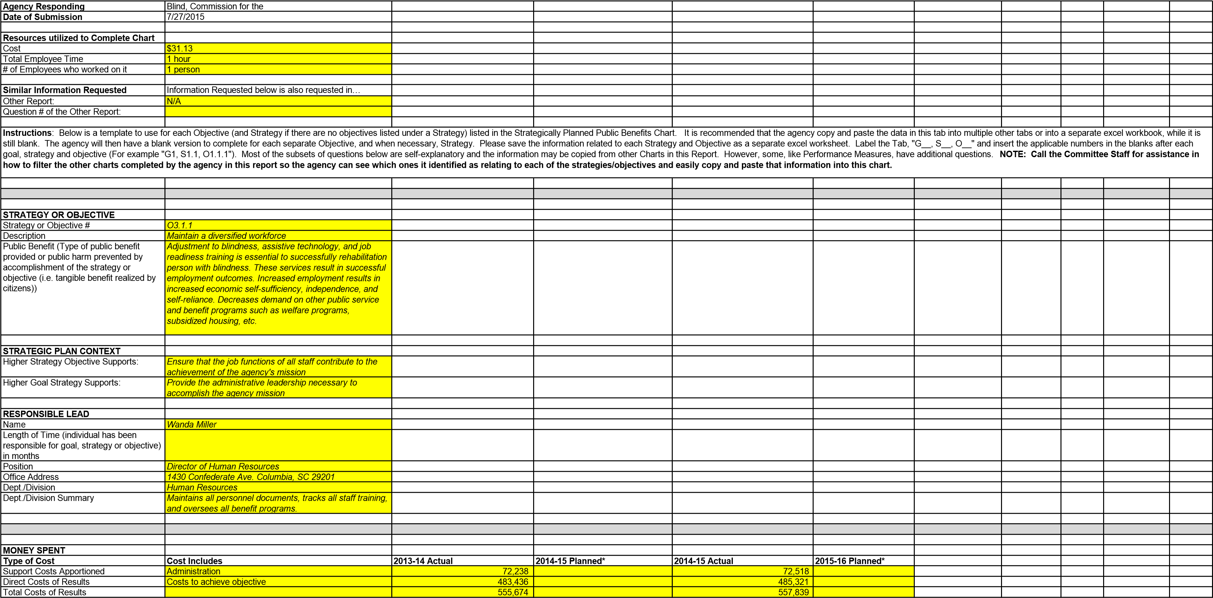
*SCCB does not capture costs in this manner. Based on historical data, SCCB is using 13% as the percent of total costs that are Support Costs. SCCB does not plan expenditures in this manner. Based on a phone conference with Charles Appleby and Jennifer Dobson on July 14th, we are leaving the planning columns blank and attaching our spending plan for FY16. It is by functional area in our agency.
By Major Program Area in 2014-15 | Amount available at end of 2013-14 | FY 2014-15 Agency Beginning Base | Aging Blind - Part 1A Recurring Funds H.4701 - State Funds | Nonrecurring Proviso 118.16 - State Funds | Tobacco MSA Provisos 118.15 - State Funds | FY 2013-14 Capital  Reserve Fund  H.4702 - State Funds | Federal  Funds | Other Funds | Total

 | $47,912 | $223,538 | $3,750 |  |  |  | $374,880 | $7,742 | $650,081
PARTNERS
Instructions: The agency already listed the partner entities which relate to each strategy and objective in the Strategically Planned Partners. Please sort that Chart by Strategy or Objective # and copy and paste the partner entities connected with this strategy or objective. Call the Committee Staff for assistance in how to sort the partner entities in the other chart so the agency can see which ones it has identified as relating to each of the agency's strategies and objectives and easily copy and paste it into this chart.
Current Partner Entities | Ways Agency works with Current Partners
indeed.com | Browse resumes and contact potential qualified candidates
State Ethics Commission | Provides ethical guidance through yearly activity reporting
SC Human Affairs | Provides consultative services and serves as a collecting house for workforce utilization data
SC Budget and Control Board | Provides consultative services on HR matters
Department of Homeland Security/E-Verify | Provides verification of eligibility and identify of hired individuals
Copy and Paste from Strategically Planned Partners Chart | Copy and Paste from Strategically Planned Partners Chart
PERFORMANCE MEASURES
Instructions: The agency already listed the Performance Measures for each objective in the Performance Measures Explained Chart so it knows if there is one or multiple Performance Measures which apply to this objective. Please complete the template below for each Performance Measure that applies to this objective.
# of years agency has tracked the measure | Performance Measure Description | 2009-10 Results | 2010-11 Actual Results | 2011-12 Actual Results | 2012-13 Actual Results | 2013-14 Actual  Results | 2014-15  Targets | 2014-15  Actual  Results | 2015-16  Targets | PM Item #
N/A
Questions Related to Performance Measure
Why was this performance measure chosen as a gauge of whether the objective had been accomplished? |  | N/A
Reasoning for 2014-15 Target Value? |  | N/A
Was 2014-15 Target a standard target, moderate challenge or a stretch challenge? Reasoning for missing 2014-15 Target Value, if missed? |  | N/A  N/A
Work being done to improve deficiencies? Reasoning for 2015-16 Target Value? |  | N/A  N/A
Is the 2014-15 Target a standard target, moderate challenge or a stretch challenge?  Provide the names of employees who are responsible for… |  | N/A
Comparison of actual performance to target value |  | N/A
Determination of whether corrective action is necessary (key objectives of correction are: (1) to remove defects, in many cases this is worker-controllable; (2) to remove the causes of defects, this may be worker or management controllable; (3) to attain a new state of process performance, one that will prevent defects from happening; and (4) to maintain or enhance the efficiency and effectiveness of the process, which is an essential condition for continuing process improvement and ultimately increasing  the competitiveness and profitability of the business itself) |  | Wanda Miller
Making any changes needed to ensure the target value is reached |  | Wanda Miller
Names an | d Titles of individuals who set this as a performance measure | James Kirby, Commissioner; Wanda | Miller, Director of Human Resources | ; Shana Robinson, Director of Quality | Assurance.
REVIEWS/AUDITS
Instructions: The agency already listed the potential negative impacts which relate to each strategy and objective in the Potential Negative Impact Chart. Please sort that Chart by Strategy or Objective # and copy and paste the negative impacts which relate or impact this strategy or objective. Call the Committee Staff for assistance in how to sort the negative impacts in the other chart so the agency can see which ones it has identified as relating to each of the agency's strategies and objectives and easily copy and paste it into this chart.
Matter(s) or Issue(s) Under Review | Reason Review was Initiated (outside request, internal policy, etc.) | Was Reviewing Entity External or Internal? | Entity Performing the Review | Date Review Began (MM/DD/YYYY) | Date Review Ended  (MM/DD/YYYY)
Vocational Rehab Grant | Single Audit Act of 1996 | External | SAO | 7/27/2014 | 3/16/2015
Vocational Rehab Grant | Single Audit Act of 1996 | External | SAO |  | 7/27/2014
Vocational Rehab Grant | Single Audit Act of 1996 | External | SAO |  | 6/16/2013
Vocational Rehab Grant | Single Audit Act of 1996 | External | SAO |  | 5/24/2012
Review of HR Exception Procedures | Internal Policy | External | Budget & Control Board |  | 11/10/2014
POTENTIAL NEGATIVE IMPACT
Instructions: The agency already listed the potential negative impacts which relate to each strategy and objective in the Potential Negative Impact Chart. Please sort that Chart by Strategy or Objective # and copy and paste the negative impacts which relate or impact this strategy or objective. Call the Committee Staff for assistance in how to sort the negative impacts in the other chart so the agency can see which ones it has identified as relating to each of the agency's strategies and objectives and easily copy and paste it into this chart.
Most Potential Negative Impact | 3 G.A. Options | Level Requires Outside Help | Outside Help to Request | Level Requires Inform G.A.
Without a diversified workforce the agency could be viewed as discriminatory, and would not benefit from a diversity of experience, thinking, and problem solving. SCCB would also not have a diversified cultural base in staff to meet the diversity of consumers. This would reduce the number of consumers served which would place that burden on the taxpayers and families. | - Consider additional funds to place more VR Counselors in the field and reduce caseload sizes in high need areas.  - Consider additional funding for SCCB to offer competitive salaries for highly trained and educated VR Counselors to encourage recruitment and retention. 3. Consider legislation that would make state government agencies model employers of qualified blind individuals by creating an expedited hiring process for blind individuals who meet the minimum qualifications for state vacancies.  (Utah & California Model) | When qualified candidates from a diverse background cannot be hired due to low pay, high caseloads, high travel time, and current counselors are unable to keep up with the demand due to the vacancies. | Contact local employment agencies and advertise vacancies anywhere possible in print and online. | When the agency can no longer hire  Or retain staff due to lack of responses to vacancy postings.
LAWS AS BASIS
Instructions: The agency already listed the Laws which support each strategy and objective in the Strategic Plan-Laws as Basis Chart. Please sort that Chart by Strategy or Objective # and copy and paste the laws which relate or impact this strategy or objective. Call the Committee Staff for assistance in how to sort the laws in the other chart so the agency can see which ones it has identified as relating to or impacting each of the agency's strategies and objectives and easily copy and paste it into this chart.
Statute, Regulation, Proviso | Summary of Statutory Requirement and/or Authority Granted
361.13 (a) Title I, Part B | Under the State Vocational Rehabilitation Services Program (Program), the Secretary provides grants to assist States in operating statewide comprehensive, coordinated, effective, efficient, and accountable programs, each of which is—  - An integral part of a statewide workforce investment system; and  - Designed to assess, plan, develop, and provide vocational rehabilitation services for individuals with disabilities, consistent with their strengths, resources, priorities, concerns, abilities, capabilities, interests, and informed choice, so that they may prepare for and engage in gainful employment.  (Authority: Section 100(a)(2) of the Act; 29 U.S.C. 720(a)(2))
LAWS TO FURTHER EVALUATE
Instructions: The agency already listed the Laws to further evaluate in the Laws to Further Evaluate Chart. Please sort that Chart by Strategy or Objective # and copy and paste the laws which relate or impact this strategy or objective which the agency recommended the Committee further evaluate. Call the Committee Staff for assistance in how to sort the laws in the other chart so the agency can see which ones it has identified as relating to or impacting each of the agency's strategies and objectives and easily copy and paste it into this chart.
Statute/Regulation/Provisos | Summary of Statutory Requirement and/or Authority Granted | Law Item # | Recommend Further Evaluation (Yes or leave blank) | Basis for Further Evaluation
N/A

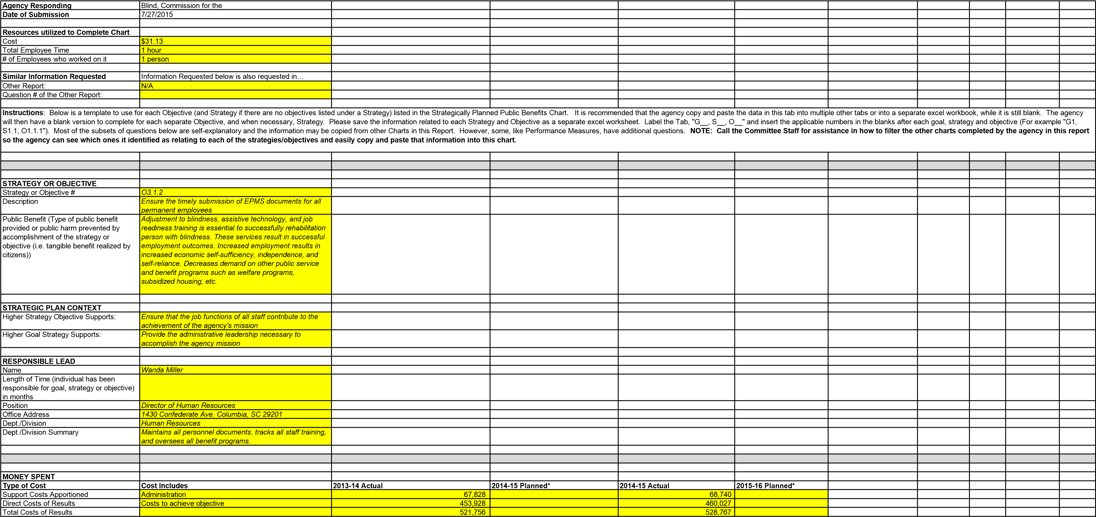
*SCCB does not capture costs in this manner. Based on historical data, SCCB is using 13% as the percent of total costs that are Support Costs. SCCB does not plan expenditures in this manner. Based on a phone conference with Charles Appleby and Jennifer Dobson on July 14th, we are leaving the planning columns blank and attaching our spending plan for FY16. It is by functional area in our agency.
By Major Program Area in 2014-15 | Amount available at end of 2013-14 | FY 2014-15 Agency Beginning Base | Aging Blind - Part 1A Recurring Funds H.4701 - State Funds | Nonrecurring Proviso 118.16 - State Funds | Tobacco MSA Provisos 118.15 - State Funds | FY 2013-14 Capital  Reserve Fund H.4702 - State Funds | Federal Funds | Other Funds | Total
 | $45,301 | $222,954 | $3,750 |  |  |  | $342,139 | $7,825 | $614,144

PARTNERS
Instructions: The agency already listed the partner entities which relate to each strategy and objective in the Strategically Planned Partners. Please sort that Chart by Strategy or Objective # and copy and paste the partner entities connected with this strategy or objective. Call the Committee Staff for assistance in how to sort the partner entities in the other chart so the agency can see which ones it has identified as relating to each of the agency's strategies and objectives and easily copy and paste it into this chart.
Current Partner Entities | Ways Agency works with Current Partners
N/A
PERFORMANCE MEASURES
Instructions: The agency already listed the Performance Measures for each objective in the Performance Measures Explained Chart so it knows if there is one or multiple Performance Measures which apply to this objective. Please complete the template below for each Performance Measure that applies to this objective.
# of years agency has tracked the measure | Performance Measure Description | 2009-10 Results | 2010-11 Actual Results | 2011-12 Actual Results | 2012-13 Actual Results | 2013-14 Actual Results | 2014-15  Targets | 2014-15  Actual  Results | 2015-16  Targets | PM Item #
3 | Workforce Engagement: EPMS |  | Exceptional Rating (43); Successful Rating (36) | Exceptional Rating (54); Successful Rating (35) | Exceptional Rating (47); Successful Rating (42) |  |  |  |  | 256, 186,  117
Questions Related to Performance Measure
Why was this performance measure chosen as a gauge of whether the objective had been accomplished? |  | This objective is no longer being measured.
Reasoning for 2014-15 Target Value? |  | N/A
Was 2014-15 Target a standard target, moderate challenge or a stretch challenge? Reasoning for missing 2014-15 Target Value, if missed? |  | N/A  N/A
Work being done to improve deficiencies? |  | N/A
Reasoning for 2015-16 Target Value? |  | N/A
Is the 2014-15 Target a standard target, moderate challenge or a stretch challenge?  Provide the names of employees who are responsible for… |  | N/A  N/A
Comparison of actual performance to target value |  | N/A
Determination of whether corrective action is necessary (key objectives of correction are: (1) to remove defects, in many cases this is worker-controllable; (2) to remove the causes of defects, this may be worker or management controllable; (3) to attain a new state of process performance, one that will prevent defects from happening; and (4) to maintain or enhance the efficiency and effectiveness of the process, which is an essential condition for continuing process improvement and ultimately increasing  the competitiveness and profitability of the business itself) |  | N/A
Making any changes needed to ensure the target value is reached |  | N/A
Names an | d Titles of individuals who set this as a performance measure | N/A
REVIEWS/AUDITS
Instructions: The agency already listed the potential negative impacts which relate to each strategy and objective in the Potential Negative Impact Chart. Please sort that Chart by Strategy or Objective # and copy and paste the negative impacts which relate or impact this strategy or objective. Call the Committee Staff for assistance in how to sort the negative impacts in the other chart so the agency can see which ones it has identified as relating to each of the agency's strategies and objectives and easily copy and paste it into this chart.
Matter(s) or Issue(s) Under Review | Reason Review was Initiated (outside request, internal policy, etc.) | Was Reviewing Entity External or Internal? | Entity Performing the Review | Date Review Began (MM/DD/YYYY) | Date Review Ended  (MM/DD/YYYY)
Vocational Rehab Grant | Single Audit Act of 1996 | External | SAO | 7/27/2014 | 3/16/2015
Vocational Rehab Grant | Single Audit Act of 1996 | External | SAO |  | 7/27/2014
Vocational Rehab Grant | Single Audit Act of 1996 | External | SAO |  | 6/16/2013
Vocational Rehab Grant | Single Audit Act of 1996 | External | SAO |  | 5/24/2012
Review of HR Exception Procedures | Internal Policy | External | Budget & Control Board |  | 11/10/2014
POTENTIAL NEGATIVE IMPACT
Instructions: The agency already listed the potential negative impacts which relate to each strategy and objective in the Potential Negative Impact Chart. Please sort that Chart by Strategy or Objective # and copy and paste the negative impacts which relate or impact this strategy or objective. Call the Committee Staff for assistance in how to sort the negative impacts in the other chart so the agency can see which ones it has identified as relating to each of the agency's strategies and objectives and easily copy and paste it into this chart.
Most Potential Negative Impact | 3 G.A. Options | Level Requires Outside Help | Outside Help to Request | Level Requires Inform G.A.
Failure to maintain employee performance standards and accountability would negatively affect SCCB's ability to meet its mandated mission, maintain high quality and effective services, and quality employment outcomes for blind citizens. | 1. Consider adjusting evaluation requirements so after the first year of service the employee changes to the state fiscal year and all permanent employees are reviewed once a year at the same time based on their program. (Each internal program is assigned a month for evaluations.) 2. Consider moving all state employee performance management tools to an internet based automated system such as SCEIS. 3. Consider funding for state agencies to obtain technical assistance on how to improve agency effectiveness and productivity through the design of impactful performance review tools. | When there is no longer any connection between an employee's performance plan and reviews and their contribution to the agency's mission, vision, and outcome measures. | There are no outside resources to assist with this situation. | When the agency can no longer hire or retain staff due to lack of responses to vacancy postings.
LAWS AS BASIS
Statute, Regulation, Proviso
Summary of Statutory Requirement and/or Authority
Granted
Title I, Part B
361.13 (a)
LAWS TO FURTHER EVALUATE
Statute/Regulation/Provisos
Summary of Statutory Requirement and/or Authority
Granted
Law Item #
Recommend Further Evaluation
Yes
(
or leave blank)
N/A
Instructions
ow to sort t
:
The agency already listed the
Laws which support each strategy and objective in the Strat
egic Plan-Laws as Basis Chart. Please sort that C
hart by Strategy or Objective # and copy
and paste the laws which relate or im
pact this strategy or objective
. Call the Committee Staff f
or assistance in h
he laws in the
d paste it into this chart.
ency's strategies and objectives and easily copy an
nes it has identified as relating to or impacting each of the ag
other chart so the agency can see which o
Instructions
e # and copy and paste the laws which re
late or impact this strategy or objective which the agency recommended the Committee further evaluate. Call the Committee Staff for
art. Please sort that Chart by Strategy or Objectiv
Laws to further evaluate in the Laws to Further Evaluate Ch
The agency already listed the
:
her chart so the agency can see which ones it has identified a
assistance in how to sort the laws in the ot
s relating to or impacting each of the agency's stra
tegies and objectives and easily copy an
d paste it into this chart.
Basis for Further Evaluation
Under the State Vocational Rehabilitation Services Program
(Program), the Secretary provides grants to
assist States in operating statewide comprehensive, coordin
ated, effective, efficient, and accountable
programs, each of which is—
(
a) An integral part of a statewide workforce investment syst
em; and
b) Designed to assess, plan, develop, and provide vocation
al rehabilitation services for individuals with
(
es, concerns, abilities, capabilities, interests, and
disabilities, consistent with their strengths, resources, prioriti
gainful employment.
informed choice, so that they may prepare for and engage in
720(a)(2))
Authority: Section 100(a)(2) of the Act; 29 U.S.C.
(
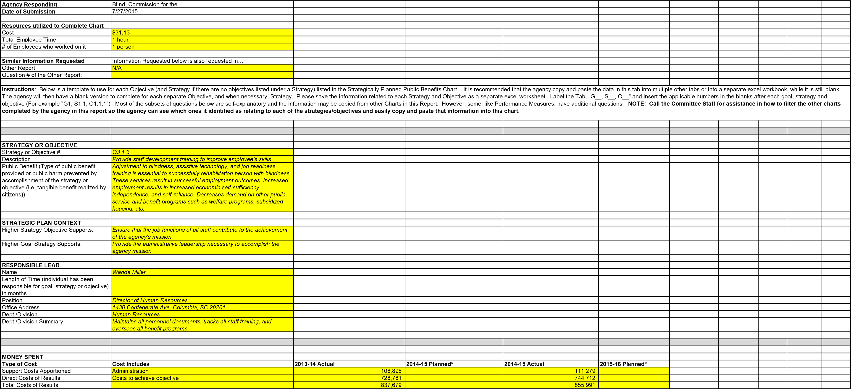
*SCCB does not capture costs in this manner. Based on historical data, SCCB is using 13% as the percent of total costs that are Support Costs. SCCB does not plan expenditures in this manner. Based on a phone conference with Charles Appleby and Jennifer Dobson on July 14th, we are leaving the planning columns blank and attaching our spending plan for FY16. It is by functional area in our agency.
By Major Program Area in 2014-15 | Amount available at end of 2013-14 | FY 2014-15 Agency Beginning Base | Aging Blind - Part 1A Recurring Funds H.4701 - State Funds | Nonrecurring Proviso 118.16 - State Funds | Tobacco MSA Provisos 118.15 - State Funds | FY 2013-14  Capital Reserve  Fund H.4702 -  State Funds | Federal  Funds | Other Funds | Total
 | $72,854 | $405,059 | $3,750 |  |  |  | $509,336 | $9,270 | $990,999
PARTNERS

Instructions: The agency already listed the partner entities which relate to each strategy and objective in the Strategically Planned Partners. Please sort that Chart by Strategy or Objective # and copy and paste the partner entities connected with this strategy or objective. Call the Committee Staff for assistance in how to sort the partner entities in the other chart so the agency can see which ones it has identified as relating to each of the agency's strategies and objectives and easily copy and paste it into this chart.
Current Partner Entities | Ways Agency works with Current Partners
Labor Licensing & Regulation | Provides staff training at no cost
Insurance Reserve Fund | Provides staff training at no cost.
Helen Keller National Center (HKNC) | Provides staff training
Hadley School for the Blind | Staff participates in free online courses
American Red Cross -Non-Profit | Trains outreach staff in CPR.
SC Division of Technology Operations | Training for I.T. staff
Microsoft | Training for I.T. staff on their website.
Freedom Scientific | Free A.T. training for staff.
PERFORMANCE MEASURES
Instructions: The agency already listed the Performance Measures for each objective in the Performance Measures Explained Chart so it knows if there is one or multiple Performance Measures which apply to this objective. Please complete the template below for each Performance Measure that applies to this objective.
# of years agency has tracked the measure | Performance Measure Description | 2009-10 Results | 2010-11 Actual Results | 2011-12 Actual Results | 2012-13 Actual Results | 2013-14 Actual  Results | 2014-15  Targets | 2014-15  Actual  Results | 2015-16  Targets | PM Item #
3 | Workforce Engagement: Training Opportunities |  | 66 | 32 | 28 |  |  |  |  | 258, 188,  119
5 | Total Number of Consumers Served |  | 3317 | 2419 | 2235 | 2115 | N/A | 2052 | N/A | 230, 161,  91, 59, 29
Questions Related to Performance Measure
Why was this performance measure chosen as a gauge of whether the objective had been accomplished? |  | The total number of consumers served directly correlates with staff performing the functions of their job description in the provision of services.
Reasoning for 2014-15 Target Value?  Was 2014-15 Target a standard target, moderate challenge or a stretch challenge? |  | N/A  N/A
Reasoning for missing 2014-15 Target Value, if missed? Work being done to improve deficiencies? |  | N/A  N/A
Reasoning for 2015-16 Target Value?  Is the 2014-15 Target a standard target, moderate challenge or a stretch challenge? |  | It is difficult to set a target for this objective as there is no way to determine the number of people with visual impairments in SC who will seek assistance. Each year people move, students arrive at local colleges, and life circumstances often create visual impairments suddenly. Therefore this is an unpredictable number each year.  N/A
Provide the names of employees who are responsible for…
Comparison of actual performance to target value |  | N/A
Determination of whether corrective action is necessary (key objectives of correction are: (1) to remove defects, in many cases this is worker-controllable; (2) to remove the causes of defects, this may be worker or management controllable; (3) to attain a new state of process performance, one that will prevent defects from happening; and  (4) to maintain or enhance the efficiency and effectiveness of the process, which is an essential condition for continuing process improvement and ultimately increasing the competitiveness and profitability of the business  itself) |  | N/A
Making any changes needed to ensure the target value is reached |  | N/A
 | Names and Titles of individuals who set this as a performance measure | James Kirby, Commissioner; Shana Robins | On, Director of Quality Assurance.
REVIEWS/AUDITS
Instructions: The agency already listed the potential negative impacts which relate to each strategy and objective in the Potential Negative Impact Chart. Please sort that Chart by Strategy or Objective # and copy and paste the negative impacts which relate or impact this strategy or objective. Call the Committee Staff for assistance in how to sort the negative impacts in the other chart so the agency can see which ones it has identified as relating to each of the agency's strategies and objectives and easily copy and paste it into this chart.
Matter(s) or Issue(s) Under Review | Reason Review was Initiated (outside request, internal policy, etc.) | Was Reviewing Entity External or Internal? | Entity Performing the Review | Date Review Began (MM/DD/YYYY) | Date Review Ended  (MM/DD/YYYY)
Vocational Rehab Grant | Single Audit Act of 1996 | External | SAO | 7/27/2014 | 3/16/2015
Vocational Rehab Grant | Single Audit Act of 1996 | External | SAO |  | 7/27/2014
Vocational Rehab Grant | Single Audit Act of 1996 | External | SAO |  | 6/16/2013
Vocational Rehab Grant | Single Audit Act of 1996 | External | SAO |  | 5/24/2012
Review of HR Exception Procedures | Internal Policy | External | Budget & Control Board |  | 11/10/2014
POTENTIAL NEGATIVE IMPACT
Instructions: The agency already listed the potential negative impacts which relate to each strategy and objective in the Potential Negative Impact Chart. Please sort that Chart by Strategy or Objective # and copy and paste the negative impacts which relate or impact this strategy or objective. Call the Committee Staff for assistance in how to sort the negative impacts in the other chart so the agency can see which ones it has identified as relating to each of the agency's strategies and objectives and easily copy and paste it into this chart.
Most Potential Negative Impact | 3 G.A. Options | Level Requires Outside Help | Outside Help to Request | Level Requires Inform G.A.
The VR profession is an ever changing
research and development based
profession, lack of staff development and
training results in staff not being current
with industry trends, best practices,
innovations, or research findings.
Consumers who are not served in the
most up to date manner will be unable to
meet the qualifications for available
employment opportunities and will be
unable to remain self-sufficient as
technology changes rapidly.
. Consider funding for specialized staff training to allow for
1
professional growth and better service to consumers. 2. Consider
expanding agencies authority to send staff to national and regional
professional conferences. 3. Consider funding for high definition video
conferencing to expand training while decreasing travel time and travel
costs.
When staff is unable to answer questions
posed by consumers, unable to train or
offer training on the latest technology, and
is unable to renew their specific licensures
due to lack of ongoing development, it is
time for help.
Reach out to other state agencies
and online for free and low cost
training opportunities for staff to build
their skills.
When staff is unable to maintain
licensures and are not able to
provide up to date services to the
consumers.
LAWS AS BASIS
Statute, Regulation, Proviso
Summary of Statutory Requirement and/or Authority Granted
361.13 (a)
Title I, Part B
LAWS TO FURTHER EVALUATE
Statute/Regulation/Provisos
Summary of Statutory Requirement and/or Authority Granted
Law Item #
Recommend Further Evaluation
(
Yes or leave blank)
N/A
Instructions
ance in ho
w to sort the
:
The agency already listed th
e Laws which support each strategy and objective in the Strategic Plan-
by Strategy or Objective # and copy an
d paste the laws which relate or impa
ct this strategy or objective.
Call the Committe
Laws as Basis Chart. Please sort that Chart
e Staff for assist
laws in the other chart so the agency can s
ee which ones it has identified as relating to or impacting each of the ag
ency's strategies and objectives and easily
copy and paste it into this chart.
Instructions
The agency already listed th
:
e Laws to further evaluate in the Laws to Further Evaluate Chart. Pleas
e sort that Chart by Strategy or Objective # a
nd copy and paste the laws which relat
e or impact this strategy or objective which the agency recommended the Committee further evaluate. Call the Committee
opy and paste it into this chart.
strategies and objectives and easily c
relating to or impacting each of the agency's
in the other chart so the agency can see which ones it has identified as
Staff for assistance in how to sort the laws
Basis for Further Evaluation
Under the State Vocational Rehabilitation Services Program (Program),
the Secretary provides grants to assist
ficient, and accountable programs, each of
States in operating statewide comprehensive, coordinated, effective, ef
which is—
a) An integral part of a statewide workforce investment system; and
(
ation services for individuals with
b) Designed to assess, plan, develop, and provide vocational rehabilit
(
ns, abilities, capabilities, interests, and
disabilities, consistent with their strengths, resources, priorities, concer
mployment.
informed choice, so that they may prepare for and engage in gainful e
720(a)(2))
Authority: Section 100(a)(2) of the Act; 29 U.S.C.
(

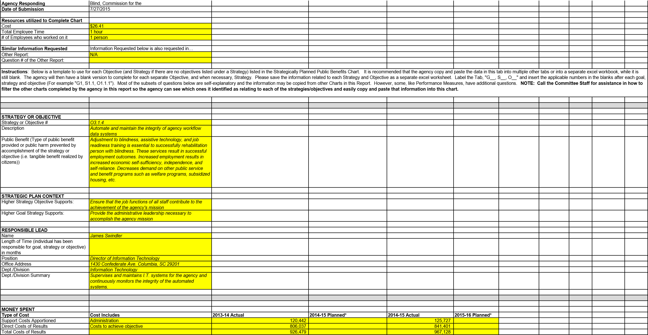
*SCCB does not capture costs in this manner. Based on historical data, SCCB is using 13% as the percent of total costs that are Support Costs. SCCB does not plan expenditures in this manner. Based on a phone conference with Charles Appleby and Jennifer Dobson on July 14th, we are leaving the planning columns blank and attaching our spending plan for FY16. It is by functional area in our agency.
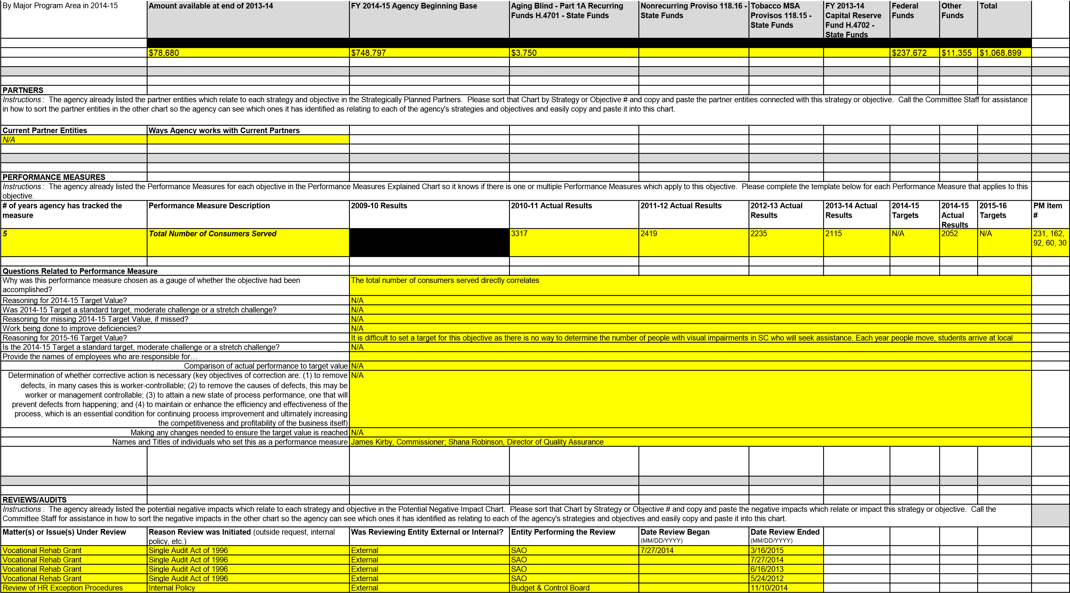
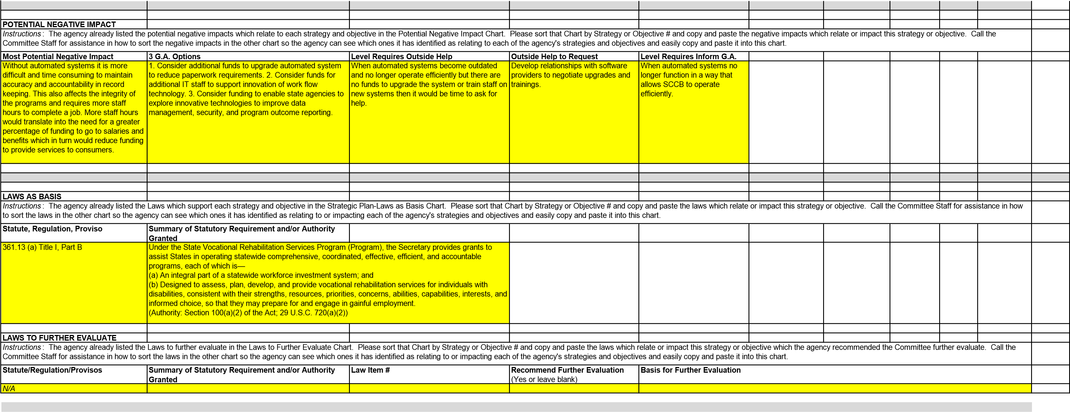

PERFORMANCE MEASURES SCCB does not have an associated
Strategy/Objective in the current
Strategic Plan
Instructions: The agency already listed the Performance Measures for each objective in the Performance Measures Explained Chart so it knows if there is one or multiple Performance Measures which apply to this objective. Please complete the template below for each
# of years agency has tracked the measure | Performance Measure Description | 2009-10 Results | 2010-11 Actual Results | 2011-12 Actual Results | 2012-13 Actual  Results | 2013-14 Actual  Results | 2014-15 Targets | 2014-15 Actual  Results | 2015-16 Targets | PM Item #
3 | Freedom of Information Act (FOIA) Response Compliance |  | 7 Days | 9 Days | 14 Days
3 | Workforce Engagement:  Employee Separation Reasons |  | Percentage Breakout of Employee Separation:  Personal (47%), Full  Retirement (18%),  Transferred to Another  Agency (18%), Dismissed  (17%) | Percentage Breakout of Employee Separation:  Other Reason 45%,  Other Employment 30%,  Dismissed 15%, Full  Retirement 10% | Percentage Breakout of Employee Separation: 50%  Dismissed, 30%  Retired, 20% Found  Other Employment
3 | Financial Performance: Older  Blind Program Average Dollars Spent Per Consumer |  | $408 | $516 | $145
3 | Financial Performance: Vocational  Rehabilitation Program Average  Dollars Spent Per Consumer |  | $1,352 | $1,523 | $1,265
3 | Financial Performance: Children's  Services Program Average Dollars  Spent Per Consumer |  | $54 | $193 | $58
3 | Financial Performance: Business  Enterprise Program Average Dollar Spent Per Vending Facility |  | $1,782 | $2,090 | $1,900
3 | Prevention of Blindness Referrals |  | 444 | 141 | 158

Agency Responding | Blind, Commission for the
Date of Submission | 7/27/2015
Resources utilized to Complete Chart
Cost | $50
Total Employee Time | 1 hour
# of Employees who worked on it | 11 people
Similar Information Requested | Information Requested below is also requested in…
Other Report: | N/A
Question # of the Other Report:
Instructions: Please list the types of searches the agency can perform within the electronic version(s) of its budget, maintained at the agency (i.e. budget by year, office, department, program, etc.), and the information the search would provide. NOTE: Responses are not limited to the number of rows below that have borders around them, please list all
That are applicable.
Search Available to Perform | Information Search would Provide
State Funded Program | Searching the budget by State Funded Program makes the current budget comparable to the Detail Budget/Budget Request that is submitted each year.
Department | Searching the budget by Department allows SCCB to see how each internal program is spending funds.
General Ledger Account | Searching the budget by General Ledger Account allows SCCB to see what types of items and services the agency is purchasing.

Agency Responding | Blind, Commission for the
Date of Submission | 7/27/2015
Resources utilized to Complete Chart
Cost | $19
Total Employee Time | 0.5 hour
# of Employees who worked on it | 1 person
Similar Information Requested | Information Requested below is also requested in…
Other Report: | N/A
Question # of the Other Report:
Instructions: Please answer the questions below to provide feedback to the Committee on this Program Evaluation Report.
Please list changes to the Report questions, format, etc. the agency recommends to Committee. |  | 1. Clarification on type of partners as SCCB works with thousands of businesses, agencies, and individuals in the daily course of business. To list them all would take weeks.
 |  | 2. Breaking down financial information by program is very doable and accurate. However attempting to do this by objective was a difficult process because many objectives overlap and different staff focus on different objectives. Attempting to break down the hourly activities of 150 people is a difficult process.
 |  | 3. Copying and pasting was not always possible as the grids from sheet to sheet did not always line up. Moving the performance measures to the Strategic, Objective Details pages was a very time consuming process as the grids were very different.
 |  | 4. There was not consistency in all of the information needed on the Objective Details pages. The financial information was very different from the other financial spreadsheets. If the Objective Details page is supposed to be a synopsis of each objective with information taken from the other pages, it should be set up with the same grids for copying and pasting.
Please list 2-3 benefits the agency sees in the public having access to the information requested in the report, in the format it was requested. |  | 1. The public can see exactly where the tax dollars go in the agency.

 |  | 2. The public can be aware of what exactly the agency offers and the goals they strive for each year, along with all the objectives to reach those goals.
Please list 2-3 benefits in performing a study of the agency that the agency sees the Committee having by having the information requested in this report available and in this format. |  | 1. This report gives a clear picture of where the dollars are spent and the number of SC citizens who benefit each year.
 |  | 2. The Committee can see at a glance the public benefit of each objective, know who is responsible if they have questions, and can see the negative impact on the citizens of SC if SCCB were not able to provide services.
Now that the agency has completed the report, please list 2-3 things the agency could do differently next time (or it could advise other agencies to do) to complete the report in less time and at a lower cost to the agency. |  | 1. Maintain an Excel spreadsheet with 5 year data in each of the categories.
 |  | 2. When completing the Accountability report, create a more detailed report for agency records that would include the majority of facts and figures requested on this report.
Please add any other feedback the agency would like to provide (add as many additional rows as necessary)

Agency Responding | Blind, Commission for the
Date of Submission | 7/27/2015
Instructions: Please list the contact information for the Current Head of the Agency first. Next, please provide the contact information for individuals at the agency the Legislative Oversight Committee should contact regarding the Oversight Study. Any correspondence from LOC about meeting or hearing dates and times, questions from the Committee, etc. will go to the Primary Contact and, if unavailable, the Secondary Contact. If the individuals serving as primary or secondary contact change or if the contact information for the primary or secondary contact change, the agency is responsible for informing LOC. If the agency wants to have the Current Head of the Agency serve as the Primary or Secondary Contact, please include that individuals information next to "Current Head of Agency" and then again next to Primary or Secondary Contact.
 | Current Head of Agency | Primary Contact | Secondary Contact
Date of Hire | 11/5/2005 | 3/28/1996 | 5/18/2015
Name | James M. Kirby | Shana Robinson | Elaine Robertson
Phone | 803-898-8822 | 803-898-8593 | 803-898-1049
Email | jkirby@sccb.sc.gov | srobinson@sccb.sc.gov | erobertson@sccb.sc.gov
Asst. email (if applicable) | Linda Johnston - ljohnston@sccb.sc.gov
Mailing Address | PO Box 2467, Columbia, SC 29202 | PO Box 2467, Columbia, SC 29202 | PO Box 2467, Columbia, SC 29202
Street | 1430 Confederate Avenue | 1430 Confederate Avenue | 1430 Confederate Avenue
City, State | Columbia, South Carolina | Columbia, South Carolina | Columbia, South Carolina
Zip Code | 29201 | 29201 | 29201

Agency Responding | Blind, Commission for the
Date of Submission | 7/27/2015
Resources utilized to Complete Chart
Cost in Employee Time | $43
Total Employee Time | 1 hour
# of Employees who worked on it | 11 people
Similar Information Requested | Information Requested below is also requested in…
Other Report: | N/A
Question # of the Other Report:
Instructions: Please list the terms, phrases or acronyms the agency uses which the Committee or general public may not know, along with the meaning of the term, phrase or acronym. NOTE: Responses are not limited to the number of rows below that have borders around them, please list all that are applicable.
Term, Phrase or Acronym | Meaning of the Term, Phrase or Acronym
SCCB | South Carolina Commission for the Blind
VR | Vocational Rehabilitation
VPN | Virtual Private Network
SOC | Security Operations Center
SC | South Carolina
JAWS | Jobs Access With Speech (Adaptive software for visually impaired)
OJT | On the Job Training
NET | National Employment Team
HKNC | Helen Keller National Training Center
HR | Human Resources
AWARE | Automated recordkeeping and report software system.
SCEIS | South Carolina Enterprise Information System
Mainframe CIS | Mainframe Client Information System
BEP | Business Enterprise Program
T & E | Training and Employment
EBMRC | Ellen Beach Mack Rehabilitation Center
EPMS | Employee Performance Management System
AUP | Agreed Upon Procedures
SAO | State Auditors Office
RSA | Rehabilitation Services Administration
Transportation Infrastructure Bank, State
Deaf and the Blind, School for the
Blind, Commission for the
Public Safety, Department of
Treasurer, S.C. Office of the
By practice the requirements in the law are no longer performed by the agency
The requirements in the law are performed by another agency The Committee should consider adding to the law standard qualifications for certain positions within the agency the law prohibits or makes it more difficult to implement ideas or plans which may decrease administrative costs, increase efficiency, allow the agency to focus more on its mission, etc. Other
Types of Partner Entities (PartnerEntityType)
Non-Profit
Federal Agency
State Agency
Private Company
Individual
Board
Committee Other
Types of Measures
Outcome Measure
Efficiency Measure
Output Measure
Input/Explanatory Measure

